|  |  |
| --- | --- |
| JOINT REPORT of  Connor Claypool,  Aidan Cram,  Calum Keelan  and  William MacMillan  Unit name and Force  Case against: John Doe  Police Reference No: (if applicable)  Case Reference No: (CCU or equivalent ref)  PF Reference No: (if applicable) | FORCE BADGE |

# Summary

The purpose of this report is to collate, analyse and explain the findings of an investigation carried out on a hard drive found in the possession of John Doe. The hard drive mentioned in this report was thought to contain illicit ornithological material and hence was brought in for investigation. Numerous methods were employed in order to successfully and thoroughly examine the drive. These methods included imaging, physical searching, logical searching, web browser and email analysis, file cracking and timeline analysis. With the methodology taken, the investigative team were able to find many files relating to ornithology. It was also found that several images containing ornithological material were only accessed by the user johndoe, providing strong evidence that the user johndoe was solely responsible for all ornithological activity on this machine.

# Description of Crime

**Incident 1** – On Feb 2, 2005, between 14:11 and 14:44, the user johndoe downloaded one ornithological image (Item 104 in Appendix A) into the ‘C:\WINDOWS’ folder, and a further 5 (Items 90-94 in Appendix A) into the user’s ‘My Documents\My Pictures’ folder. The user also downloaded an ornithological webpage (Item 145 in Appendix B) into the user’s ‘My Documents’ folder and created an ornithological document (Item 147 in Appendix B) in this folder.

**Incident 2** – On Feb 2, 2005, between 15:10 and 15:13, the user johndoe downloaded two audio files from an ornithological website, one into the user’s ‘My Documents’ folder and another into the user’s ‘Local Settings\Temp’ folder.

**Incident 3** – On Feb 2, 2005, between 16:32 and 16:47, the user johndoe created an encrypted archive containing 5 ornithological images (Items 136-140 in Appendix A) in the user’s ‘My Documents’ folder.

**Incident 4** – On Feb 3, 2005, between 11:35 and 11:47, the user johndoe created a new hard disk volume ‘F:’ and stored 11 ornithological images there (Items 105-114 and 127 in Appendix A).

**Incident 5** – On Feb 3, 2005, between 12:08 and 12:23, the user johndoe stored a Zip archive file containing 7 ornithological images (Items 128-134 in Appendix A) in the ‘C:\WINDOWS’ folder, and downloaded an ornithological audio file into the ‘E:\birds\audio’ folder on an external USB drive.

**Incident 6** – On Feb 3, 2005, between 14:14 and 14:46, the user johndoe created a document containing an ornithological image (Item 142 in Appendix B) in the user’s ‘My Documents\My Music’ folder, and stored a matching ornithological image (Item 98 in Appendix A) in the ‘C:\WINDOWS\mui’ folder.

**Incident 7** – On Feb 3, 2005, between 14:54 and 15:07, the user johndoe downloaded one ornithological image (Item 83 in Appendix A) into the user bob’s ‘My Documents\My Music’ folder, and another (Item 84 in Appendix A) into johndoe’s own ‘Desktop’ folder. The user also downloaded 4 ornithological images (Items 85-88 in Appendix A) into the user’s ‘My Documents\My Pictures’ folder, and another ornithological image (Item 89 in Appendix A) and a web page containing ornithological material (Item 144 in Appendix B) into the user’s ‘My Documents’ folder.

**Incident 8** – On Feb 3, 2005, between 15:36 and 15:56, the user johndoe moved an ornithological image (Item 127 in Appendix A) to the Recycle Bin on the ‘F:’ drive, stored a document containing ornithological materials (Item 141 in Appendix B) on the ‘C:’ drive, and edited the file ‘C:\WINDOWS\ODBC.INI’ (Item 148 in Appendix B), a legitimate configuration file found to contain additional ornithological text.

**Incident 9** – On Feb 9, 2005, between 11:27 and 11:30, the user johndoe downloaded, installed and ran an ornithological screensaver program (Screenshot in Item 135 in Appendix A).

**Incident 10** – On Feb 9, 2005, between 16:56 and 17:10, the user johndoe created a document containing an ornithological title in its metadata (Item 143 in Appendix B) in the user’s ‘My Documents’ folder, accessed the ‘F:’ drive, which contained 22 ornithological images at this time (Items 105-126 in Appendix A), and viewed at least one of these (Item 105).

These incidents are described in more detail in Appendix D, Table 5, and the raw timeline data for Incidents 1 through 10 are included in Appendix D, Tables 6 through 15. The corresponding browser history and downloads records for Incidents 1, 2, 5, 7 and 9 are included in Appendix C.

# Description of Investigation

## Job Description and Instructions

The investigators were given a Hard Disk Drive belonging to John Doe and asked to analyse it for incriminating information. The focus of this investigation was on ornithological images that could be found on the drive.

## List of Recovered and Examined Items

One item was retrieved from the scene. This was a Maxtor hard drive with a storage capacity of 5Gb believed to belong to the suspect.

## Methodology

This section describes the methodology used to analyse the recovered items for digital evidence. Definitions for terms highlighted in **bold** when they are first used, in this section and in subsequent sections, can be found in the Glossary.

### Imaging and Partition Audit

#### Partition Audit

The investigators made use of both the fdisk and mmls tools when completing this section of the investigation. Specifically, when running the fdisk command, the p and F subcommands where run.

#### Partition Recovery

When using the testdisk tool, the investigator needed to use the deep scan function to locate the deleted partition. Once found, the tool was used to write a new partition table with the deleted partition now indexed. The integrity of the data was verified using a modified MD5 Hash, which will be described below. This will later be analysed to determine what files were contained there.

#### MD5

To ensure the validity of the results obtained during this investigation the investigators used MD5 hashing, which creates a unique series of numbers and letters, of the disk image. This can be compared to the hash created when copying the original disk. If even one bit of data is altered on the disk then the hash will also change, this allows for certainty that any methods of extracting data from the disk will not have altered any of the data it contains.

This step was conducted at the beginning and end of every stage of the investigation to ensure the evidential integrity. This was done using a script that executed a series of commands that, when run, would automatically check and document the integrity of the evidence.

The hash for the drive is: d63dd1b8917ca28bac7c955fc3b6cd25

#### Clock Skew

By opening the bios of the suspects computer, the investigators were able to compare the time to the time of the “time.is” website.

### Physical Search

In this stage, the investigators first made use of **file carving** tools to recover files from the john doe image. Through using these techniques, the team was able to recover a range of different file types from john doe’s hard drive. The team were able to search through the metadata of some of these images and link them to a camera which it was discovered had taken many pictures containing birds or bird watching activities. The team also ran the disk image through autopsyand carried out a keyword search aiming to find any reference to bird watching.

### Logical Search

In this stage (whose name refers to the logical abstraction a drive’s folder structure provides over the way digital data is physically stored), any partitions on the acquired disk image are **mounted** so that the files and folders they contain may be explored like normal drives. In this situation, partitions are mounted read-only to prevent any changes to the image. The partitions are then searched for files of specific types, such as images and documents. The name, location, content and any **metadata** of each file relevant to the case is then recorded.

### Operating System Artefact Analysis

In this stage, the files and folders present on each partition are examined to determine which **operating system**, if any, is installed there. Items of data specific to the operating systems found are then analysed for information such as which user accounts exist on the system, when they logged in, and, crucially, which files they viewed.

### File Cracking

Some files have been secured using different types of **encryption**. This made the files inaccessible to investigators. This led the investigators to break the encryption in order to access any potential evidence hidden inside. Some were found to have no incriminating data; however, information was found in others that was deemed to be inappropriate.

#### GPG

A collection of files where placed inside a gpg file which when accessed by the investigators was found to contain 5 pictures of birds.

### Web Browser and Email Analysis

This stage involves gathering evidence obtained from any Internet browsers and Email clients installed on the system. It was found that two Internet browsers where installed on the system, Internet Explorer and Mozilla Firefox. The Email client installed on the system was Mozilla Thunderbird.

### Timeline Analysis

This stage involves gathering time information relating to specific events, such as file creation times or browser history times, from the partitions on the acquired disk image. This allows a detailed timeline of system activity to be constructed, which can be searched for events relating to files relevant to the case. In analysing these results and comparing them with those of previous stages, a picture of which users performed which activities at which times should become as clear as possible.

## Analysis

This section describes the analyses performed. Procedures and commands were run from an Ubuntu Linux 19.10 workstation unless otherwise specified. Linux commands preceded by a ‘#’ symbol were run as **root**, while commands preceded by a ‘$’ were run as a normal user. References to the ‘case directory’ pertain to a working folder where results and temporary files could be stored during the analysis.

### Imaging and Partition Audit

Imaging is the process of creating an identical copy of all data stored on the Disk.

#### Partition Audit

It is possible to conceal data on the disk by placing it on a “hidden” part of the disk that the computer cannot normally see. By completing a partition audit the investigators were able to determine that there was an unallocated partition on the disk. This indicated that a partition recovery would be necessary to determine what evidence could be contained there.

#### Clock Skew

An analysis was done of the clock skew of the suspects computer. There was a small deviation, less than one second, this is within acceptable parameters. This means that the dates recovered in this investigation can be considered as reliable.

### Physical Search

The investigating team used the linux console to run commands on the disk image file. The first command used was **foremost**, which recovered files from the image by matching common headers and footers shared by specific file types. This returned a range of files, including JPG images containing sensitive material (birds). The **metacam** command was used to find metadata within these indecent images and the team were able to isolate some images that were taken with the **canon powershot** camera, which allows us to link these files to other files downloaded by John Doe as the canon powershot images were downloaded from the same website. The team also found positive results for birdwatching in a **keyword search** carried out using the Autopsy tool. Using this method was able to find multiple mentions of bird watching through email communications and in many files on the drive.

### Logical Search

First, the partitions on the acquired disk image were mounted on a Windows workstation, using the procedure given in Appendix D, Subsection 2.1. Each partition was then scanned for malware using Avast Antivirus by right-clicking on the mounted drive in Windows Explorer and clicking ‘Scan selected items for viruses’. No malware was discovered.

The partitions were then mounted on a Linux workstation, using the procedure given in Appendix D, Subsection 2.2, making partitions 1 (the first partition) and 2 (the recovered deleted partition) available under the folders ‘/mnt/jd1’ and ‘/mnt/jd2’, respectively.

Next, the **bash script** given in Appendix D, Listing 7 (which in turn makes use of the **Python script** given in Appendix D, Listing 8) was run to find every JPEG image, PNG image, GIF image, BMP image, Microsoft Word document, PDF document, HTML document and Zip archive on partitions 1 and 2. It then copied each file to a new folder in the case directory specific to the given partition and file type, while renaming the file to preserve information about its original location. For instance, the file ‘img.jpg’ in the folder ‘Documents and Settings/user1’ on partition 1 would be copied to the new folder ‘jpg_partition_1’ and renamed to ‘Documents and Settings__user1__img.jpg’. This allowed the files of each type to easily be browsed, as all files of the same type were stored in a single folder with no nested folders, while making their original locations clear.

The recovered files were then examined to determine their relevance to the case. The relevant files found are described in Appendix D, Table 1. Additionally, for each JPEG image and Word document, metadata was extracted using the command in Listing 1, replacing ‘FILE’ with the name of the file. Any relevant metadata found, such as camera details and authorship information, is given in Appendix D, Table 2.

Listing 1: Command used to extract metadata from each JPEG image and Word document using exiftool



### Operating System Artefact Analysis

Browsing partition 1 revealed a ‘WINDOWS’ folder and a ‘boot.ini’ file, indicating an installation of Microsoft Windows, with the contents of ‘boot.ini’ listing the Windows version as XP Professional. Partition 2 contained no indication of an operating system, only image and document files.

The first Windows artefacts analysed were the files making up the **registry**, a store of settings and usage records. RegRipper was used to extract information from these. Firstly, the commands given in Listing 2 were run to gather information about mounted devices and USB drives used. Their output, given in Appendix D, Listing 12, revealed that partitions 1 and 2 (identified by their offsets) and a USB drive were mounted as the ‘C:’, ‘F:’ and ‘E:’ drives, respectively.

Listing 2: Commands used to get information about storage devices using RegRipper



Next, the command in Listing 3 was run to list information about the users on the system. The output of this command, given in Appendix D, Listing 13, revealed three users who had logged in: ‘jane’, ‘johndoe’ and ‘bob’. It also showed ‘johndoe’ was an Administrator, having complete control over the system, and had logged in 21 times, while ‘jane’ and ‘bob’ were restricted users who had logged in once.

Listing 3: Command used to list information about user accounts using RegRipper



The bash script given in Appendix D, Listing 9 was then run to extract information from specific locations in each user’s user-specific registry file: the **OpenSaveMRU** list, the **RecentDocs** list, the **Wallpaper MRU** list, and various records of recently used Microsoft Office files. The output of this script is given in Appendix D, Listing 14. These results also highlighted further relevant files, which are described in Appendix D, Table 3.

Next, the bash script given in Appendix D, Listing 10 was run to use the program pasco to extract information from the Internet Explorer history of each user, which, importantly, records accesses to files in general, not just web browser accesses. The output of this script is given in Appendix D, Listing 15.

Finally, the bash script given in Appendix D, Listing 11 was run to search for **Windows shortcut files** belonging to each user and determine the file they point to. The output of this script is given in Appendix D, Listing 16.

These results were then cross-referenced with the list of relevant files recovered, to determine which users viewed these files. The results of this comparison are shown in Appendix D, Table 4, with accesses to many relevant files recorded in multiple locations for the user johndoe, and none for other users.

### Web Browser and Email Analysis

#### Internet Explorer Analysis

To analyse user data from the Internet Explorer browser, the following index.dat files have been extracted from the disk image and converted into a readable format using the tool Pasco.

* Documents and Settings\<user>\Local Settings\Temporary Internet Files\Content.IE5\index.dat
* Documents and Settings\<user>\Local Settings\History\History.IE5\index.dat
* Documents and Settings\<user>\Cookies\index.dat
* WINDOWS\pchealth\helpctr\OfflineCache\index.dat
* WINDOWS\system32\config\systemprofile\Cookies\index.dat
* WINDOWS\system32\config\systemprofile\Local Settings\History\History.IE5\index.dat

All the index.dat files have been examined and the only files with relevant data are the files contained within the user profiles of Bob and JohnDoe.

#### Firefox Analysis

To analyse the User data from the Firefox browser, the following folders and files have been extracted from the disk image:

* C:\Documents and Settings\<User Profile>\Application Data\Mozilla\Firefox\Profiles\*.default\bookmarks.html
* C:\Documents and Settings\<User Profile>\Application Data\Mozilla\Firefox\Profiles\*.default\history.dat
* C:\Documents and Settings\<User Profile>\Application Data\Mozilla\Firefox\Profiles\*.default\cookies.txt
* C:\Documents and Settings\<User Profile>\Application Data\Mozilla\Firefox\Profiles\*.default\Cache

The following tools have been used to examine the extracted data:

* MZHistoryView
* MZCacheView
* Irfanview
* [www.wayback.com](http://www.wayback.com/)

After analysing the extracted data from the Firefox browser, the only illegal activity was found under the user account user found to have any illegal activity was JohnDoe.

#### Thunderbird Email Analysis

To analyse the Email data from Mozilla Thunderbird, the tool Autopsy was used. The only User account to have an email profile was the user JohnDoe.

### Timeline Analysis

To extract time-related data from the repaired disk image (so that data from both partitions could be processed), the tool log2timeline was used, as shown in Listing 4. Data gathered by log2timeline includes file creation, modification and access times, registry key write times, and Internet Explorer history times.

Listing 4: Command to create a timeline of system activity using log2timeline



This data was then sorted and imported into Elasticsearch, a database system designed for storing and analysing millions of computer events, using the command in Listing 5. The procedure for setting up Elasticsearch and Kibana (the interface for viewing Elasticsearch data) prior to this command, and for preparing for analysis following it, is given in Appendix D, Subsection 5.1.

Listing 5: Command used to import log2timeline data into Elasticsearch



The resulting timeline was then analysed in Kibana primarily by searching for references to relevant files. Ten incidents were identified, which are described in Appendix D, Table 5. The timeline data (filtered for relevance) for these incidents are given in Appendix D, Tables 6 through 15. Additionally, Appendix D, Table 16 contains a timeline of user registry file times. This data (as well as the login information in Appendix D, Listing 13) was compared with the incident timelines to provide further evidence regarding the user responsible. Activity that occurred before a user’s registry file was created or after it was last modified is highly unlikely to have been performed by that user, due to the frequency with which user registry data is written during user activity. Firefox browser history and downloads were also manually compared with the timeline data, since log2timeline was unable to read this data.

## Production List and Associated Descriptions

|  |  |
| --- | --- |
| Number of item(s) | Description |
| 1 | Maxtor 5Gb Hard Drive |

# Conclusion

After performing a complete forensic analysis on the harddrive seized from JohnDoe, it was found to contain both illegal images and audio of Birds. While most of the illegal content was found in the user profile for JohnDoe, any illegal content stored on the local computer was found to have been accessed only under the user account of JohnDoe and no other account on the computer. A second partition was found to have been created by JohnDoe which contained various illegal images of birds, as part of the forensic investigation this partition had to be restored. To try and avoid detection the user JohnDoe has used file encryption to try and hide some of the illegal images but this encryption has been cracked as part of the investigation. Evidence of a USB flash drive was found both as part of the Registry and Browser Analysis, evidence suggests that the flashdrive was used to store illegal images and is would be advantageous for the investigation team to review this USB device. A number of emails where received from the email address [ben@example.com](mailto:ben@example.com) containing images of birds and also contained an email thanking JohnDoe for sending Ben some pictures, it would be beneficial for the investigation team to further investigate this.

# Glossary

**Bash script –** Bash is the standard ‘shell’ or command line system on Linux in which a user can type in commands to run programs, read and write files, and perform many other tasks. A Bash script is one or more Bash commands saved to a file that can be executed by Bash to run the commands it contains.

**Encryption** – Files that are encrypted have been protected with a password or ‘key’ in such a way that they can only be read with this password or key – otherwise they appear like random data.

**File carving -** The process of reassembling files from data fragments.

**Metadata** –Metadata is data about the primary contents of a file which is also stored within that file. For example, images often contain metadata describing the camera they were taken with, and Microsoft Word documents may contain metadata about the author.

**Mounting** – The process of mounting a disk drive or other storage device refers to making it available to browse on a computer system. On Windows, mounted drives are mapped to a drive letter such as ‘D’, and on Linux drives must be mounted under an existing folder, such as ‘/mnt/usb1’.

**OpenSaveMRU** – This is a registry key specific to each user account which records which files that user has recently opened or saved through the standard Windows dialog box, the window which opens when the ‘Open’ or ‘Save’ option is clicked in the ‘File’ menu in many programs, or when a file is downloaded to a specific location in a web browser.

**OpenWith** – This is a registry key storing a user’s settings regarding which programs open which file types.

**Operating System** – An operating system is the software that sits between the computer hardware and the different programs a person uses, such as web browsers or word processors. Examples of operating systems include Microsoft Windows and MacOS.

**Python script –** Pythonis a computer programming language in which lines of code are run by a so-called interpreter program. A Python script refers to a collection of lines of Python code saved to a file which can be run by the Python interpreter program.

**RecentDocs** – This is a registry key specific to each user account which records the files most recently opened by that user.

**Registry** – The registry is a database of configuration and usage information used by the Windows operating system. This database is split across multiple files, some of which contain data about the whole system, and some of which contain data about a specific user account. The information stored in the registry is organised intokeys (which function similarly to the folders in which files are stored) which may contain subkeys as well as values, the actual data. See **OpenSaveMRU**, **OpenWith, RecentDocs**, **UserAssist** and **Wallpaper MRU** for some of the registry keys of evidential value.

**Root** – The user ‘root’ on a Linux operating system (and some others) is the user account which has complete access to the computer. This account has full read and write access to any data present on the system, and has permission to perform other tasks, like mounting drives or installing software, which standard users are prevented from doing.

**Userassist** – This is a registry key which contains information about programs run by a specific user.

**Wallpaper MRU** – This is a registry key specific to each user account which records the files most recently used as that user’s wallpaper or desktop background image.

**Windows prefetch –** Windows prefetch is a system where commonly used program code is preloaded and stored by windows to speed up access times. Windows prefetch records therefore provide information as to when programs were run.

**Windows shortcut file** – Windows shortcut files, which often have a ‘.lnk’ extension, are files which link to other files. The location of these files is especially important: for instance, shortcut files under the user’s ‘Recent’ folder on Windows XP point to recently used files, and those under ‘Recent’, ‘History’ or similar folders in folders relating to specific programs point to files recently opened in that program.

# Appendix A: Recovered Images

|  |  |  |  |  |
| --- | --- | --- | --- | --- |
| Item 1 | Item 2 | Item 3 | Item 4 | Item 5 |
| Item 6 | Item 7 | Item 8 | Item 9 | Item 10 |
| Item 11 | Item 12 | Item 13 | Item 14 | Item 15 |
| Item 16 | Item 17 | Item 18 | Item 19 | Item 20 |
| Item 21 | Item 22 | Item 23 | Item 24 | Item 25 |
| Item 26 | Item 27 | Item 28 | Item 29 | Item 30 |
| Item 31 | Item 32 | Item 33 | Item 34 | Item 35 |
| Item 36 | Item 37 | Item 38 | Item 39 | Item 40 |
| Item 41 | Item 42 | Item 43 | Item 44 | Item 45 |
| Item 46 | Item 47 | Item 48 | Item 49 | Item 50 |
| Item 51 | Item 52 | Item 53 | Item 54 | Item 55 |
| Item 56 | Item 57 | Item 58 | Item 59 | Item 60 |
| Item 61 | Item 62 | Item 63 | Item 64 | Item 65 |
| Item 66 | Item 67 | Item 68 | Item 69 | Item 70 |
| Item 71 | Item 72 | Item 73 | Item 74 | Item 75 |
| Item 76 | Item 77 | Item 78 | Item 79 | Item 80 |
| Item 81 | Item 82 |  |  |  |
| Item 83 | Item 84 | Item 85 | Item 86 | Item 87 |
| Item 88 | Item 89 | Item 90 | Item 91 | Item 92 |
| Item 93 | Item 94 | Item 95 | Item 96 | Item 97 |
| Item 98 | Item 99 | Item 100 | Item 101 | Item 102 |
| Item 103 | Item 104 | Item 105 | Item 106 | Item 107 |
| Item 108 | Item 109 | Item 110 | Item 111 | Item 112 |
| Item 113 | Item 114 | Item 115 | Item 116 | Item 117 |
| Item 118 | Item 119 | Item 120 | Item 121 | Item 122 |
| Item 123 | Item 124 | Item 125 | Item 126 | Item 127 |
| Item 128 | Item 129 | Item 130 | Item 131 | Item 132 |
| Item 133 | Item 134 | Item 135 |  |  |
| Item 136 | Item 137 | Item 138 | Item 139 | Item 140 |

# Appendix B: Recovered Documents

*Item 141: Birdwatching.doc*  
**BIRDWATCHING IN THAILAND**   
**Feathered Magic from Mangroves to Mountaintops by Antony Lynam**

One of the great attractions for nature tourists visiting Thailand is the diversity of environments extending across mountain peaks, lowland rainforests, mangroves, coral reefs, farmland and urban jungles. Within a day, or even a few hours travel, one can easily make the transition between these places and witness natural marvels large and small.  
  
For wildlife enthusiasts no group maintains interest and pleasure more than birds. While special efforts are required to see in the wild charismatic species such as elephants and primates, birds are found across the entire spectrum of environments from pristine to severely degraded areas.

Part of the attraction for birds lies in their diversity. Nine hundred and seventy eight bird species have been recorded in Thailand, approximately 10% of the world's total. At the Isthmus of Kra between latitudes 11° and 13°N, a major biogeographic transition between Indochinese and Sundaic forests produces a special diversity of birds with a total of 152 species of birds reaching the northern or southern range limits of their geographic ranges.

Two-thirds of Thai birds are residents, the remainder are seasonal visitors. Locations where migrants congregate, often in large numbers, are highly accessible making Thailand a special destination for birdwatchers.

Many birds are susceptible to human disturbance because they have small geographic ranges, a result of specific habitat requirements. For example, Deignan's babbler - a non-descript forest bird is found on Doi Chiang Dao and nowhere else in the world. Gurney's pitta are only found in lowland rainforests. Fewer than 30 birds remain in the last known population in Thailand at Khao Nor Chuchi, Krabi. Efforts by local and international conservation agencies strive to increase protection efforts and reafforest areas encroached by rubber farmers, though time is running out. With approximately 20% of the birds found in Thailand being globally or regionally endangered species, this makes the country a birdwatching haven for bird enthusiasts.

**IDENTIFYING BIRDS**  
Birds are distinguished first by their size and shape. They range from diminutive flowerpeckers, sunbirds and white-eyes, about the size of your index finger, to lanky storks and egrets that stand almost a metre tall, and Green peafowl with its spectacular 2m tail. The form of the beak offers vital clues about the bird's diet. For example a thin curved tube for sipping nectar or a sharp hook for tearing flesh. The pattern and colour of plumage can tell apart the sexes as in pheasants where males are bright and striking, and females are drab and dowdy. By far the most useful character for identification is a bird's voice. This is especially true in forests where on average 90% of birds are hidden from view. The most experienced birdwatchers in the tropics know their songs and calls.

**BEST TIMES TO SEE BIRDS**   
The nesting season is a good time to be watching birds. During this most active time in a bird's life a variety of vocalizations and behaviours are exhibited. In Thailand, as in other tropical countries, the nesting season coincides with the period when food is in abundant supply. A bird expends much energy in courting, mating, incubating eggs, defending a nest and feeding offspring. Most birds nest during the transition between dry and wet seasons when new leaves and grass shoots sprout. This occurs from February to June. Certain birds depend on the availability of water and nest throughout the rainy season.

Migrants are best observed during their passage into or out of the country, or as they pass through on their way to other places. Most conspicuously, half a million ducks spend their winter in Thailand, feeding and resting in watery roosts from Chiang Saen to Thale Noi. Thousands of garganey and Lesser treeduck flock during January and February.

Shorebirds like sandpipers, stints and plovers migrate long-distances between nesting grounds in Eurasia and tropical Asia and wintering grounds in Australasia. They stop to feed in Thailand's mudflats and mangroves during September to May where they stock up on invertebrates and crustaceans. During October, the southward migration of hawks over peninsular Thailand is an avian spectacle. Chinese goshawks, Japanese sparrowhawks, crested honey buzzards, black bazas, and others are seen coasting on thermals in their thousands daily. Less conspicuous is the blue-winged pitta, a ground dwelling bird that arrives with the rains to nest in deciduous and bamboo forests, and escapes the hot season for the wetter forests of Malaysia and Sumatra.

**WHERE TO FIND BIRDS**   
Given that many birds are denizens of certain times, places, habitats or seasons, the amateur naturalist can remember them by association.

**PARKS, TEMPLES AND GARDENS**   
Some species like barn swallows, magpie robins, mynas and starlings can be found around Bangkok and environs. *Lumphini Park,* a heavily-used green area in the city centre supports a variety of birds with over 90 species having been recorded there. Temples near Bangkok and Ayutthaya preserve pockets of the natural landscape including birds such as black kites, parakeets and woodland birds that are characteristic of the habitats.

**RICE PADDIES, MARSHES AND PONDS**   
Rice paddies, marshes and ponds away from built-up areas support breeding populations of Asian openbill stork and many other waterbirds.   
Key sites: *Suphan Buri-Ayutthaya* and *Beung Boraphet.*

**PEAT SWAMP FORESTS**  
Almost the last vestige of Thailand's peat swamp forest at *Phru To Daeng or Chalerm Phrakiat Wildlife Sanctuary* in Narathiwat supports Lesser adjutants, a kind of stork, along with several birds characteristic of Sundaic forests.

**LAKES, RIVER SANDBANKS AND REEDBEDS**   
Lakes, river sandbanks and reedbeds preserve unique assemblages of wintering waterfowl and perching birds.   
Key sites: *Chiang Saen, Fang Hot Springs,* and *Thaton.*

**AGRICULTURAL LANDSCAPES**   
Agricultural landscapes across the country support species that tolerate human presence and include kites, rollers, bee-eaters, coucals, weavers and bulbuls.

**SANDY BEACHES, MANGROVE AND TIDAL FLATS**   
Sandy beaches are attractive to tourists but are barren habitats for birds, while little-visited mangroves and tidal flats that are rich in nutrients and microorganisms, are favoured feeding haunts for migrant waders. Some birds like the Brown-winged kingfisher and Mangrove pitta, are entirely restricted to mangroves while Mangrove whistlers and flyeaters rarely leave the area.   
Key sites: *Samut Sakhon, Ban Laem in Petchburi,* and *Krabi*.

**OFFSHORE ISLANDS**  
Offshore islands such as *Phi Phi, Libong, Surin* and the *Similans* support fewer species than similar sized mainland habitats but some such as Nicobar and Pied Imperial pigeon are entirely restricted to these refuges.

**SEASCAPES**   
While there are fewer seabirds in the warm Thai waters compared with those in the northern and southern hemispheres, frigate birds, skuas, boobies, and terns are among the rewards for marine birders.

**FORESTS**   
Most resident Thai birds depend upon forests for their survival. Rainforests in the extreme south support the greatest avian diversity, while seasonally dry dipterocarp, mixed deciduous and evergreen forests in the centre and north.  
Key sites: *Khao Yai National Park, Kaeng Krachan National Park, Khao Soi Dao, Nam Nao National Park, Khao Nor Chuchi, Ban Nai Chong,* and *Hala Bala Wildlife Sanctuary.*

**MOUNTAINS**   
Sibias, minlas, and laughing thrushes are relatives of species found in the Himalayas and southern China, and can only be found in mountain forests. Following surveys of high mountain peaks in the last decade, at least 20 new species or 2% of the total have been added to the lists for Thailand.   
Key sites: *Doi Pha Hom Pok, Doi Chiang Dao, Doi Inthanon, Doi Ang Khang,* and *Doi Suthep.*

By visiting these enchanting destinations, travellers can appreciate the avian wonders that Thailand offers and better understand the importance of the wild and not so wild areas that preserve them.

**Contact information:**   
Bird Conservation Society of Thailand (BCST)*   
69/12 Soi Ramindra 24, Joorakaebau, Ladprao, Bangkok 10230, Thailand   
Email: [bcst@box1.a-net.net.th](mailto:bcst@box1.a-net.net.th)   
Tel: 66-(0)-2943-5965  
Web sites:   
[www.bcst.org/index_ebird.html](http://www.bcst.org/index_ebird.html)  
[www.thai.net/bcst](http://www.thai.net/bcst)  
* The Bird Conservation Society of Thailand (BCST) is a BirdLife Partner

Oriental Bird Club (OBC)  
c/o Uthai Treesucon, 723/1 Mu 2 Soi Ram Intra, Joorakhaebua, Bangkok 10230.   
E-mail:   
[utree@loxinfo.co.th](mailto:utree@loxinfo.co.th)  
[mail@orientalbirdclub.org](mailto:mail@orientalbirdclub.org)   
Web site: [www.orientalbirdclub.org](http://www.orientalbirdclub.org)  
  
Wildlife Conservation Society - Thailand Programme  
P.O. Box 170, Laksi, Bangkok 10210  
Tel: +662-503 4478, +662-503 4479  
Fax: +662-503 4096  
Email: [thailand@wcs.org](mailto:thailand@wcs.org)

**Reference information:**  
Field guide  
Robson, C. 2002.   
A field guide to the birds of Thailand.   
Asia Books, Bangkok. 272pp.

**TAT PUBLICATIONS ON NATURE TOURISM**For more information on birdwatching in Thailand, please refer to the following nature tourism guide books in the "National Park" series published by the Tourism Authority of Thailand as part of the Tourism and Employment Creation Plan implemented under the Social Investment Project.

* KHAO YAI: DONG PHAYA YEN FOREST RANGE  
  ISBN 974-8252-70-1
* KAENG KRACHAN:  
  Amazing Forest of Phetchburi River  
  ISBN 974-8252-72-8
* KHAO SOK   
  Fascinating Limestone Mountains Amid The Verdant Forest of Surat Thani, Thailand  
  ISBN 974-679-099-4
* DOI INTHANON - DOI SUTHEP  
  The Himalayan Springs of Thailand   
   SBN 974-8252-67-1
* PHU LUANG   
  The Kingdom of Plants   
  ISBN 974-8252-73-6

**BIRDWATCHING TIPS**

* Consult field guides, checklists, and maps prior to arriving at the birdwatching destination.
* Dress in colours that blend in with the surroundings.
* Bring appropriate equipment such as telescope, bird guide, and a notebook.
* Plan to arrive at the destination at sunrise when birds are first out in search for food and are most active.
* Walk slowly stopping at intervals to listen for calling birds.
* Look for the birds in thickets, on the branches of trees, and on the ground.
* Avoid talking, smoking, or walking on dry leaves, all of which will scare birds away.

**CONSERVING BIRD DIVERSITY**Across the world, humans coexist with birds but human activities often affect the survival prospects for birds. Forty-eight species of birds found in Thailand (5% of the total) are globally threatened by the loss or disturbance of their habitats, food resources, and breeding areas, and by other human actions, and so require special conservation attention. A further 97 species (10%) are potentially threatened if current trends persist.

In Thailand, 101 species (10% of the total) are hunted as pests, for food or for the pet trade and are directly threatened by humans. The list of hunted species includes waterbirds, birds of prey, pheasants, parakeets, pigeons, hornbills, pittas weavers, bulbuls, and other forest birds. Worldwide the trade in birds includes 2,600 species and several million birds each year. Ten percent of threatened birds worldwide are affected by the bird trade.

There are a number of ways in which the numbers and distribution of threatened birds are being restored. Habitat conservation programmes are an important mechanism. Feeding habitats for seasonal migrants are being preserved by incorporating mangroves and coastal tidal areas in marine protected areas. Lowland forests that support Gurney's pitta and other diversity are being protected and a reafforestation programme planned. Preventing encroachment around the edges of parks maintains the integrity of forest blocks used by the majority of native birds, including migrant raptors and songbirds.  
  
In most cases, preserving and protecting natural habitats can bring back even highly endangered populations of rare birds. These measures are relatively cost effective to implement. As an example, a 3-year Khao Yai Conservation Project preserved over 2,000 sq km of wildlife habitat, discouraged poaching, and provided employment alternatives for local forest resource users, at an annual cost of 7 million baht (US$171,000).

For critically endangered species, whose populations are extremely small, and whose survival in the wild is uncertain due to factors that simply cannot be controlled, other more costly measures such as captive breeding, are being considered. Captive breeding is risky because birds need to be recovered from the wild to establish breeding populations, and injury is possible. Some species do not breed well in captivity because their natural courting and nesting behaviours are no longer possible. Strict controls on who is allowed to breed endangered species, registration of individuals, and enforcement of laws so that commercial sale is not possible, need to be adopted. Without these controls, captive breeding programmes cannot succeed.

**HOW YOU CAN HELP IN THE CONSERVATION OF BIRDS**   
  
Visitors to Thailand can assist efforts to preserve and maintain the diversity of birds and their habitats simply by visiting national parks and other wilderness areas. Bird enthusiasts can report the species they observe to authorities. Checklists are now available at many popular national parks. Tourists can report evidence of suspicious activity that might lead to the arrest of unscrupulous individuals trapping or hunting birds and can also participate as volunteers in habitat conservation programmes. In these ways, tourists can help reduce the threats to birds, and at the same time enjoy Thailand's birdwatching paradise.

**Contact information:**

**TO REPORT BIRD SPECIES OBSERVED**

* **TO REPORT BIRD SPECIES OBSERVED**  
  Please contact the Park Visitor Centre of the National Park   
  or   
  Bird Conservation Society of Thailand (BCST)*   
  69/12 Soi Ramindra 24, Joorakaebau, Ladprao, Bangkok 10230, Thailand   
  Email: [bcst@box1.a-net.net.th](mailto:bcst@box1.a-net.net.th)   
  Tel: 66-(0)-2943-5965  
  Web sites:   
  [www.bcst.org/index_ebird.html](http://www.bcst.org/index_ebird.html)  
  [www.thai.net/bcst](http://www.thai.net/bcst)  
  * The Bird Conservation Society of Thailand (BCST) is a BirdLife Partner
* **TO REPORT EVIDENCE OF SUSPICIOUS ACTIVITY**Please contact   
  Willdife Protection and Suppression Office  
  Department of National Parks, Wildlife, and Plant Conservation   
  61 Paholyothin Road, Chatuchak, Bangkok 10900  
  Tel: 66-(0)-2579-5266
* **HABITAT CONSERVATION VOLUNTEER PROGRAMMES**Please contact   
  Wildlife Conservation Society - Thailand Programme  
  P.O. Box 170, Laksi, Bangkok 10210  
  Tel: +662-503 4478, +662-503 4479  
  Fax: +662-503 4096  
  Email: [thailand@wcs.org](mailto:thailand@wcs.org)

**FAMILIES OF BIRDS IN THAILAND UNDER THREAT**  
The following bird species are under threat because there is a high demand for them and they are hunted for the local, regional and global bird trade. To help preserve the species, please refrain from purchasing any of the following birds as pets, and if you happen to witness any of the following birds being sold or traded, or note any suspicious activities involving them, please contact:  
The Willdife Protection and Suppression Office  
Department of National Parks, Wildlife, and Plant Conservation   
61 Paholyothin Road, Chatuchak, Bangkok 10900  
Tel: 66-(0)-2579-5266

1. Phasianidae (wood partridges and pheasants) - 4 species
2. Anatidae (White-winged duck) - 1 species
3. Picidae (woodpeckers and barbets ) - 3 species
4. Bucerotidae (hornbills) - 7 species
5. Upupidae (Common hoopoe) - 1 species
6. Cuculidae (Coral-billed ground cuckoo) - 1 species
7. Psittacidae (parrots and parakeets) - 4 species
8. Columbidae (pigeons) - 12 species
9. Accipitridae (birds of prey) - 9 species
10. Threskiornithidae (White-shouldered ibis) - 1 species
11. Ciconiidae (Lesser adjutant) - 1 species
12. Pittidae (pittas) - 3 species
13. Irenidae (Asian fairy bluebird and leafbirds) - 6 species
14. Corvidae (jays, crows, magpies, orioles and minivets) - 14 species
15. Muscicapidae (thrushes, robins, and sharmas) - 3 species
16. Sturnidae (starlings and mynas) - 3 species
17. Paridae (Yellow-cheeked tit) - 1 species
18. Pycnonotidae (bulbuls) - 7 species
19. Zosteropidae (Japanese white-eye) - 1 species
20. Sylvidae (laughing thrushes, mesias, minlas and sibias) - 8 species
21. Nectariniidae (Scarlet-backed flowerpecker) - 1 species
22. Passeridae (weavers and munias) - 7 species
23. Fringillidae (grosbeaks and buntings) - 3 species

**About The Author   
ANTONY LYNAM**   
Antony Lynam (Ph.D.), Wildlife Conservation Society (WCS)- Thailand Programme Director and conservation scientist, works with the Thailand Department of National Parks, Wildlife and Plants to develop programmes for the conservation of the country's endangered species, park resources management, and the design and conduct of training curriculum for park rangers.

An Australian citizen, he has authored a number of technical papers and popular articles concerning conservation issues in Australia, North America, and Thailand, and was a contributor to the seminal volume on habitat fragmentation "Tropical Forest Remnants: Ecology, Conservation and Management". He writes frequently on natural history for magazines, journals and newspapers including Wildlife Conservation, The Nation, The Bangkok Post, and The Natural History Bulletin of The Siam Society.

*Item 142: Image from Doc1.doc*



*Item 143: stuf.doc*

Dear Sir

Further to our conversation everything we have discussed has been done

Yours faithfully

John Doe

*Item 144: ostbk2b2.htm*

**FACILITIES**

CHICKS

Young chicks can be maintained in a variety of suitable facilities. A small portable pen, 12 feet long, 4 feet wide and 2 foot high can be adequate for a number of chicks. The pen is placed on short cut grass and moved daily. Chicks are brought out to the pen after the temperature reaches above 60 F and the sun is shining. Birds can be maintained in this type of facility until the temperature drops or until weather is prohibitive. Include some type of shade and wind break as young birds are sensitive to extreme sun and wind.

Young birds should be brought indoors in the evening and maintained in a heated environment until at least 2 to 3 months of age. Temperature in indoor shelters should be maintained at least 65 F and enough room to allow the birds to exercise should be provided. In areas where weather is more severe, this period may need to be extended.

Do not provide feed at night but available water is acceptable. Feed the young birds as outlined in CARE OF YOUNG BIRDS section, prior to turning them out in the morning.

JUVENILES

Juvenile birds between 3 and 10 months of age can be maintained in a similar, but larger facility as young birds. For convenience, access to the indoor facility should be available directly from the outdoor pens. However, shelter is not needed except in extremely cold areas. The amount of space per bird, for both indoor and outdoor facilities should be increased for this age bird as compared to that available for younger chicks. Outdoor pens can be of any type of substrate but ground cover such as grass, clover, or alfalfa is ideal. Grass should be kept at a closely mowed level, especially when grass begins to dry out or turn to seed, as impactions are more common at this time. Daily mowing may be necessary during some periods of the year.

ADULTS

Pens and facilities for adults vary considerably. Most ranchers maintain adult pairs or trios in facilities that range from five thousand square feet to an acre or more. In general, the more room that can be provided, the better the situation. Common fences and line of sight access to neighboring pairs is often desirable but may not be practicable with overly aggressive males.

Housing or shade is usually provided although not always utilized. If birds are accustomed to being fed and watered in a shed they will be more easily confined when necessary and may build the nest and lay indoors. Alley-ways for movement of birds from pen to pen, access for haling, and provisions for confinement for veterinary care should be considered at the time of construction. Although suprising, most ratites do not require indoor shelter once over 6 months of age and often refuse to use such structures, independent of weather.

Fencing is dependent on personal preference and economics. Chain link is good but may result in problems related to leg and foot injures and is not easily climbed if escape from the pen by egg gatherers is necessary. Tubular "cattle" type fence is suitable and offer some benefits and others types of woven wire fencing are routinely used.

Many ranchers are now utilizing group pens consisting of several males and numerous females in larger acreage. This appears to provide some benefits and is more nearly similar to a natural situation. Early results indicate that increased fertility, more egg numbers, and extended laying periods can be expected in this type of set up. Several acres of enclosed pasture are needed for this type of operation.

Difficulties with a group breeding situation include the inability to determine exactly the resultant chicks parentage.

[Ostrich Book](http://ostbk2.htm)

*Item 145: Webpage in aa010703a.htm and aa010703a_files*

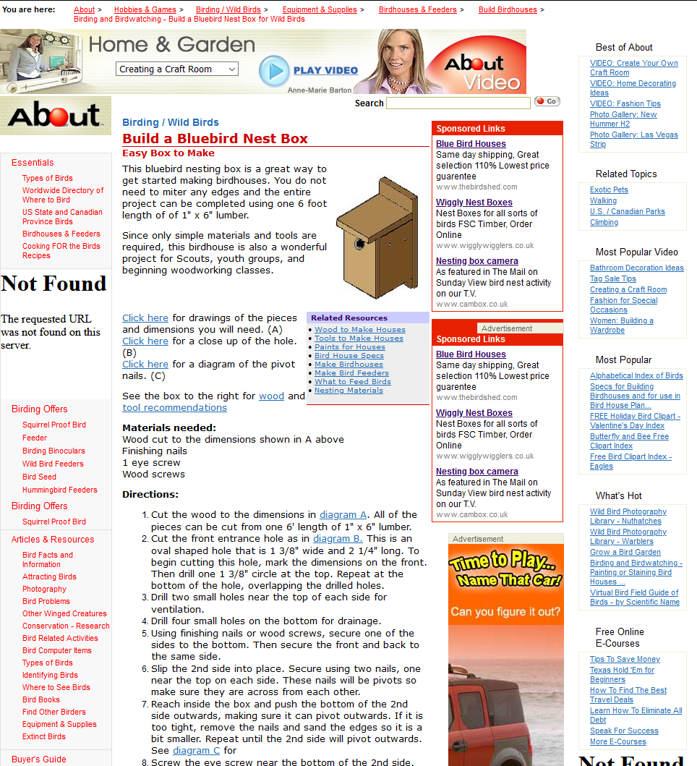

*Item 146: guide.doc*

# An Insider’s Guide to Enjoying Your First Birding Field Trip

by Pete Dunne

Field trips are a lot like going to a dance, and there are two schools of thought. You can just waltz onto the dance floor and let the other person lead or you can learn a few basic dance steps beforehand. Here, for those who want to get a jump on etiquette, are some of the basic rules of the birding field trip. Learn them, and you'll spend more time birding and less time tripping over your feet.

**• Rule 1 - Never miss an opportunity to use a restroom.**

Your capacity for birding may be limitless but your bladder is not. Some leaders are generous with their planned rest stops; some are miserly. Whenever the group arrives at a planned rest stop, take full advantage {and mind your coffee consumption between stops).

**• Rule 2 - Familiarize yourself with whatever pre-trip information is sent.**

Most organized field trips come with instructions. In the pre-trip material, you will almost certainly find the answers to your most pressing questions: dress, equipment needs, time commitment, lunch plans. Being prepared is the first step toward having a great time.

Re: Clothing. Rule of thumb: In winter, if in doubt, just bring it. In hot weather, cover up for sun protection-this means hat, long-sleeved cotton shirt, long pants. At any time of year, avoid bright colors, particularly white. In the universal language of wild creatures, white means "Danger! Watch Out! Hide ! It's not the message you want to send.

**• Rule 3 - Don't be late.**

When you join a group, you sacrifice a measure of self-determination. One of the quickest ways to annoy the group leader and everyone else, is to arrive late and delay the group's departure.

**• Rule 4 - Don't wander off.**

The second quickest way to annoy the group leader is to wander off. You don't want to be left behind and you don't want to be the focus of an unnecessary search. If you plan to leave the group, for a short time or for the balance of the day, be certain you inform the leader.

It is in your interest to stay close to the leader and the more experienced members of the group so that you can rely on their knowledge and bird-finding skills.

Staying close applies to car caravanning, too. The rule of thumb is one car length back for every ten miles per hour of velocity. Thirty miles per hour; three car lengths behind the bumper ahead of you. Sixty miles per hour; six lengths. Don't trust yourself to keep the pace? Don't drive. Car-pool with someone else.

**• Rule 5 - Come prepared.**

If the trip involves driving, make sure you have enough fuel to see you through. If the instructions state "bring lunch," don't assume that you'll be able to stop at a convenience store to pick up a sandwich. Do that, and you'll likely be eating alone.

**• Rule 6 - Check out your equipment before the trip.**

The single greatest frustration first-time trip goers face in not inexperience, but rather the lousy or malfunctioning equipment - usually optics.

If your binoculars aren't working, ask whether a loaner is available. It you don't own binoculars, do not rush out to the nearest discount store and buy some for the trip. People who do this usually end up with instruments they soon replace. Borrow binoculars for the trip. Use your field trip experience to see what instruments experienced birders are using in order to make an educated purchase later.

**• Rule 7 - Speak Softly.**Human voices put wildlife on alert. Talking may also prevent a leader from hearing songs or calls and keep you from hearing instructions. Field trips are social and conversation is part of the field trip experience. If you want to converse, do so in whispers or stand away from the group.

**• Rule 8 - Keep motion to a minimum.**

More than sound, birds react to motion. In close proximity to birds, don't move quickly and above all do not advance until the leader gives the word. Want to draw the ire of a group? Walk toward "the bird of the day" and scare it away.

**• Rule 9 - Don't monopolize the leader.**

Sure you have questions. Sure you want to get to know the leader, and you want them to come to recognize your wonderful qualities, too. One of those qualities should be deference, because everyone in the group shares your ambition. Deference extends to use of the spotting scopes, too.

When the leader trains his scope on an interesting bird, and you were first to get a glimpse last time, defer to others the next several times. No matter what your place in line, first looks through a scope are quick looks. After you get an identifying glimpse, step quickly aside for the next person. If the bird is moving, reposition the scope so the next user won't have to pan back and forth. After everyone has had their glimpse, more leisurely viewing is possible.

**• Rule 10 - Do ask questions.**

Leaders want to share their knowledge, and questions are the catalyst that unlocks it. Don't be intimidated by what you don't know or what you presume that others know. Chances are your question is shared by others in the group. You may not be the leader, but if you trigger the answer to a question that some other member of the group was too shy to utter, you'll be their hero. That's it. All you need to know to get the most out of your first field trip experience. If it seems like too much to remember, just remember Rule #1. At any other time, there will be someone else around to ask for assistance.

This guide has been reproduced with the permission of Pete Dunne. Minor editing by Ron Bourque.

*Item 147: nestboxtips.txt*

Tips for Nest Boxes this spring/summer

If you have old boxes in your garden, clean out any of last years nesting material or any old bits of food that may have been stored in there.

If you are putting up new nest boxes make sure that they are out of the reach of cats and Squirrels.

Check that the box isn’t in full sun otherwise young birds may literally bake in the heat.

Experiment with different kinds of bird boxes – the open-fronted “Robin” boxes may even attract Spotted Flycatchers.

Make sure any boxes are at least 15mm in thickness.

Face boxes away from prevailing winds.

Don’t put nest boxes to close together in a small area as this will only lead to territorial fights.

Always make sure that there is enough food and fresh water made available close by.

Do not but bird boxes with perches attached – the birds do not need them and it may only invite predators.

Never buy a bird table with a nest box built in, as nesting birds will only come into conflict with feeding ones.

*Item 148: ODBC.INI*

[ODBC 32 bit Data Sources]

MS Access Database=Microsoft Access Driver (*.mdb) (32 bit)

Excel Files=Microsoft Excel Driver (*.xls) (32 bit)

dBASE Files=Microsoft dBase Driver (*.dbf) (32 bit)

[MS Access Database]

Driver32=C:\WINDOWS\system32\odbcjt32.dll

[Excel Files]

Driver32=C:\WINDOWS\system32\odbcjt32.dll

[dBASE Files]

Driver32=C:\WINDOWS\system32\odbcjt32.dll

;“Without doubt the presence of Lake Michigan affects the

;movement and distribution of birdlife in the Dunes more than

;any other single factor. The shores of this enormous lake provide

;leading lines that control flight paths of numerous migrants, and

;the vast open waters draw legions of transitory and wintering birds.

;During autumn the elongate north-south boundaries of the lake become

;airways along which thousands of migrants navigate toward

;wintering areas. Southbound birds following the shores are ultimately

;guided into the

;Dunes Area, at the toe of

;the lake. This avian convergence

;at the bottom of

;Lake Michigan is termed

;the funneling effect.”

;The funneling effect explains

;the unusually high

;diversity of autumn birds

;in northwest Indiana.

;“Lake Michigan also provides

;two important avian habitats that are otherwise quite rare in the

;Midwest: the deep lake and the beach. Waters of the lake attract

;large numbers of bay and sea ducks, many of which are virtually

;unrecorded at inland sites in the Midwest. Additionally, the lake

;attracts a number of rare periodic transients, including the Purple

;Sandpiper, Red Phalarope, Pomarine Jaeger, Parasitic Jaeger, Great

;Black-backed Gull, Glaucous Gull, Iceland Gull, Thayer’s Gull,

;Sabine’s Gull, Little Gull, Black-legged Kittiwake. Extensive beaches

;provide resting and feeding areas for shorebirds, especially those

;species preferring sand rather than mudflats, e.g., Sanderling, Red

;Knot, and Baird’s Sandpiper.

;“The deep waters of Lake Michigan also constitute a significant

;obstacle to migrants. During nocturnal flights many north-bound

;passerines overfly land’s end and daybreak finds them over the lake.

;When landfall is visible, they often fly directly to the shore, where

;they immediately land for rest and feeding.

;This effect generates an anomalously high concentration of passerines

;in parks and woodlands immediately adjacent to the lake”

;(Brock 5).

# Appendix C: Browser History Records

## 1 Internet Explorer Analysis

Listing 1.1: Command to locate all index.dat files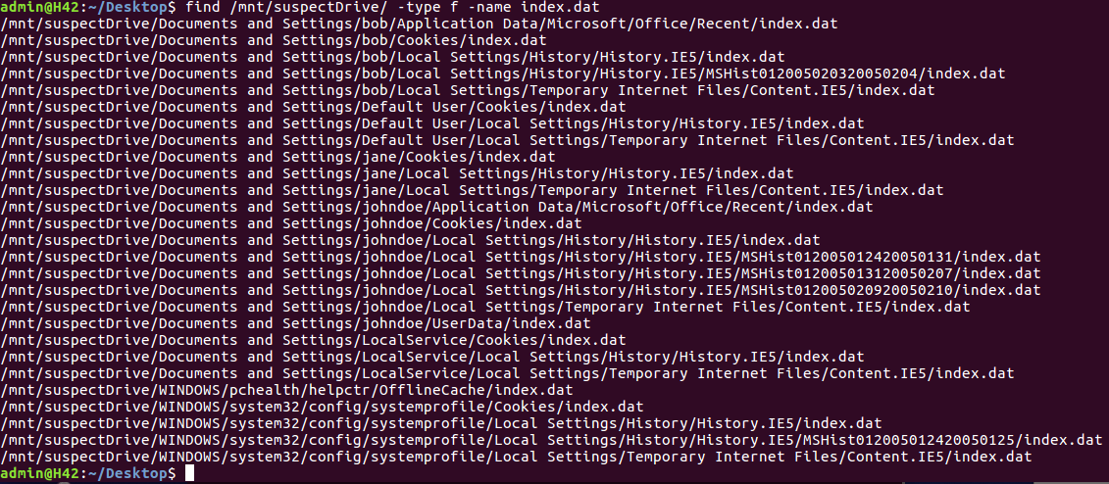

Listing 1.2: User Bob Pasco converted index.dat files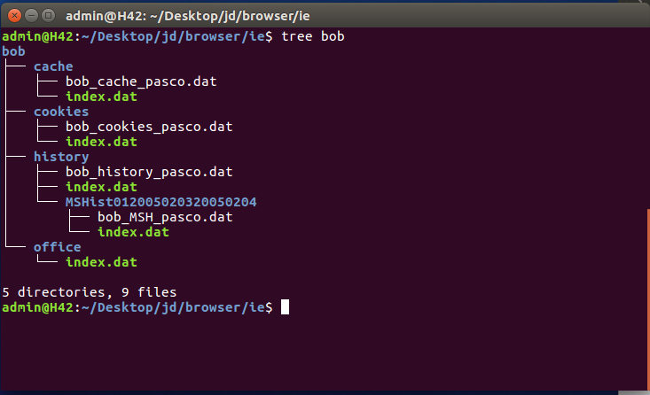

Listing 1.3: User Jane Pasco converted index.dat files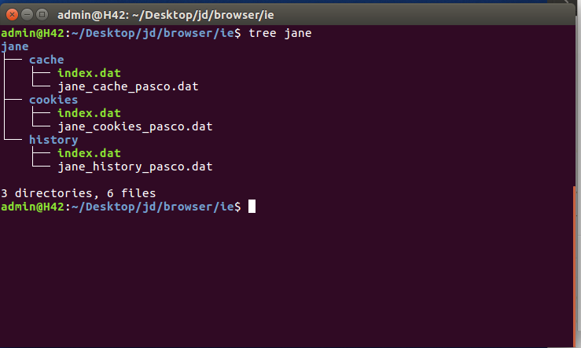

Listing 1.4: User JoneDoe Pasco converted index.dat files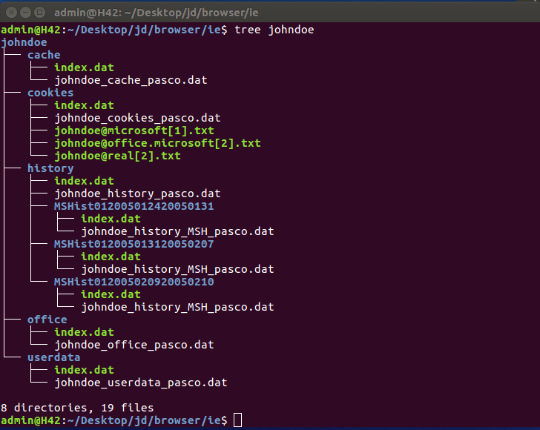

Listing 1.5: History.dat files for the User Bob with no logged access to the file ready2fledge.jpg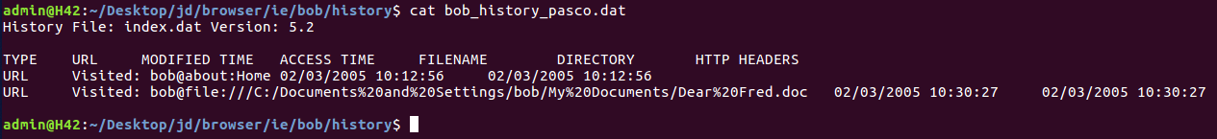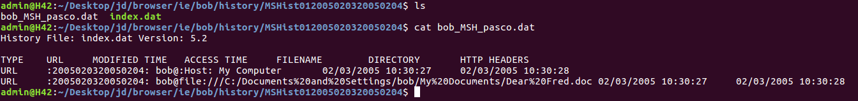

*Listing 1.6: Internet Explorer history for user John Doe on 02/02/2005*

|  |  |  |
| --- | --- | --- |
| Date | Time | Description |
| 02/02/2005 | 14:18:14 | Navigated within Windows to the file C:\Documents and Settings\johndoe\My Documents\My Pictures\snow_geese.jpg |
| 02/02/2005 | 14:20:33 | Navigated within windows to the file C:\Documents and Settings\johndoe\My Documents\My Pictures\7107298.jpg |
| 02/02/2005 | 14:25:59 | Navigated within windows to the file C:\Documents and Settings\johndoe\My Documents\aa010703a.htm |
| 02/02/2005 | 14:28:19 | Navigated within windows explorer to the file C:\Documents and Settings\johndoe\My Documents\My Pictures\wbpremium_s.jpg |
| 02/02/2005 | 14:29:30 | Navigated within windows explorer to the file C:\Documents and Settings\johndoe\My Documents\nestboxtips.txt |
| 02/02/2005 | 14:43:36 | Navigated within windows explorer to the file C:\Documents and Settings\johndoe\My Documents\My Pictures\40m.jpg |
| 02/02/2005 | 15:11:51 | Navigated within windows explorer to the file C:\Documents and Settings\johndoe\My Documents\kakapo.ram |

*Listing 1.7: Internet Explorer history for user John Doe on 03/02/2005*

|  |  |  |
| --- | --- | --- |
| Date | Time | Description |
| 03/02/2005 | 12:22:51 | Navigated within windows explorer to the file E:\birds\audio\aggressive_song.wav |
| 03/02/2005 | 14:14:59 | Navigated within windows explorer to the file C:\EvanstonWoodpecker.jpg |
| 03/02/2005 | 14:17:48 | Navigated within windows explorer to the file C:\Documents and Settings\All Users\Documents\My Music\Sample Music\Doc1.doc |
| 03/02/2005 | 14:49:29 | Navigated within Windows Explorer to the file E:\birds\Killdeer.jpg |
| 03/02/2005 | 15:00:19 | Navigated within Windows Explorer to the file C:\Documents and Settings\johndoe\My Documents\My Pictures\babyscot_vyoung.jpg |
| 03/02/2005 | 15:00:27 | Navigated within Windows Explorer to the file C:\Documents and Settings\johndoe\My Documents\My Pictures\babyscot_2weeks1.jpg |
| 03/02/2005 | 15:01:38 | Navigated within Windows Explorer to the file C:\Documents and Settings\johndoe\My Documents\My Pictures\177.jpg |
| 03/02/2005 | 15:02:45 | Navigated within Windows Explorer to the file C:\Documents and Settings\johndoe\My Documents\ostbk2b2.htm |
| 03/02/2005 | 15:04:48 | Navigated within Windows Explorer to the file C:\Documents and Settings\johndoe\Desktop\birdtrans2.jpg |
| 03/02/2005 | 15:05:03 | Navigated within Windows Explorer to the file C:\Documents and Settings\johndoe\My Documents\My Pictures\chicks2.jpg |
| 03/02/2005 | 15:05:44 | Navigated within Windows Explorer to the file C:\Documents and Settings\johndoe\My Documents\newbies2.jpg |
| 03/02/2005 | 15:06:42 | Navigated within Windows Explorer to the file C:\Documents and Settings\bob\My Documents\My Music\ready2fledge.jpg |
| 03/02/2005 | 15:49:39 | Navigated within Windows Explorer to the file C:\birdwatching.doc |
| 03/02/2005 | 15:51:54 | Navigated within Windows Explorer to the file E:\birds\non images\BookList.doc |
| 03/02/2005 | 15:52:01 | Navigated within Windows Explorer to the file E:\birds\non images\BirdingGuide.pdf |

*Listing 1.8: Internet Explorer history for user John Doe on 09/02/2005*

|  |  |  |
| --- | --- | --- |
| Date | Time | Description |
| 09/02/2005 | 11:28:00 | Navigated within Windows Explorer to the file C:\Documents and Settings\johndoe\My Documents\birds.zip |
| 09/02/2005 | 12:28:01 | Navigated within Windows Explorer to the following files:  C:\Documents and Settings\johndoe\My Documents\My Pictures\babyscot_vyoung.jpg  C:\EvanstonWoodpecker.jpg  E:\birds\audio\aggressive_song.wav  C:\Documents and Settings\johndoe\My Documents\ostbk2b2.htm  C:\Documents and Settings\johndoe\My Documents\My Pictures\177.jpg  C:\Documents and Settings\johndoe\My Documents\My Pictures\40m.jpg  C:\Documents and Settings\johndoe\My Documents\kakapo.ram  C:\Documents and Settings\johndoe\My Documents\My Pictures\7107298.jpg  C:\birdwatching.doc  C:\Documents and Settings\johndoe\My Documents\aa010703a.htm  C:\Documents and Settings\All Users\Documents\My Music\Sample Music\Doc1.doc  C:\Documents and Settings\johndoe\My Documents\nestboxtips.txt  C:\Documents and Settings\johndoe\My Documents\My Pictures\tn_duck_3.jpg  C:\Documents and Settings\bob\My Documents\My Music\ready2fledge.jpg  C:\Documents and Settings\johndoe\Desktop\birdtrans2.jpg  C:\Documents and Settings\johndoe\My Documents\My Pictures\wbpremium_s.jpg  E:\birds/Killdeer.jpg  C:\Documents and Settings\johndoe\My Documents\My Pictures\babyscot_2weeks1.jpg  C:\Documents and Settings\johndoe\My Documents\newbies2.jpg  C:\Documents and Settings\johndoe\My Documents\My Pictures\snow_geese.jpg  E:\birds\non images\BirdingGuide.pdf  E:\birds\non images\BookList.doc |
| 09/02/2005 | 16:57:49 | Navigated within Windows Explorer to the following file C:\Documents and Settings\johndoe\My Documents\stuf.doc |
| 09/02/2005 | 17:00:50 | Navigated within Windows Explorer to the following file C:\Program Files\MSN\aggressive_song.wav |
| 09/02/2005 | 17:06:28 | Navigated within Windows Explorer to the following file F:\AlmondMarshGreatBlueHeronStalling.jpg |

## 2 Mozilla Firefox Analysis

*Listing 2.1: Firefox bookmarks for User JohnDoe*



*Listing 2.2: Internet Archive screenshot for the bookmark- Free Bird Wallpaper*

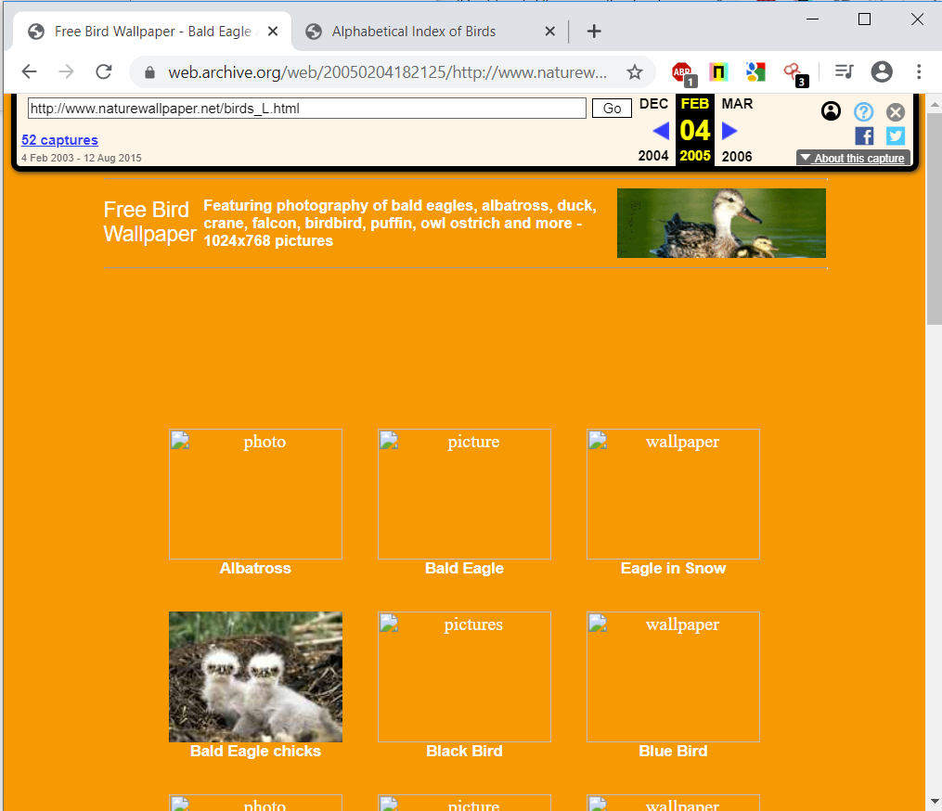

*Listing 2.3: Internet Archive screenshot for the bookmark- Alphabetical Index of Birds*

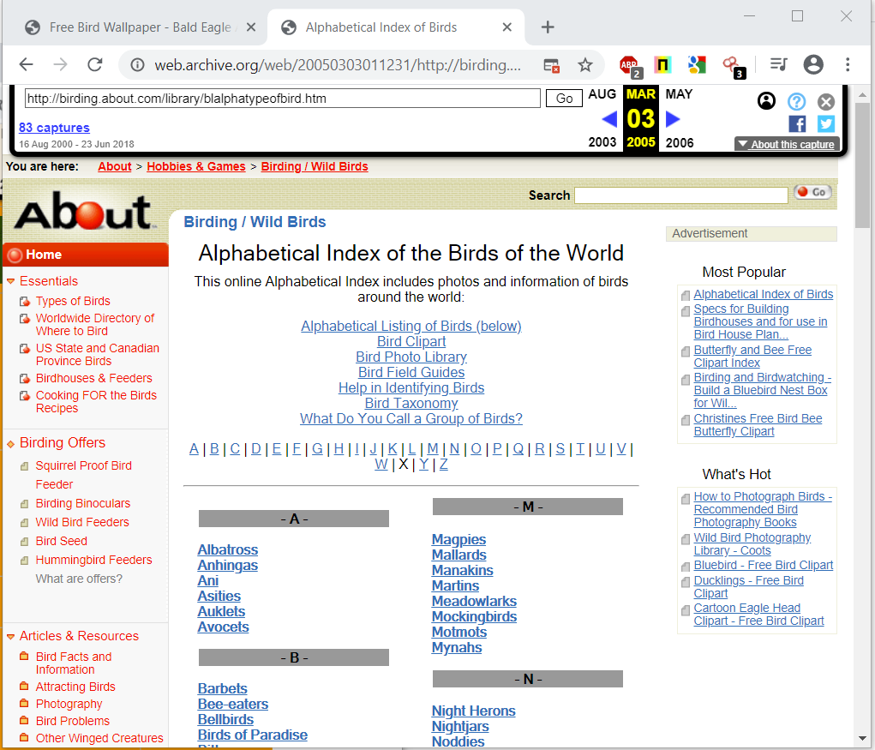

*Listing 2.3: Internet Archive screenshot for the bookmark- Chickadee Karaoke*

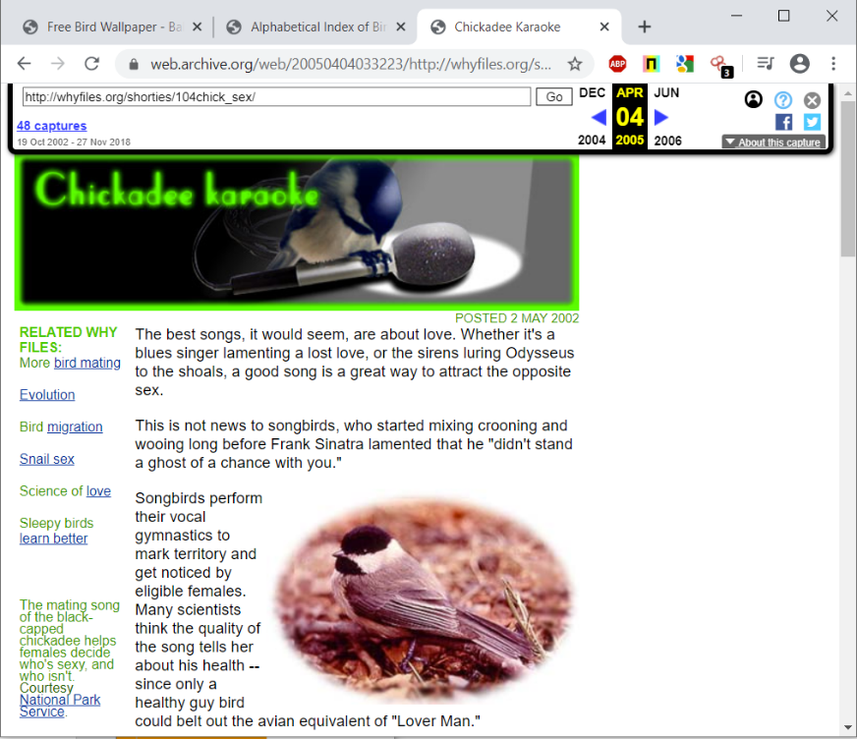

*Listing 2.4: Mozilla Firefox browser activity for 02/02/2005*

|  |  |  |
| --- | --- | --- |
| Date | Time | Description |
| 02/02/2005 | 14:11:46 | Searched [www.google.co.uk](http://www.google.co.uk/) for the phrase “Birds” |
| 02/02/2005 | 14:11:54 | Visited [www.pbs.org/lifeofbirds](http://www.pbs.org/lifeofbirds) |
| 02/02/2005 | 14:12:05 | Visited [www.pbs.org/lifeofbirds/songs/index.html](http://www.pbs.org/lifeofbirds/songs/index.html) |
| 02/02/2005 | 14:14:49 | A Browser advert for Bird books supplied by [www.amazon.co.uk](http://www.amazon.co.uk/) was displayed and the user visited the link |
| 02/02/2005 | 14:14:59 | Visited a page on [www.amazon.co.uk](http://www.amazon.co.uk/) where you can purchase the book “Garden Birds” |
| 02/02/2005 | 14:15:29 | Visited a page on [www.amazon.co.uk](http://www.amazon.co.uk/) where you can purchase the book “The Secret Lives of Garden Birds” |
| 02/02/2005 | 14:15:42 | Searched [www.google.com](http://www.google.com/) for the phrase “Bird Wallpaper” |
| 02/02/2005 | 14:15:51 | Visited [www.naturewallpaper.net/birds_L.html](http://www.naturewallpaper.net/birds_L.html) |
| 02/02/2005 | 14:16:21 | Visited [www.naturewallpaper.net/birdsLpages/image4.html](http://www.naturewallpaper.net/birdsLpages/image4.html) |
| 02/02/2005 | 14:18:45 | Visited [www.naturewallpaper.net/birdsLpages/image21.html](http://www.naturewallpaper.net/birdsLpages/image21.html) |
| 02/02/2005 | 14:19:52 | Visited [www.uk.shop.com](http://www.uk.shop.com/) and searched for the phrase “Bald Eagle” |
| 02/02/2005 | 14:20:19 | Visited [www.uk.shop.com](http://www.uk.shop.com/) and viewed a page where you can purchase the video “Bird Watches Paradise” |
| 02/02/2005 | 14:22:25 | Searched [www.google.co.uk](http://www.google.co.uk/) for the phrase “Bird Stories” |
| 02/02/2005 | 14:22:38 | Visited [www.birding.about.com/od/stories1](http://www.birding.about.com/od/stories1) |
| 02/02/2005 | 14:23:04 | Visited [www.birding.about.com/library/weekly/aa102598.htm](http://www.birding.about.com/library/weekly/aa102598.htm) |
| 02/02/2005 | 14:23:56 | Visited <http://birding.about.com/library/blalphatypeofbird.htm> |
| 02/02/2005 | 14:24:18 | Visited <http://birding.about.com/library/blhousespecs.htm> |
| 02/02/2005 | 14:24:32 | Visited <http://birding.about.com/od/buildhouses/> |
| 02/02/2005 | 14:24:42 | Visited <http://birding.about.com/cs/birdhousesfeeders/a/buildingindex.htm> |
| 02/02/2005 | 14:24:55 | Visited <http://birding.about.com/library/weekly/aa010703a.htm> |
| 02/02/2005 | 14:26:43 | Visited <http://birding.about.com/library/blhousefeederpaint.htm> |
| 02/02/2005 | 14:27:07 | Visited <http://www.haiths.com/> |
| 02/02/2005 | 14:40:24 | Visited <http://www.imdb.com/title/tt0056869/> and watched a trailer for the movie “The Birds” |
| 02/02/2005 | 15:11:41 | Visited <http://www.pbs.org/lifeofbirds/songs/kakapo.ram> |
| 02/02/2005 | 15:12:06 | Visited <http://www.pbs.org/lifeofbirds/songs/dawn.ram> |

*Listing 2.5: Mozilla Firefox browser history log and Internet archive for* [*www.pbs.org*](http://www.pbs.org)

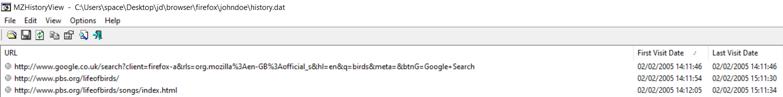

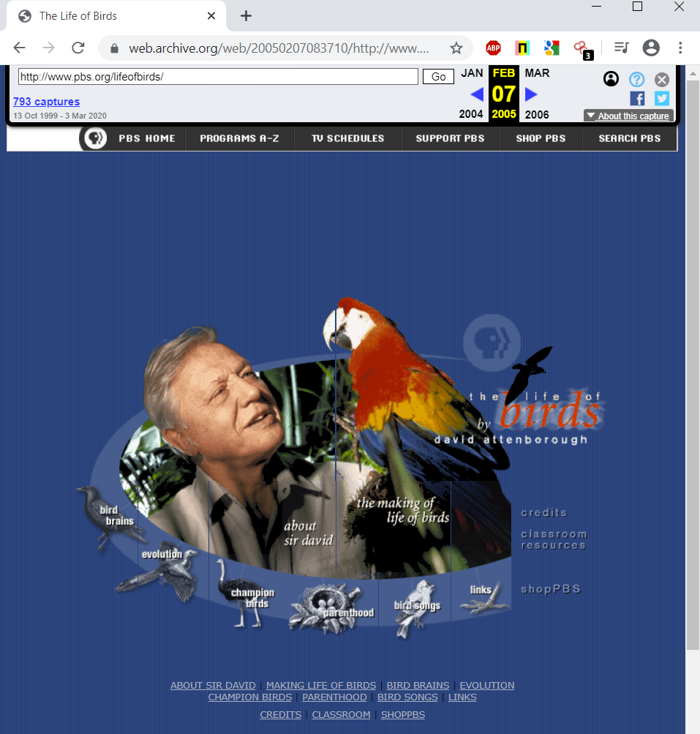

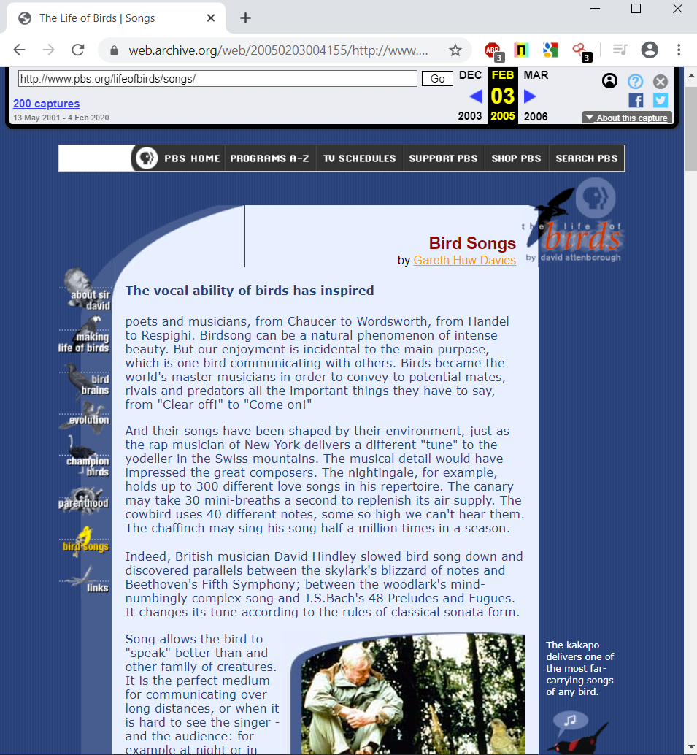

*Listing 2.6: Mozilla Firefox browser history log and Internet archive for* [*www.amazon.co.uk*](http://www.amazon.co.uk)

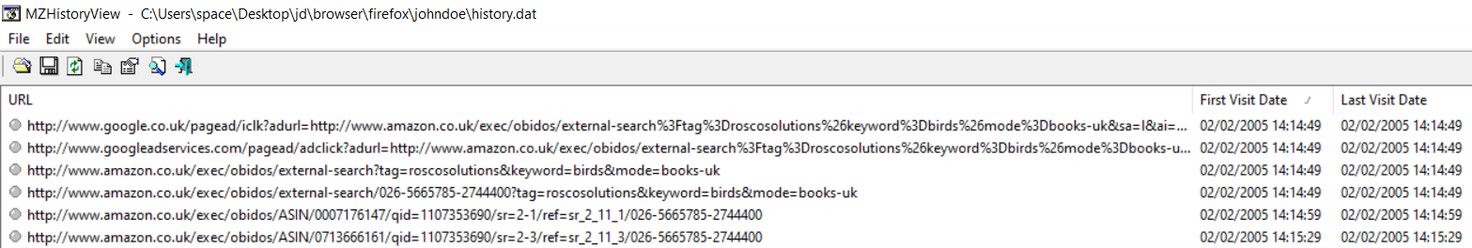





*Listing 2.7: Mozilla Firefox browser history log and Internet archive for* [*www.naturewallpaper.net*](http://www.naturewallpaper.net)

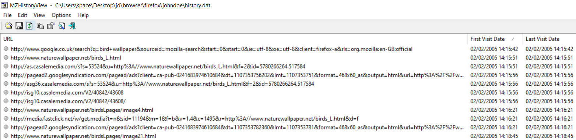



*Listing 2.8: Mozilla Firefox browser history log and Internet archive for* [*www.ukshop.com*](http://www.ukshop.com)

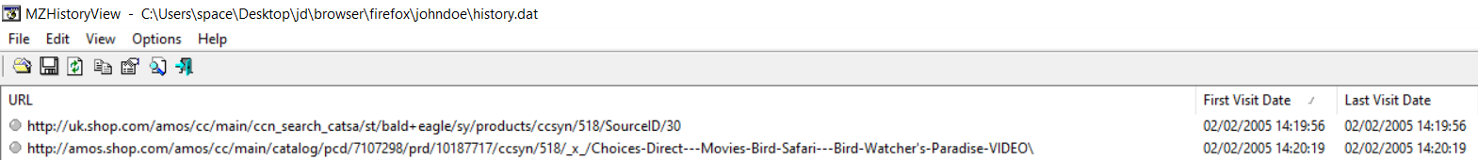

*Listing 2.9: Mozilla Firefox browser history log and Internet archive for www.birding.about.com*

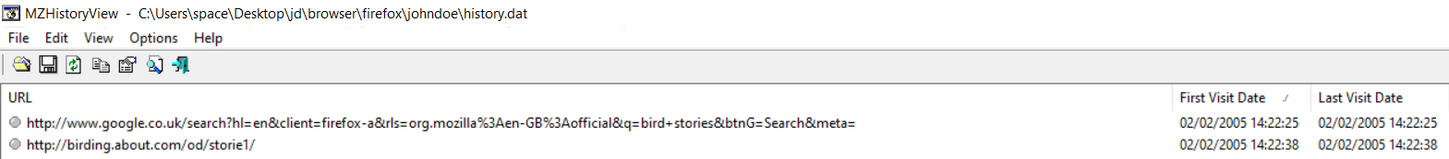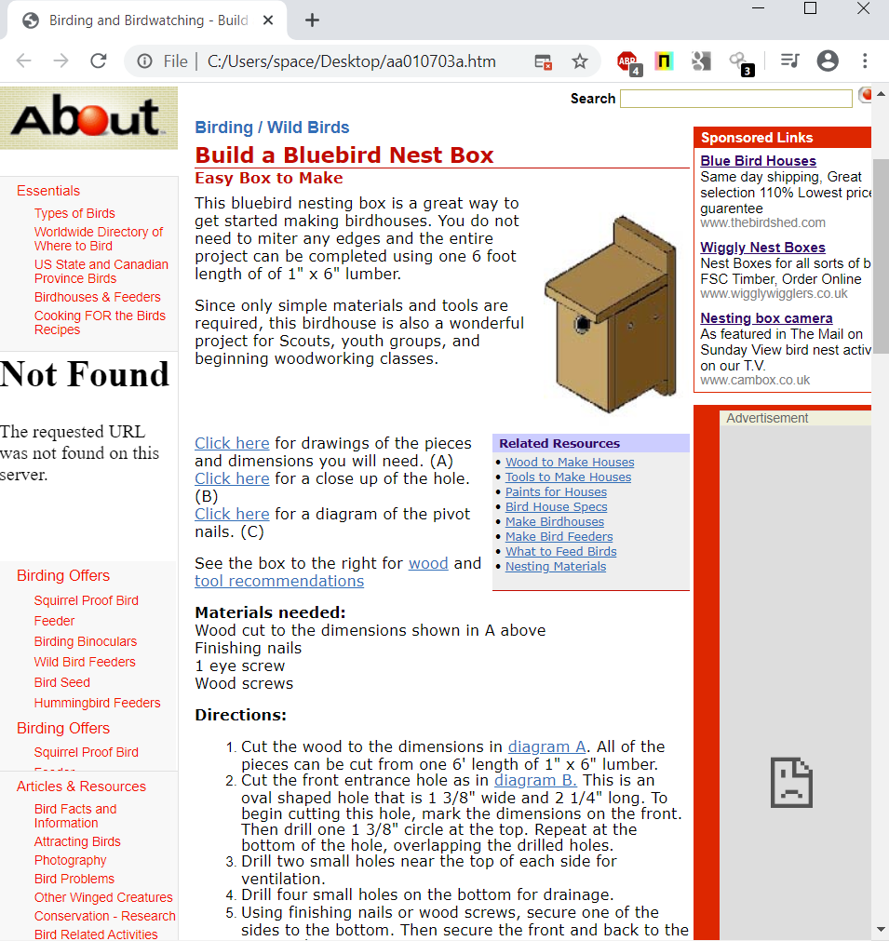

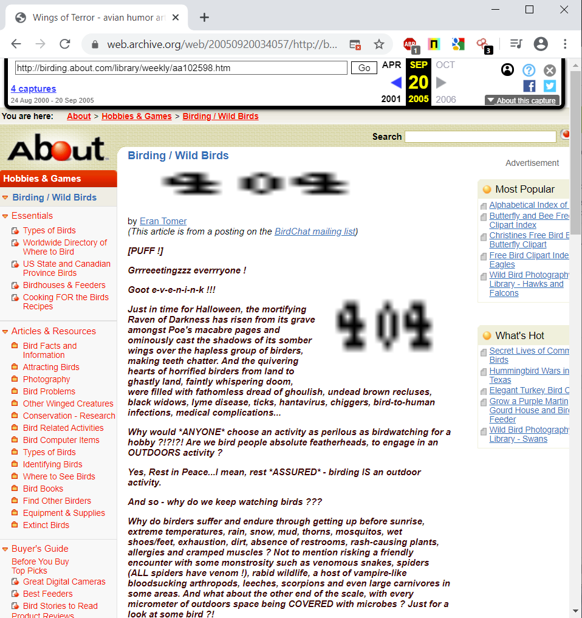

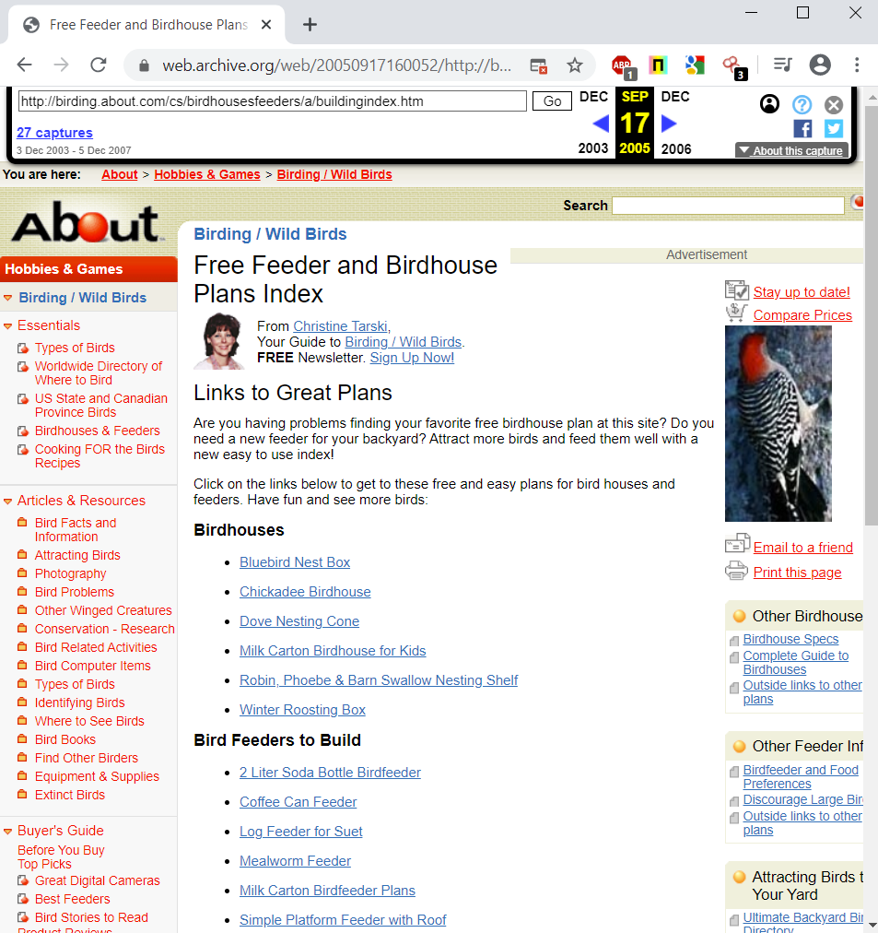

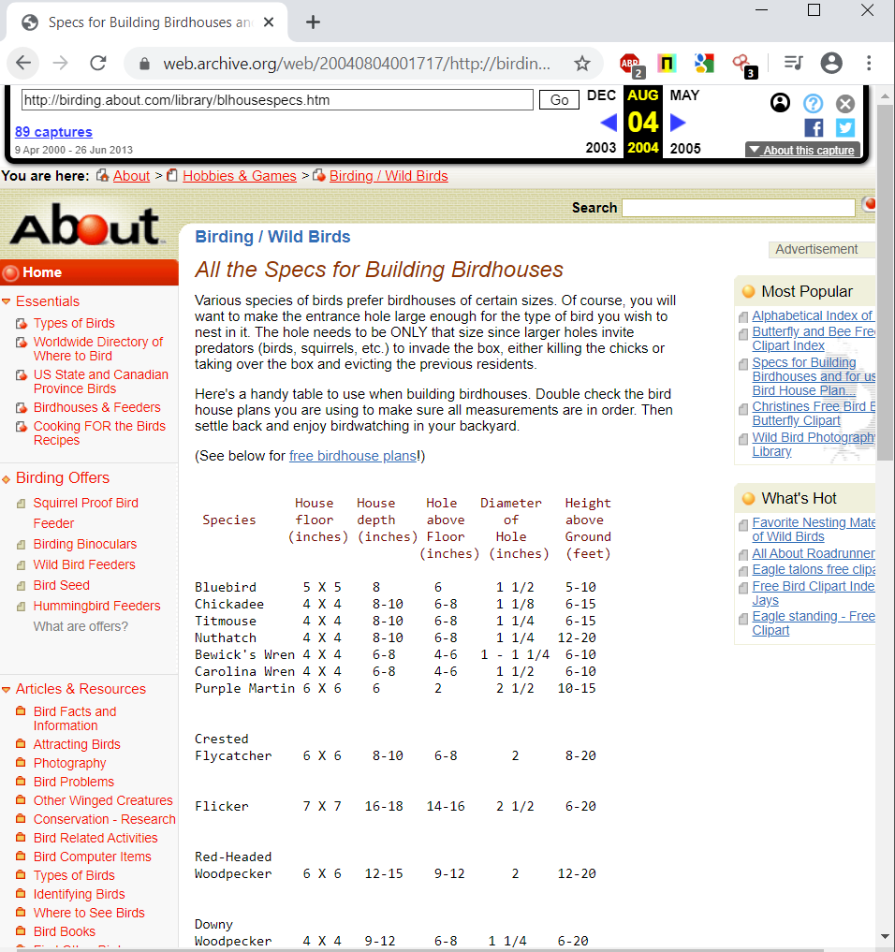

# 

*Listing 2.10: Mozilla Firefox browser history log and Internet archive for* [*www.haiths.com*](http://www.haiths.com)

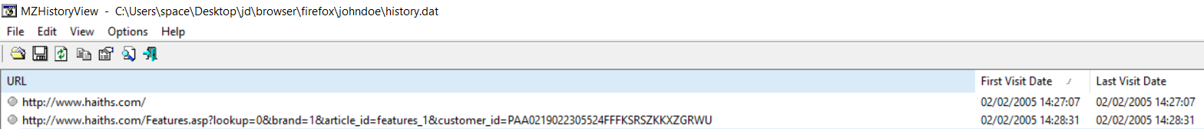

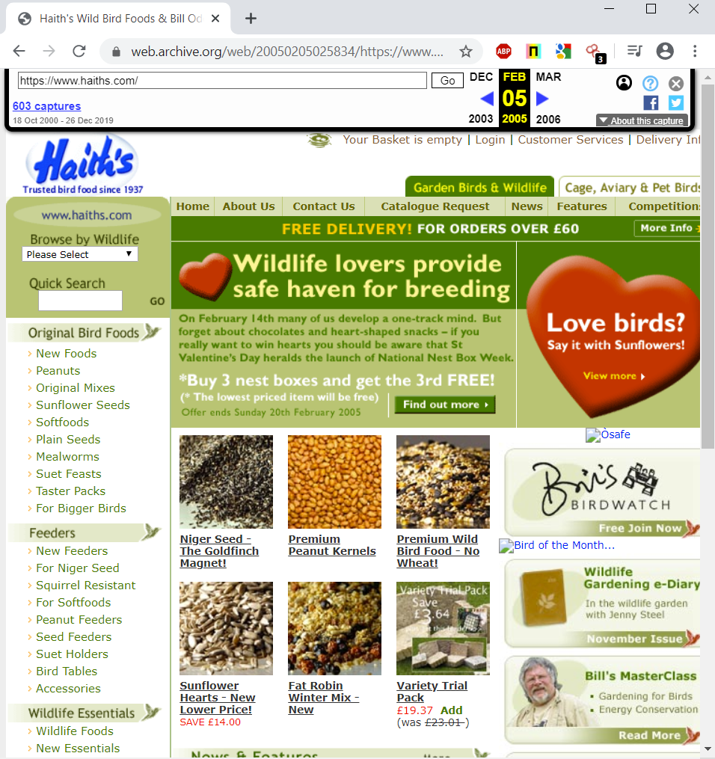

*Listing 2.11: Mozilla Firefox browser history log and Internet archive for* [*www.imdb.com*](http://www.imdb.com)

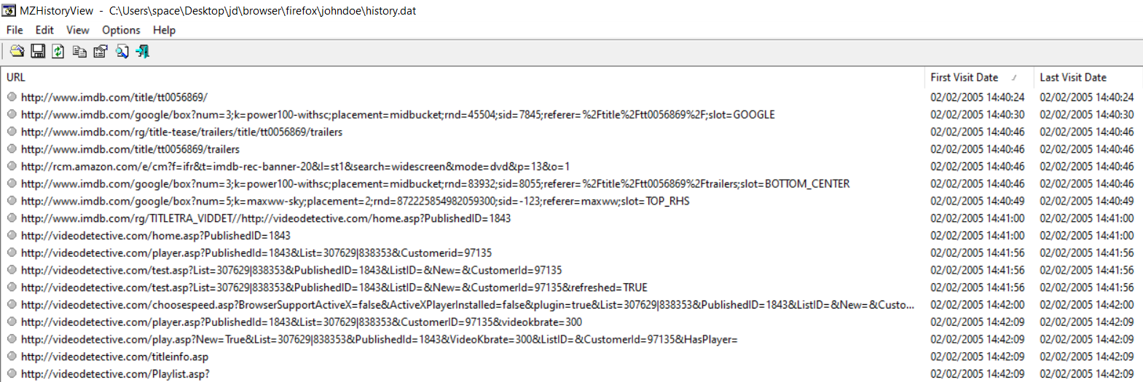



*Listing 2.12: Mozilla Firefox browser history log and Internet archive for* [*www.pbs.org*](http://www.pbs.org)

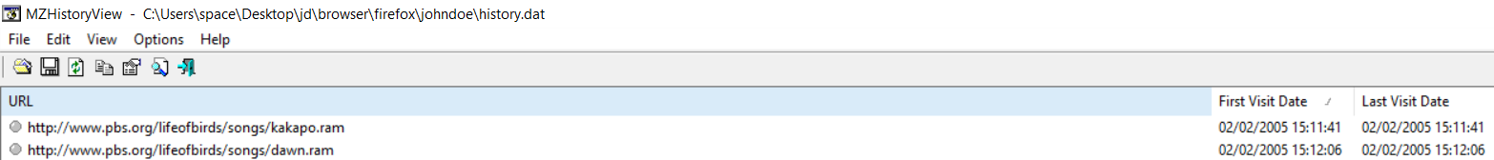

*Listing 2.13 Mozilla Firefox browser activity for 03/02/2005*

|  |  |  |
| --- | --- | --- |
| Date | Time | Description |
| 03/02/2005 | 12:21:40 | Searched [www.google.co.uk](http://www.google.co.uk/) for the phrase “Bird Mating Calls” |
| 03/02/2005 | 12:21:56 | Visited <http://whyfiles.org/shorties/104chick_sex/> |
| 03/02/2005 | 14:59:29 | Performed an Image search on [www.google.co.uk](http://www.google.co.uk/) for the phrase “Young Chicks” and viewed an image called “babyscot_vyoung.jpg” |
| 03/02/2005 | 14:59:56 | Visited <http://freespace.virgin.net/cobber.budgies/stories/scottie_a.html> |
| 03/02/2005 | 15:01:02 | Performed an Image search on [www.google.co.uk](http://www.google.co.uk/) for the url [www.insaneanimals.com/items/177.jpg](http://www.insaneanimals.com/items/177.jpg) |
| 03/02/2005 | 15:01:08 | Visited <http://www.insaneanimals.com/funny-animals/177.html?sort=date> |
| 03/02/2005 | 15:01:53 | Performed an Image search on [www.google.co.uk](http://www.google.co.uk/) for the phrase “Young Chicks” |
| 03/02/2005 | 15:02:14 | Performed an Image search on [www.google.co.uk](http://www.google.co.uk/) for the URL <http://www.cvm.okstate.edu/instruction/kocan/disk2/images/img0056.jpg> then navigated to the URL <http://www.cvm.okstate.edu/instruction/kocan/ostrich/ostbk2b2.htm> |
| 03/02/2005 | 15:03:32 | Performed an Image search on [www.google.co.uk](http://www.google.co.uk/) for the phrase “Young Chicks” |
| 03/02/2005 | 15:03:54 | Performed an Image search on [www.google.co.uk](http://www.google.co.uk/) for the URL <http://people.cornell.edu/pages/sah67/chicks2.jpg> then navigated to the page <http://people.cornell.edu/pages/sah67/summer.html> |

*Listing 2.14 Mozilla Firefox browser log and Internet archive for activity for whyfiles.org*

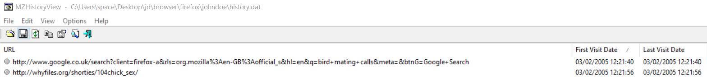

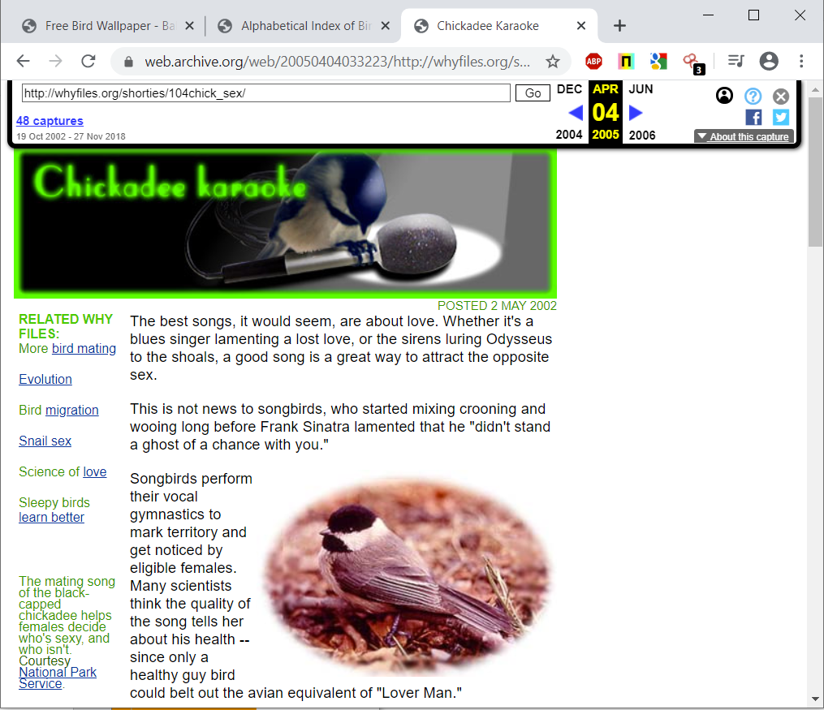

*Listing 2.15 Mozilla Firefox browser log and Internet archive for activity for freespace.virgin.net*

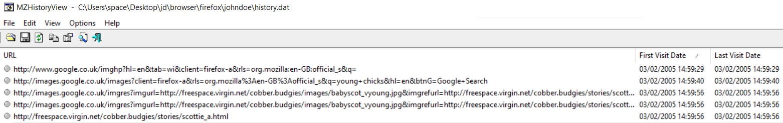

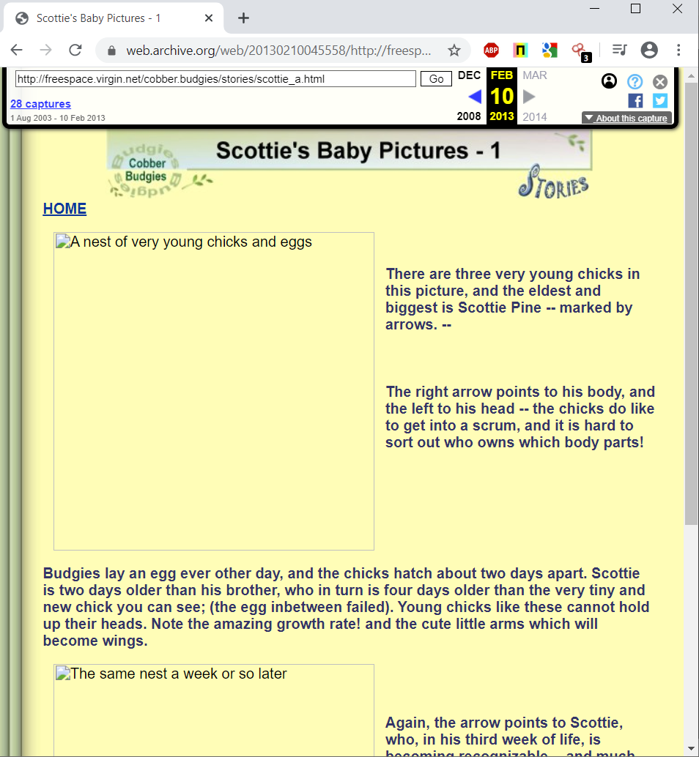

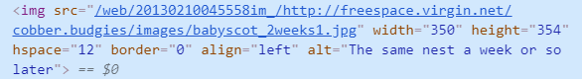

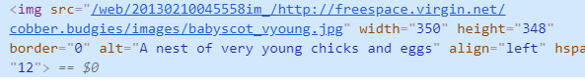

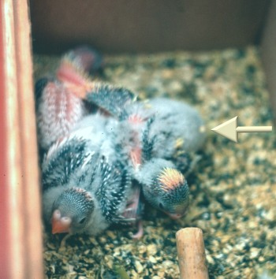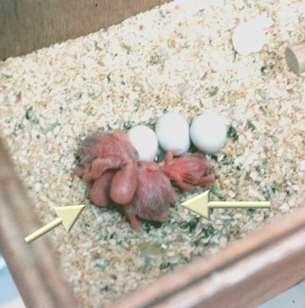

*Listing 2.16 Mozilla Firefox browser log and Internet archive for activity for insaneanimals.com*

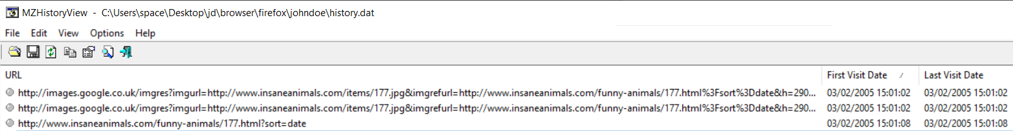

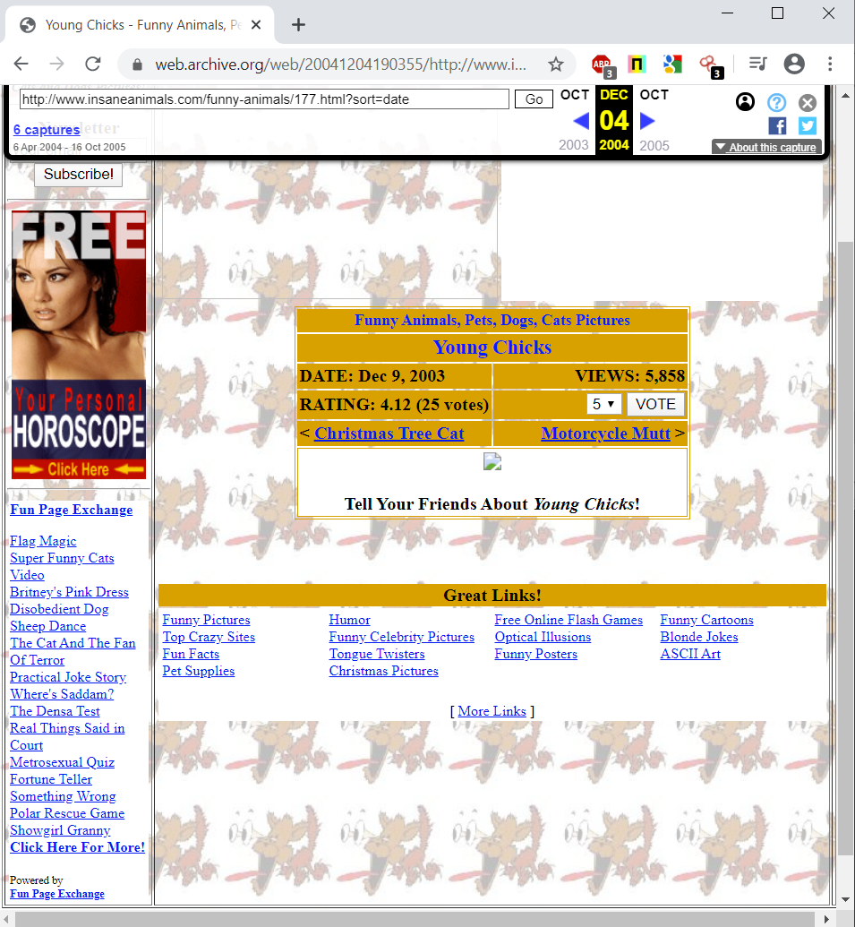

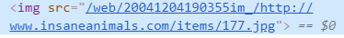

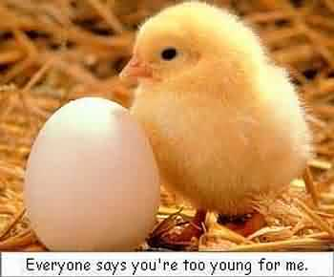

*Listing 2.17 Mozilla Firefox browser log for young chick search*



*Listing 2.18 Mozilla Firefox browser log and Internet archive for activity for* [*www.cvm.okstate.edu*](http://www.cvm.okstate.edu)

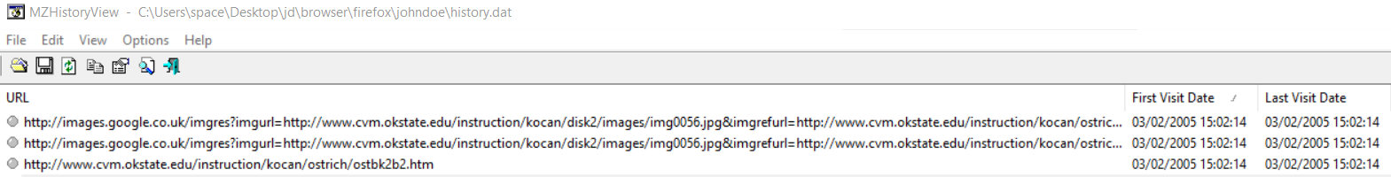

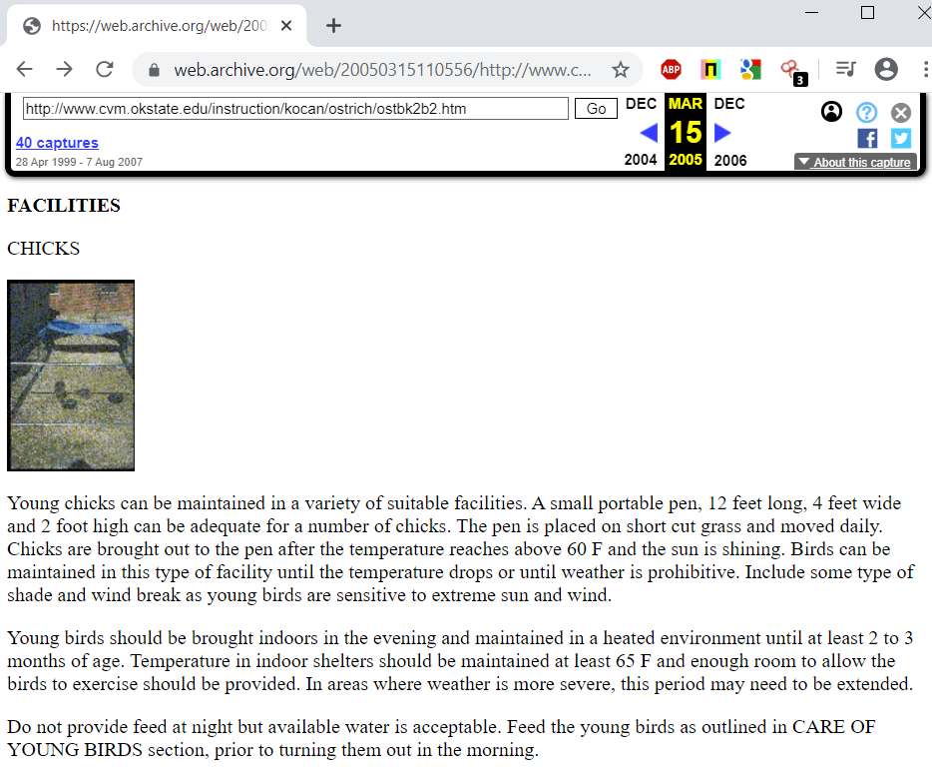

*Listing 2.19 Mozilla Firefox Internet history for 09/02/2005*

|  |  |  |
| --- | --- | --- |
| Date | Time | Description |
| 09/02/2005 | 11:27:00 | Performed a search on [www.google.co](http://www.google.co).uk for the phrase “Bird Screensavers” |
| 09/02/2005 | 11:27:12 | Navigated to <http://www.traveltex.com/screen.asp?SN=6245300&LS=0&SS=1> |

*Listing 2.20 Mozilla Firefox Internet history browser log and Internet archive for activity* [*www.traveltex.com*](http://www.traveltex.com)

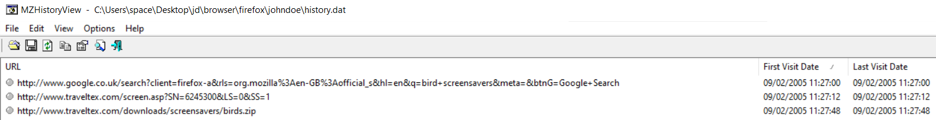



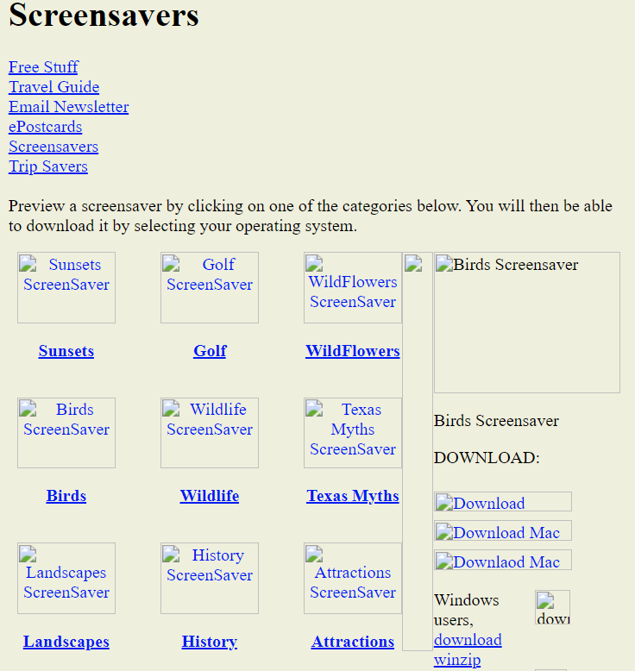

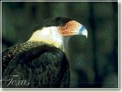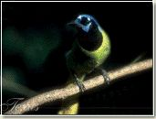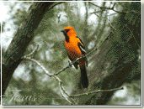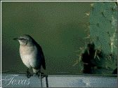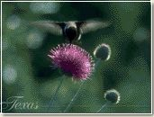

## 3 Thunderbird Email Analysis

Using Autopsy to view the emails contained within the User profile for JohnDoe , it was found that the profile contained five emails in the inbox that contained illegal content.

*Listing 3.1 Email received from ben@example.org* 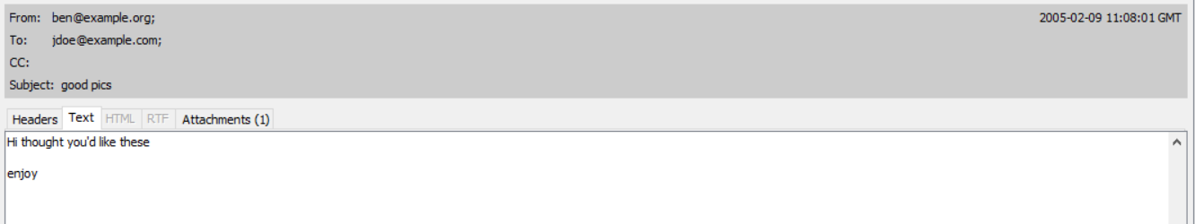

*Listing 3.2 Email received from ben@example.org*

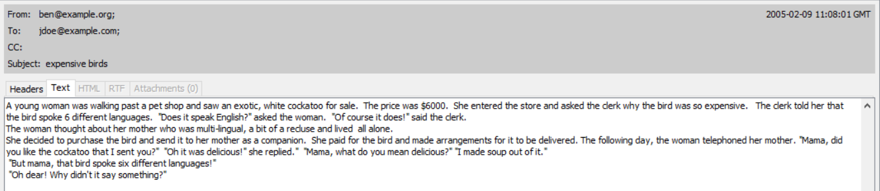

*Listing 3.3 Email received from* [*ben@example.org*](mailto:ben@example.org) *with attachments*

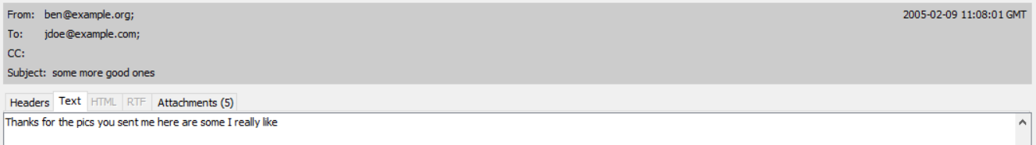

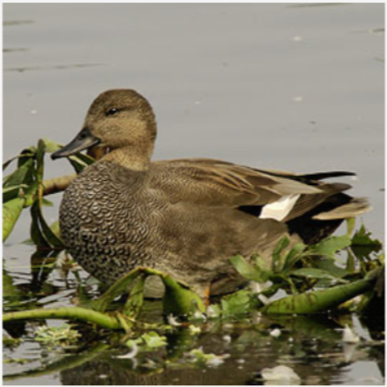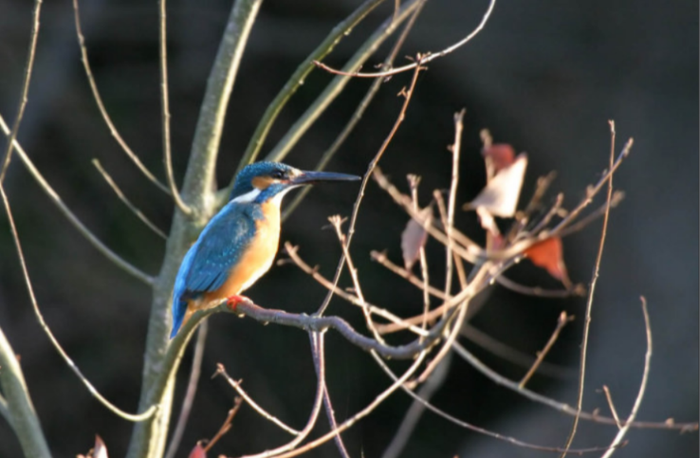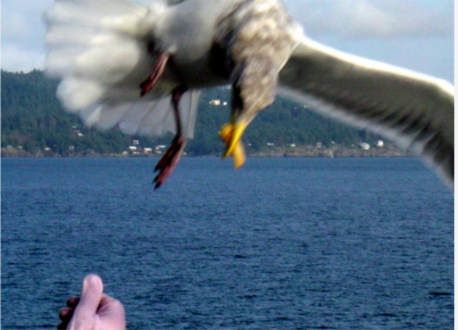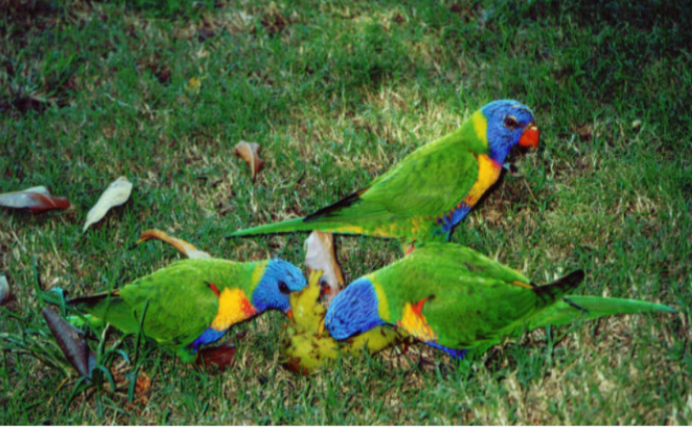

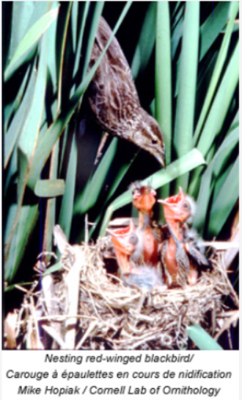

*Listing 3.4 Email received from ben@example.org*

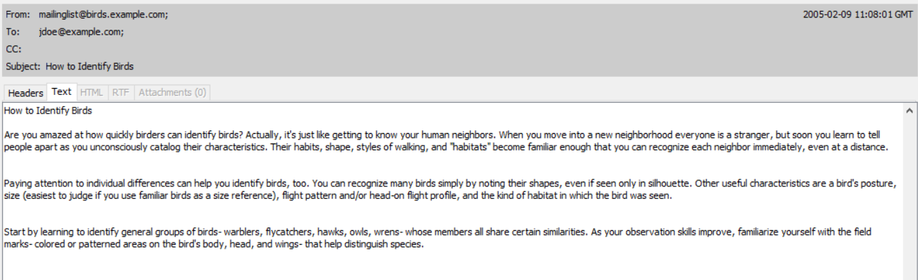

*Listing 3.5 Email received from* [*ben@example.org*](mailto:ben@example.org) *with attachments*

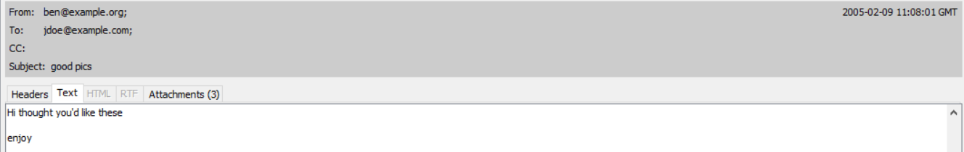

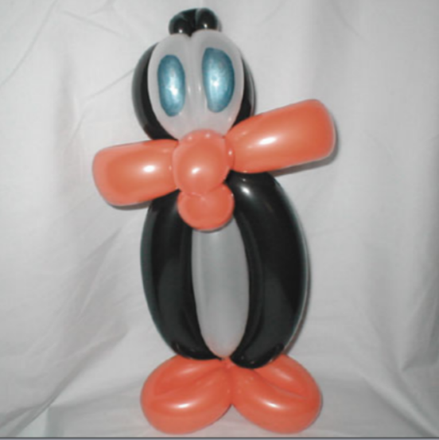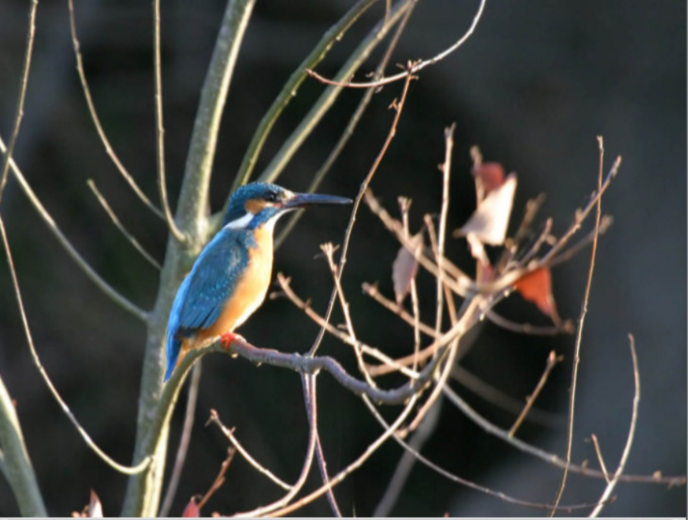

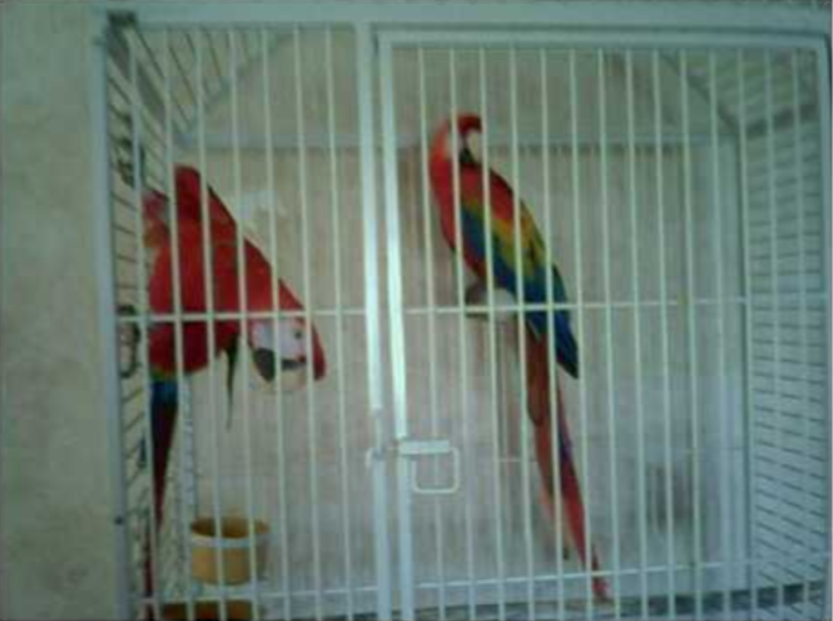

# Appendix D: Analysis Procedures and Results

## 1 Imaging and Partition Audit

### 1.1 Fdisk results

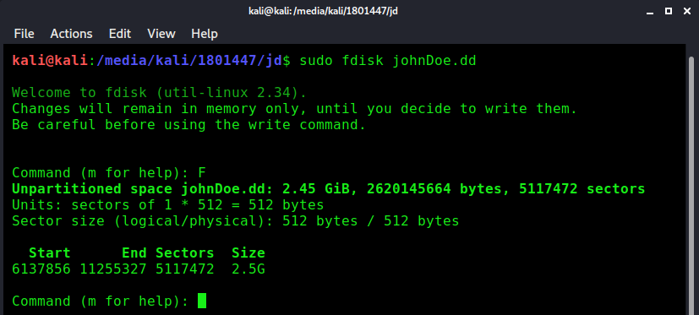

### 1.2 mmls results

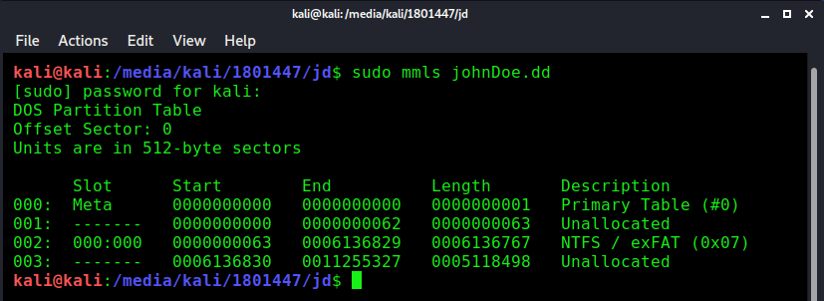

### 1.3 partition recovery

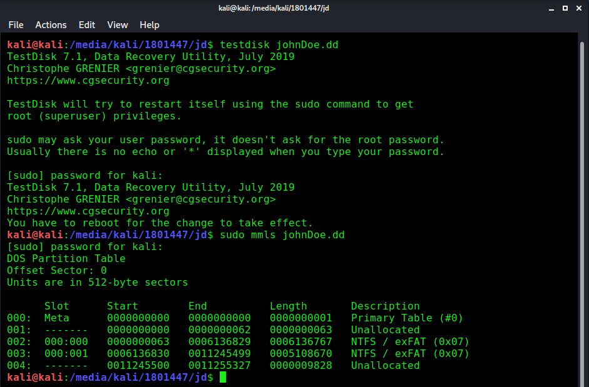

## 2 Logical Search

### 2.1 Procedure for Mounting Partitions under Windows

The partitions of the acquired disk image were mounted on Windows using OSFmount. The program was started, ‘Mount New…’ was selected, and the repaired version of the acquired disk image was browsed to. Both partitions were selected, and then in the mount options ‘Read-only drive’ was selected to prevent any changes to the image. Clicking ‘Mount’ on this screen made the partitions available, with their drive letters listed in the main program window.

### 2.2 Procedure for Mounting Partitions under Linux

The commands used to mount each partition, making partitions 1 and 2 available read-only under ‘/mnt/jd1’ and ‘/mnt/jd2/’, respectively, are given in Listing 6. These commands were run from the folder containing the acquired disk image so only its name had to be specified. The offset numbers, or starting locations of each partition in the disk image, specified in bytes, were calculated using the offsets discovered during the partition audit, which were given in sectors of 512 bytes. Since these offsets were specified by hand, these commands could use the original disk image, which does not contain the details for the second partition in its partition table.

Listing 6: Commands used to mount each partition on Linux



### 2.3 Scripts

Listing 7: Bash script for finding and copying files of relevant types



Listing 8: Python script used to copy a list of files to a single folder



### 2.4 Results

Table 1: Relevant files discovered

|  |  |  |  |  |
| --- | --- | --- | --- | --- |
| Item | App. | File | Partition | Relevance |
| 83 | A | Documents and Settings/bob/My Documents/My Music/ready2fledge.jpg | 1 | Image of birds |
| 84 | A | Documents and Settings/johndoe/Desktop/birdtrans2.jpg | 1 | Image of bird |
| 85 | A | Documents and Settings/johndoe/My Documents/My Pictures/177.jpg | 1 | Image of bird |
| 86 | A | Documents and Settings/johndoe/My Documents/My Pictures/babyscot_2weeks1.jpg | 1 | Image of birds |
| 87 | A | Documents and Settings/johndoe/My Documents/My Pictures/babyscot_vyoung.jpg | 1 | Image of birds |
| 88 | A | Documents and Settings/johndoe/My Documents/My Pictures/chicks2.jpg | 1 | Image of birds |
| 89 | A | Documents and Settings/johndoe/My Documents/newbies2.jpg | 1 | Image of birds |
| 90 | A | Documents and Settings/johndoe/My Documents/My Pictures/40m.jpg | 1 | Image of film cover for ‘The Birds’ (1963) |
| 91 | A | Documents and Settings/johndoe/My Documents/My Pictures/7107298.jpg | 1 | Image of bird |
| 92 | A | Documents and Settings/johndoe/My Documents/My Pictures/snow_geese.jpg | 1 | Image of birds |
| 93 | A | Documents and Settings/johndoe/My Documents/My Pictures/tn_duck_3.jpg | 1 | Image of bird |
| 94 | A | Documents and Settings/johndoe/My Documents/My Pictures/wbpremium_s.jpg | 1 | Possible image of birds |
| 95 | A | Program Files/frankbeecostume_1827_34457581 | 1 | Image of person in bird costume |
| 96 | A | Program Files/frankbeecostume_1827_84985892 | 1 | Image of person in bird costume |
| 97 | A | Program Files/frankbeecostume_1827_96360352 | 1 | Image of person in bird costume |
| 98 | A | WINDOWS/mui/FantailFrontView.exe | 1 | Image of bird |
| 99 | A | Documents and Settings/johndoe/Application Data/Mozilla/Firefox/Profiles/w4nf3obl.default/Cache/8FF8EA93d01 | 1 | Animated image including birds |
| 100 | A | Documents and Settings/johndoe/Application Data/Mozilla/Firefox/Profiles/w4nf3obl.default/Cache/83E8FA9Dd01 | 1 | Animated image including birds |
| 101 | A | Documents and Settings/johndoe/Application Data/Mozilla/Firefox/Profiles/w4nf3obl.default/Cache/B6E058BDd01 | 1 | Animated image of birds |
| 102 | A | Documents and Settings/johndoe/Application Data/Mozilla/Firefox/Profiles/w4nf3obl.default/Cache/B6E0589Dd01 | 1 | Animated image of birds |
| 103 | A | Documents and Settings/johndoe/Application Data/Mozilla/Firefox/Profiles/w4nf3obl.default/Cache/B2906B79d01 | 1 | Animated image including birds |
| 104 | A | WINDOWS/FirefoxWallpaper.bmp | 1 | Image of birds |
| 105 | A | AlmondMarshGreatBlueHeronStalling.jpg | 2 | Image of bird |
| 106 | A | AmericanAvocetWinterPlumage.jpg | 2 | Image of bird |
| 107 | A | AmericanWhitePelicansCircling.jpg | 2 | Image of birds |
| 108 | A | BaldEagle7oClock.jpg | 2 | Image of bird |
| 109 | A | BarnOwl.jpg | 2 | Image of bird |
| 110 | A | BellbirdJumpingOffBranch.jpg | 2 | Image of bird |
| 111 | A | BlackNeckedStiltsFromBehind.jpg | 2 | Image of birds |
| 112 | A | BlackSwan.jpg | 2 | Image of bird |
| 113 | A | BlackVultureSunningOnPost.jpg | 2 | Image of bird |
| 114 | A | brd_Ornithologist_TWG.jpg | 2 | Image of bird |
| 115 | A | GreatBlueHeronWithFish.jpg | 2 | Image of bird |
| 116 | A | GreatEgretInVoloBog.jpg | 2 | Image of bird |
| 117 | A | GreatEgretOverflyingRoseateSpoonbills.jpg | 2 | Image of birds |
| 118 | A | GreenHeronCloseup.jpg | 2 | Image of bird |
| 119 | A | GreenHeronOnChicagoLakeshore.jpg | 2 | Image of bird |
| 120 | A | ImmatureSnowyEgretTakingOff.jpg | 2 | Image of bird |
| 121 | A | june03screen.jpg | 2 | Image of bird |
| 122 | A | junescreen01.jpg | 2 | Image of bird |
| 123 | A | KeaAndMountain.jpg | 2 | Image of bird |
| 124 | A | KeaAtTopOfMacKinnonPass0930.jpg | 2 | Image of bird |
| 125 | A | KeaEatingRentalCar.jpg | 2 | Image of bird |
| 126 | A | KeaRetrievingBakedBeanCanFromTarn.jpg | 2 | Image of bird |
| 127 | A | Recycler/Df1.jpg | 2 | Image of bird |
| 128-134 | A | WINDOWS/CrouchingKokako.dll | 1 | Zip archive containing 7 images of birds |
| 135 | A | Documents and Settings/johndoe/Application Data/Mozilla/Firefox/Profiles/w4nf3obl.default/Cache/CE0AD533d01 | 1 | Zip archive containing a bird image screensaver program |
| 141 | B | birdwatching.doc | 1 | Bird conservation guide |
| 142 | B | Documents and Settings/johndoe/My Documents/My Music/Doc1.doc | 1 | Image of bird |
| 143 | B | Documents and Settings/johndoe/My Documents/stuf.doc | 1 | Suspicious communication |
| 144 | B | Documents and Settings/johndoe/My Documents/ostbk2b2.htm | 1 | Bird keeping guide |
| 145 | B | Documents and Settings/johndoe/My Documents/aa010703a.htm (and Documents and Settings/johndoe/My Documents/aa010703a_files) | 1 | Webpage about birds |
| 146 | B | guide.doc | 2 | Birding field trip guide |

Table 2: Metadata of relevant files

|  |  |  |
| --- | --- | --- |
| Item | App. | Metadata |
| 83 | A | * Camera: Canon PowerShot SD100 * Time: Sun, 20 June 2004 18:01:44 |
| 84 | A | * Camera: Canon PowerShot SD100 * Time: Thu, 17 June 2004 18:42:34 |
| 88 | A | * Camera: Canon PowerShot SD100 * Time: Sun, 27 June 2004 18:28:34 |
| 89 | A | * Camera: Canon PowerShot SD100 * Time: Tue, 22 June 2004 21:10:50 |
| 110 | A | * Camera: Canon EOS-1DS * Time: Jan 29 2003 16:14 |
| 141 | B | * Author: golf * Company: cyberia * Created: 12/3/2003 8:56:00 AM * Last Saved: 12/3/2003 8:56:00 AM * Last Edited By: Bruce Rogers |
| 142 | B | * Author: John Doe * Created: 2/3/2005 7:16:00 AM * Last Saved: 2/3/2005 7:17:00 AM * Last Edited By: John Doe |
| 143 | B | * Title: Birds To Find * Author: John Doe * Created: 2/9/2005 9:51:00 AM * Last Saved: 2/9/2005 9:57:00 AM * Last Edited By: John Doe |
| 146 | B | * Author: Paul Teddy * Company: Dreamagine * Created: 9/15/2002 1:09:00 PM * Last Saved: 9/15/2002 1:17:00 PM * Last Edited By: Paul Teddy |

## 3 Operating System Artefact Analysis

### 3.1 Scripts

Listing 9: Bash script for extracting file usage information from user registry files using RegRipper



Listing 10: Bash script for extracting each user's IE history using pasco



Listing 11: Bash script to find and parse shortcut files belonging to each user using Harlan Carvey's 'lnk.pl' tool



### 3.2 Results

Listing 12: RegRipper results showing mounted devices and USB storage devices



Listing 13: RegRipper results showing user accounts and groups

samparse v.20160203

(SAM) Parse SAM file for user & group mbrshp info

User Information

-------------------------

Username        : Administrator [500]

SID             : S-1-5-21-725345543-854245398-1202660629-500

Full Name       :

User Comment    : Built-in account for administering the computer/domain

Account Type    : Default Admin User

Name            :

Last Login Date : Never

Pwd Reset Date  : Mon Jan 24 16:31:26 2005 Z

Pwd Fail Date   : Never

Login Count     : 0

  --> Normal user account

  --> Password does not expire

Username        : Guest [501]

SID             : S-1-5-21-725345543-854245398-1202660629-501

Full Name       :

User Comment    : Built-in account for guest access to the computer/domain

Account Type    : Default Guest Acct

Name            :

Last Login Date : Never

Pwd Reset Date  : Never

Pwd Fail Date   : Never

Login Count     : 0

  --> Password not required

  --> Account Disabled

  --> Normal user account

  --> Password does not expire

Username        : HelpAssistant [1000]

SID             : S-1-5-21-725345543-854245398-1202660629-1000

Full Name       : Remote Desktop Help Assistant Account

User Comment    : Account for Providing Remote Assistance

Account Type    : Custom Limited Acct

Name            :

Last Login Date : Never

Pwd Reset Date  : Mon Jan 24 15:37:21 2005 Z

Pwd Fail Date   : Never

Login Count     : 0

  --> Account Disabled

  --> Normal user account

  --> Password does not expire

Username        : SUPPORT_388945a0 [1002]

SID             : S-1-5-21-725345543-854245398-1202660629-1002

Full Name       : CN=Microsoft Corporation,L=Redmond,S=Washington,C=US

User Comment    : This is a vendor's account for the Help and Support Service

Account Type    : Custom Limited Acct

Name            :

Last Login Date : Never

Pwd Reset Date  : Mon Jan 24 15:42:04 2005 Z

Pwd Fail Date   : Never

Login Count     : 0

  --> Account Disabled

  --> Normal user account

  --> Password does not expire

Username        : johndoe [1003]

SID             : S-1-5-21-725345543-854245398-1202660629-1003

Full Name       :

User Comment    :

Account Type    : Default Admin User

Name            :

Last Login Date : Wed Feb  9 16:49:18 2005 Z

Pwd Reset Date  : Mon Jan 24 16:36:30 2005 Z

Pwd Fail Date   : Wed Feb  2 15:08:27 2005 Z

Login Count     : 21

  --> Normal user account

  --> Password does not expire

Username        : jane [1004]

SID             : S-1-5-21-725345543-854245398-1202660629-1004

Full Name       : jane

User Comment    :

Account Type    : Custom Limited Acct

Name            :

Last Login Date : Thu Feb  3 11:23:04 2005 Z

Pwd Reset Date  : Wed Feb  2 12:37:25 2005 Z

Pwd Fail Date   : Wed Feb  2 15:08:27 2005 Z

Login Count     : 1

  --> Normal user account

  --> Password does not expire

Username        : bob [1005]

SID             : S-1-5-21-725345543-854245398-1202660629-1005

Full Name       : bob

User Comment    :

Account Type    : Custom Limited Acct

Name            :

Last Login Date : Thu Feb  3 10:12:34 2005 Z

Pwd Reset Date  : Wed Feb  2 15:08:54 2005 Z

Pwd Fail Date   : Never

Login Count     : 1

  --> Normal user account

  --> Password does not expire

-------------------------

Group Membership Information

-------------------------

Group Name    : Users [4]

LastWrite     : Thu Jan  1 00:00:00 1970 Z

Group Comment : Users are prevented from making accidental or intentional system-wide changes.  Thus, Users can run certified applications, but not most legacy applications

Users :

  S-1-5-21-725345543-854245398-1202660629-1004

  S-1-5-21-725345543-854245398-1202660629-1005

  S-1-5-4

  S-1-5-11

Group Name    : Remote Desktop Users [0]

LastWrite     : Thu Jan  1 00:00:00 1970 Z

Group Comment : Members in this group are granted the right to logon remotely

Users         : None

Group Name    : Administrators [2]

LastWrite     : Thu Jan  1 00:00:00 1970 Z

Group Comment : Administrators have complete and unrestricted access to the computer/domain

Users :

  S-1-5-21-725345543-854245398-1202660629-500

  S-1-5-21-725345543-854245398-1202660629-1003

Group Name    : Guests [1]

LastWrite     : Thu Jan  1 00:00:00 1970 Z

Group Comment : Guests have the same access as members of the Users group by default, except for the Guest account which is further restricted

Users :

  S-1-5-21-725345543-854245398-1202660629-501

Group Name    : Backup Operators [0]

LastWrite     : Thu Jan  1 00:00:00 1970 Z

Group Comment : Backup Operators can override security restrictions for the sole purpose of backing up or restoring files

Users         : None

Group Name    : Replicator [0]

LastWrite     : Thu Jan  1 00:00:00 1970 Z

Group Comment : Supports file replication in a domain

Users         : None

Group Name    : Power Users [0]

LastWrite     : Thu Jan  1 00:00:00 1970 Z

Group Comment : Power Users possess most administrative powers with some restrictions.  Thus, Power Users can run legacy applications in addition to certified applications

Users         : None

Group Name    : Network Configuration Operators [0]

LastWrite     : Thu Jan  1 00:00:00 1970 Z

Group Comment : Members in this group can have some administrative privileges to manage configuration of networking features

Users         : None

Listing 14: RegRipper results showing information pertaining to file viewing by each user

User: johndoe

================

comdlg32 v.20180702

Software\Microsoft\Windows\CurrentVersion\Explorer\ComDlg32

LastWrite Time Thu Jan  1 00:00:00 1970 (UTC)

LastVisitedMRU

LastWrite: Thu Jan  1 00:00:00 1970

  MRUList = acb

  a -> EXE: firefox.exe

    -> Last Dir: C:\Documents and Settings\johndoe\My Documents

  c -> EXE: WinPT.exe

    -> Last Dir: C:\Documents and Settings\johndoe\My Documents

  b -> EXE: notepad.exe

    -> Last Dir: C:\Documents and Settings\johndoe\My Documents

OpenSaveMRU

LastWrite: Thu Jan  1 00:00:00 1970

OpenSaveMRU\OpenSaveMRU

LastWrite Time: Thu Jan  1 00:00:00 1970 Z

  MRUList = a

  a -> C:\Documents and Settings\johndoe\My Documents\birdpics

OpenSaveMRU\*

LastWrite Time: Thu Jan  1 00:00:00 1970 Z

  MRUList = jihgfedcba

  j -> C:\Documents and Settings\johndoe\My Documents\birds.zip

  i -> C:\Documents and Settings\bob\My Documents\My Music\ready2fledge.jpg

  h -> C:\Documents and Settings\johndoe\My Documents\newbies2.jpg

  g -> C:\Documents and Settings\johndoe\My Documents\My Pictures\chicks2.jpg

  f -> C:\Documents and Settings\johndoe\Desktop\birdtrans2.jpg

  e -> C:\Documents and Settings\johndoe\My Documents\ostbk2b2.htm

  d -> C:\Documents and Settings\johndoe\My Documents\My Pictures\177.jpg

  c -> C:\Documents and Settings\johndoe\My Documents\My Pictures\babyscot_2weeks1.jpg

  b -> C:\Documents and Settings\johndoe\My Documents\My Pictures\babyscot_vyoung.jpg

  a -> E:\birds\audio\aggressive_song.wav

OpenSaveMRU\exe

LastWrite Time: Thu Jan  1 00:00:00 1970 Z

  MRUList = a

  a -> C:\Documents and Settings\johndoe\Desktop\AdbeRdr70_enu_full.exe

OpenSaveMRU\htm

LastWrite Time: Thu Jan  1 00:00:00 1970 Z

  MRUList = ba

  b -> C:\Documents and Settings\johndoe\My Documents\ostbk2b2.htm

  a -> C:\Documents and Settings\johndoe\My Documents\aa010703a.htm

OpenSaveMRU\jpg

LastWrite Time: Thu Jan  1 00:00:00 1970 Z

  MRUList = bajihgfedc

  b -> C:\Documents and Settings\bob\My Documents\My Music\ready2fledge.jpg

  a -> C:\Documents and Settings\johndoe\My Documents\newbies2.jpg

  j -> C:\Documents and Settings\johndoe\My Documents\My Pictures\chicks2.jpg

  i -> C:\Documents and Settings\johndoe\Desktop\birdtrans2.jpg

  h -> C:\Documents and Settings\johndoe\My Documents\My Pictures\177.jpg

  g -> C:\Documents and Settings\johndoe\My Documents\My Pictures\babyscot_2weeks1.jpg

  f -> C:\Documents and Settings\johndoe\My Documents\My Pictures\babyscot_vyoung.jpg

  e -> C:\Documents and Settings\johndoe\My Documents\My Pictures\40m.jpg

  d -> C:\Documents and Settings\johndoe\My Documents\My Pictures\wbpremium_s.jpg

  c -> C:\Documents and Settings\johndoe\My Documents\My Pictures\7107298.jpg

OpenSaveMRU\ram

LastWrite Time: Thu Jan  1 00:00:00 1970 Z

  MRUList = a

  a -> C:\Documents and Settings\johndoe\My Documents\kakapo.ram

OpenSaveMRU\txt

LastWrite Time: Thu Jan  1 00:00:00 1970 Z

  MRUList = a

  a -> C:\Documents and Settings\johndoe\My Documents\nestboxtips.txt

OpenSaveMRU\wav

LastWrite Time: Thu Jan  1 00:00:00 1970 Z

  MRUList = a

  a -> E:\birds\audio\aggressive_song.wav

OpenSaveMRU\zip

LastWrite Time: Thu Jan  1 00:00:00 1970 Z

  MRUList = a

  a -> C:\Documents and Settings\johndoe\My Documents\birds.zip

recentdocs v.20100405

(NTUSER.DAT) Gets contents of user's RecentDocs key

RecentDocs

**All values printed in MRUList\MRUListEx order.

Software\Microsoft\Windows\CurrentVersion\Explorer\RecentDocs

LastWrite Time Thu Jan  1 00:00:00 1970 (UTC)

  38 = New Volume (F:)

  11 = AlmondMarshGreatBlueHeronStalling.jpg

  37 = MSN

  18 = aggressive_song.wav

  36 = stuf.doc

  35 = birds.zip

  34 = WINDOWS

  33 = ODBC.INI

  14 = non images

  13 = BirdingGuide.pdf

  32 = BookList.doc

  21 = Local Disk (C:)

  5 = birdwatching.doc

  31 = My Music

  3 = ready2fledge.jpg

  2 = newbies2.jpg

  1 = My Pictures

  0 = chicks2.jpg

  30 = birdtrans2.jpg

  29 = ostbk2b2.htm

  28 = 177.jpg

  27 = babyscot_2weeks1.jpg

  26 = babyscot_vyoung.jpg

  25 = birds

  24 = Killdeer.jpg

  23 = Sample Music

  22 = Doc1.doc

  20 = EvanstonWoodpecker.jpg

  19 = audio

  17 = bookmarks.html

  15 = cookies.txt

  12 = kakapo.ram

  10 = Q3 Thread (Statechart).gif

  9 = Prac4

  8 = Prac4.gif

  6 = nestboxtips.txt

  4 = aa010703a.htm

Software\Microsoft\Windows\CurrentVersion\Explorer\RecentDocs\.doc

LastWrite Time Thu Jan  1 00:00:00 1970 (UTC)

MRUListEx = 1,3,2,0

  1 = stuf.doc

  3 = BookList.doc

  2 = birdwatching.doc

  0 = Doc1.doc

Software\Microsoft\Windows\CurrentVersion\Explorer\RecentDocs\.gif

LastWrite Time Thu Jan  1 00:00:00 1970 (UTC)

MRUListEx = 1,0

  1 = Q3 Thread (Statechart).gif

  0 = Prac4.gif

Software\Microsoft\Windows\CurrentVersion\Explorer\RecentDocs\.htm

LastWrite Time Thu Jan  1 00:00:00 1970 (UTC)

MRUListEx = 1,0

  1 = ostbk2b2.htm

  0 = aa010703a.htm

Software\Microsoft\Windows\CurrentVersion\Explorer\RecentDocs\.html

LastWrite Time Thu Jan  1 00:00:00 1970 (UTC)

MRUListEx = 0

  0 = bookmarks.html

Software\Microsoft\Windows\CurrentVersion\Explorer\RecentDocs\.INI

LastWrite Time Thu Jan  1 00:00:00 1970 (UTC)

MRUListEx = 0

  0 = ODBC.INI

Software\Microsoft\Windows\CurrentVersion\Explorer\RecentDocs\.jpg

LastWrite Time Thu Jan  1 00:00:00 1970 (UTC)

MRUListEx = 4,3,2,1,0,9,8,7,6,5

  4 = AlmondMarshGreatBlueHeronStalling.jpg

  3 = ready2fledge.jpg

  2 = newbies2.jpg

  1 = chicks2.jpg

  0 = birdtrans2.jpg

  9 = 177.jpg

  8 = babyscot_2weeks1.jpg

  7 = babyscot_vyoung.jpg

  6 = Killdeer.jpg

  5 = EvanstonWoodpecker.jpg

Software\Microsoft\Windows\CurrentVersion\Explorer\RecentDocs\.pdf

LastWrite Time Thu Jan  1 00:00:00 1970 (UTC)

MRUListEx = 0

  0 = BirdingGuide.pdf

Software\Microsoft\Windows\CurrentVersion\Explorer\RecentDocs\.ram

LastWrite Time Thu Jan  1 00:00:00 1970 (UTC)

MRUListEx = 0

  0 = kakapo.ram

Software\Microsoft\Windows\CurrentVersion\Explorer\RecentDocs\.txt

LastWrite Time Thu Jan  1 00:00:00 1970 (UTC)

MRUListEx = 1,0

  1 = cookies.txt

  0 = nestboxtips.txt

Software\Microsoft\Windows\CurrentVersion\Explorer\RecentDocs\.wav

LastWrite Time Thu Jan  1 00:00:00 1970 (UTC)

MRUListEx = 0

  0 = aggressive_song.wav

Software\Microsoft\Windows\CurrentVersion\Explorer\RecentDocs\.zip

LastWrite Time Thu Jan  1 00:00:00 1970 (UTC)

MRUListEx = 0

  0 = birds.zip

Software\Microsoft\Windows\CurrentVersion\Explorer\RecentDocs\Folder

LastWrite Time Thu Jan  1 00:00:00 1970 (UTC)

MRUListEx = 4,2,3,1,6,9,0,8,7,5

  4 = New Volume (F:)

  2 = MSN

  3 = WINDOWS

  1 = non images

  6 = Local Disk (C:)

  9 = My Music

  0 = My Pictures

  8 = birds

  7 = Sample Music

  5 = audio

wallpaper v.200800810

(NTUSER.DAT) Parses Wallpaper MRU Entries

wallpaper

Software\Microsoft\Windows\CurrentVersion\Explorer\Wallpaper\MRU

LastWrite Time Thu Jan  1 00:00:00 1970 (UTC)

42 -> C:\Documents and Settings\All Users\Documents\My Pictures\Sample Pictures\Winter.jpg

41 -> C:\Documents and Settings\All Users\Documents\My Pictures\Sample Pictures\Water lilies.jpg

40 -> C:\Documents and Settings\All Users\Documents\My Pictures\Sample Pictures\Sunset.jpg

39 -> C:\Documents and Settings\All Users\Documents\My Pictures\Sample Pictures\Blue hills.jpg

38 -> C:\Documents and Settings\johndoe\My Documents\My Pictures\wbpremium_s.jpg

37 -> C:\Documents and Settings\johndoe\My Documents\My Pictures\tn_duck_3.jpg

36 -> C:\Documents and Settings\johndoe\My Documents\My Pictures\snow_geese.jpg

35 -> C:\Documents and Settings\johndoe\My Documents\My Pictures\7107298.jpg

34 -> C:\Documents and Settings\johndoe\My Documents\My Pictures\40m.jpg

33 -> C:\WINDOWS\Web\Wallpaper\Windows XP.jpg

32 -> C:\WINDOWS\Web\Wallpaper\Wind.jpg

31 -> C:\WINDOWS\Web\Wallpaper\Vortec space.jpg

30 -> C:\WINDOWS\Web\Wallpaper\Tulips.jpg

29 -> C:\WINDOWS\Web\Wallpaper\Stonehenge.jpg

28 -> C:\WINDOWS\Web\Wallpaper\Ripple.jpg

27 -> C:\WINDOWS\Web\Wallpaper\Red moon desert.jpg

26 -> C:\WINDOWS\Web\Wallpaper\Radiance.jpg

25 -> C:\WINDOWS\Web\Wallpaper\Purple flower.jpg

24 -> C:\WINDOWS\Web\Wallpaper\Power.jpg

23 -> C:\WINDOWS\Web\Wallpaper\Peace.jpg

22 -> C:\WINDOWS\Web\Wallpaper\Moon flower.jpg

21 -> C:\WINDOWS\Web\Wallpaper\Home.jpg

20 -> C:\WINDOWS\Web\Wallpaper\Friend.jpg

19 -> C:\WINDOWS\Web\Wallpaper\Follow.jpg

18 -> C:\WINDOWS\Web\Wallpaper\Crystal.jpg

17 -> C:\WINDOWS\Web\Wallpaper\Bliss.bmp

16 -> C:\WINDOWS\Web\Wallpaper\Azul.jpg

15 -> C:\WINDOWS\Web\Wallpaper\Autumn.jpg

14 -> C:\WINDOWS\Web\Wallpaper\Ascent.jpg

13 -> C:\WINDOWS\Zapotec.bmp

12 -> C:\WINDOWS\winnt256.bmp

11 -> C:\WINDOWS\winnt.bmp

10 -> C:\WINDOWS\Soap Bubbles.bmp

9 -> C:\WINDOWS\Santa Fe Stucco.bmp

8 -> C:\WINDOWS\River Sumida.bmp

7 -> C:\WINDOWS\Rhododendron.bmp

6 -> C:\WINDOWS\Prairie Wind.bmp

5 -> C:\WINDOWS\Greenstone.bmp

4 -> C:\WINDOWS\Gone Fishing.bmp

3 -> C:\WINDOWS\Firefox Wallpaper.bmp

2 -> C:\WINDOWS\FeatherTexture.bmp

1 -> C:\WINDOWS\Coffee Bean.bmp

0 -> C:\WINDOWS\Blue Lace 16.bmp

officedocs v.20080324

(NTUSER.DAT) Gets contents of user's Office doc MRU keys

officedocs v.20080324

MSOffice version 11.0 located.

Common\Open Find\Microsoft Office Word\Settings\Save As\File Name MRU

LastWrite Time Thu Jan  1 00:00:00 1970 (UTC)

stuf.doc

Software\Microsoft\Office\11.0Excel\Recent Files not found.

Software\Microsoft\Office\11.0\PowerPoint\Recent File List not found.

User: jane

================

comdlg32 v.20180702

Software\Microsoft\Windows\CurrentVersion\Explorer\ComDlg32 not found.

recentdocs v.20100405

(NTUSER.DAT) Gets contents of user's RecentDocs key

Software\Microsoft\Windows\CurrentVersion\Explorer\RecentDocs not found.

wallpaper v.200800810

(NTUSER.DAT) Parses Wallpaper MRU Entries

Software\Microsoft\Windows\CurrentVersion\Explorer\Wallpaper\MRU not found.

officedocs v.20080324

(NTUSER.DAT) Gets contents of user's Office doc MRU keys

officedocs v.20080324

MSOffice version not found.

User: bob

================

comdlg32 v.20180702

Software\Microsoft\Windows\CurrentVersion\Explorer\ComDlg32 not found.

recentdocs v.20100405

(NTUSER.DAT) Gets contents of user's RecentDocs key

RecentDocs

**All values printed in MRUList\MRUListEx order.

Software\Microsoft\Windows\CurrentVersion\Explorer\RecentDocs

LastWrite Time Thu Jan  1 00:00:00 1970 (UTC)

  0 = Dear Fred.doc

Software\Microsoft\Windows\CurrentVersion\Explorer\RecentDocs\.doc

LastWrite Time Thu Jan  1 00:00:00 1970 (UTC)

MRUListEx = 0

  0 = Dear Fred.doc

wallpaper v.200800810

(NTUSER.DAT) Parses Wallpaper MRU Entries

Software\Microsoft\Windows\CurrentVersion\Explorer\Wallpaper\MRU not found.

officedocs v.20080324

(NTUSER.DAT) Gets contents of user's Office doc MRU keys

officedocs v.20080324

MSOffice version 11.0 located.

Common\Open Find\Microsoft Office Word\Settings\Save As\File Name MRU

LastWrite Time Thu Jan  1 00:00:00 1970 (UTC)

Software\Microsoft\Office\11.0Excel\Recent Files not found.

Software\Microsoft\Office\11.0\PowerPoint\Recent File List not found.

Table 3: Further relevant files discovered

|  |  |  |  |  |
| --- | --- | --- | --- | --- |
| Item | App. | File | Partition | Relevance |
| 147 | B | Documents and Settings/johndoe/My Documents/nestboxtips.txt | 1 | Bird nesting box guide |
| 148 | B | WINDOWS/ODBC.INI | 1 | Ornithological information in comments |

Listing 15: IE history of each user, primarily showing local files accessed

User: johndoe

================

about:Home

http://office.microsoft.com/officeupdate/maincatalog.aspx?lc=en-gb

file:///C:/Documents%20and%20Settings/johndoe/Desktop/birdtrans2.jpg

file:///C:/birdwatching.doc

http://www.mozilla.org/products

http://v5.windowsupdate.microsoft.com/v5consumer/default.aspx

file:///C:/Program%20Files/Real/RealPlayer/Firstrun/context.htm

http://download.mozilla.org/?product=firefox&os=win&lang=en-GB

file:///C:/Documents%20and%20Settings/johndoe/My%20Documents/aa010703a.htm

http://office.microsoft.com/en-gb/officeupdate/default.aspx

file:///C:/Documents%20and%20Settings/johndoe/My%20Documents/My%20Pictures/babyscot_vyoung.jpg

file:///E:/birds/Killdeer.jpg

file:///C:/Documents%20and%20Settings/johndoe/My%20Documents/My%20Pictures/177.jpg

file:///C:/Program%20Files/Real/RealPlayer/Firstrun/1.htm

file:///C:/Documents%20and%20Settings/johndoe/My%20Documents/ostbk2b2.htm

file:///D:/Prac5/Q3%20Thread%20(Statechart).gif

res://C:\Program%20Files\Real\RealPlayer\rpplugins\rpmn3260.dll/black.html

javascript:parent.fnScan();

file:///C:/Documents%20and%20Settings/johndoe/My%20Documents/My%20Pictures/snow_geese.jpg

file:///C:/Documents%20and%20Settings/johndoe/Application%20Data/Mozilla/Firefox/Profiles/w4nf3obl.default/bookmarks.html

res://C:\WINDOWS\system32\shdoclc.dll/dnserror.htm

http://v5.windowsupdate.microsoft.com/v5consumer/resultslist.aspx?ln=en-us&id=0

file:///E:/birds/non%20images/BirdingGuide.pdf

file:///C:/Documents%20and%20Settings/johndoe/My%20Documents/newbies2.jpg

http://office.microsoft.com/en-gb/FX010354621033.aspx

javascript:catchEvent('continue');

http://v5.windowsupdate.microsoft.com/v5consumer/resultslist.aspx?ln=en-us&id=6

http://www.mozilla.org/products/thunderbird

http://office.microsoft.com/search/redir.aspx?AssetID=ES790020331033&Origin=HH010704921033&CTT=5

file:///D:/Prac4/Prac4.gif

file:///C:/Documents%20and%20Settings/johndoe/My%20Documents/My%20Pictures/7107298.jpg

file:///C:/Documents%20and%20Settings/johndoe/My%20Documents/My%20Pictures/wbpremium_s.jpg

file:///C:/Documents%20and%20Settings/johndoe/My%20Documents/birds.zip

http://office.microsoft.com/en-gb/FX010329501033.aspx

http://office.microsoft.com/search/redir.aspx?AssetID=ES790020331033&CTT=5&Origin=HA010492041033

javascript:parent.fnExpressScan();

http://www.mozilla.org/products/firefox

file:///C:/Documents%20and%20Settings/bob/My%20Documents/My%20Music/ready2fledge.jpg

file:///C:/Documents%20and%20Settings/johndoe/My%20Documents/stuf.doc

file:///C:/Documents%20and%20Settings/johndoe/My%20Documents/My%20Pictures/tn_duck_3.jpg

http://64.12.168.243/pub/mozilla.org/thunderbird/releases/1.0/win32/en-US/Thunderbird%20Setup%201.0.exe

http://v5.windowsupdate.microsoft.com/v5consumer/resultslist.aspx?ln=en-us&id=1&LinkId=SOFTWARE&TocIndex=

http://office.microsoft.com/en-gb/FX010355751033.aspx

file:///C:/Program%20Files/Real/RealPlayer/DataCache/Login/index.html

file:///E:/birds/audio/aggressive_song.wav

file:///F:/AlmondMarshGreatBlueHeronStalling.jpg

about:blank

file:///C:/WINDOWS/ODBC.INI

file:///C:/Program%20Files/MSN/aggressive_song.wav

file:///C:/WINDOWS/system32/oobe/actshell.htm

https://account.real.com/acct/intro/msg.html?msg=frweur

file:///C:/EvanstonWoodpecker.jpg

file:///E:/birds/non%20images/BookList.doc

file:///C:/Documents%20and%20Settings/johndoe/My%20Documents/nestboxtips.txt

http://v5.windowsupdate.microsoft.com/v5consumer/default.aspx?ln=en-us

http://download.mozilla.org/?product=thunderbird&os=win&lang=en-US

http://www.real.com/intro/index_upsell_manager.html?DC=NSP01D&optin=true&country=gb&language=en-gb&icon=tiscali&LI=en&PBR=10485800

file:///C:/Documents%20and%20Settings/johndoe/My%20Documents/My%20Pictures/babyscot_2weeks1.jpg

file:///C:/Documents%20and%20Settings/johndoe/My%20Documents/kakapo.ram

file:///C:/Documents%20and%20Settings/johndoe/Application%20Data/Mozilla/Firefox/Profiles/w4nf3obl.default/cookies.txt

file:///C:/Documents%20and%20Settings/johndoe/My%20Documents/My%20Pictures/chicks2.jpg

file:///C:/Documents%20and%20Settings/johndoe/My%20Documents/My%20Pictures/40m.jpg

file:///C:/Program%20Files/Adobe/Acrobat%207.0/Reader/Legal/Adobe%20Reader/7.0.0/en_US/license.html

http://windowsupdate.microsoft.com

http://www.linorg.usp.br/mozilla//firefox/releases/1.0/win32/en-GB/Firefox%20Setup%201.0.exe

http://mozilla.mirrors.tds.net/pub/mozilla.org/firefox/releases/1.0/win32/en-GB/Firefox%20Setup%201.0.exe

file:///C:/Documents%20and%20Settings/All%20Users/Documents/My%20Music/Sample%20Music/Doc1.doc

:Host: www.linorg.usp.br

http://v5.windowsupdate.microsoft.com/v5consumer/default.aspx

http://office.microsoft.com/officeupdate/maincatalog.aspx?lc=en-gb

http://office.microsoft.com/en-gb/FX010355751033.aspx

http://v5.windowsupdate.microsoft.com/v5consumer/resultslist.aspx?ln=en-us&id=1&LinkId=SOFTWARE&TocIndex=

http://office.microsoft.com/en-gb/FX010354621033.aspx

http://www.linorg.usp.br/mozilla//firefox/releases/1.0/win32/en-GB/Firefox%20Setup%201.0.exe

http://64.12.168.243/pub/mozilla.org/thunderbird/releases/1.0/win32/en-US/Thunderbird%20Setup%201.0.exe

http://v5.windowsupdate.microsoft.com/v5consumer/resultslist.aspx?ln=en-us&id=0

:Host: v5.windowsupdate.microsoft.com

http://www.mozilla.org/products/thunderbird

:Host: 64.12.168.243

http://office.microsoft.com/en-gb/FX010329501033.aspx

http://www.mozilla.org/products/firefox

http://v5.windowsupdate.microsoft.com/v5consumer/resultslist.aspx?ln=en-us&id=6

http://office.microsoft.com/en-gb/officeupdate/default.aspx

file:///C:/WINDOWS/system32/oobe/actshell.htm

http://www.mozilla.org/products

:Host: My Computer

http://mozilla.mirrors.tds.net/pub/mozilla.org/firefox/releases/1.0/win32/en-GB/Firefox%20Setup%201.0.exe

:Host: mozilla.mirrors.tds.net

http://v5.windowsupdate.microsoft.com/v5consumer/default.aspx?ln=en-us

:Host: www.mozilla.org

:Host: office.microsoft.com

file:///C:/Documents%20and%20Settings/All%20Users/Documents/My%20Music/Sample%20Music/Doc1.doc

:Host: My Computer

file:///C:/Program%20Files/Real/RealPlayer/Firstrun/1.htm

file:///C:/Program%20Files/Real/RealPlayer/DataCache/Login/index.html

file:///C:/Documents%20and%20Settings/johndoe/My%20Documents/My%20Pictures/7107298.jpg

file:///C:/Documents%20and%20Settings/johndoe/My%20Documents/kakapo.ram

file:///D:/Prac5/Q3%20Thread%20(Statechart).gif

file:///C:/Documents%20and%20Settings/johndoe/My%20Documents/My%20Pictures/40m.jpg

file:///C:/Documents%20and%20Settings/johndoe/My%20Documents/My%20Pictures/177.jpg

file:///C:/birdwatching.doc

file:///D:/Prac4/Prac4.gif

file:///C:/Documents%20and%20Settings/johndoe/My%20Documents/ostbk2b2.htm

file:///C:/Documents%20and%20Settings/johndoe/Application%20Data/Mozilla/Firefox/Profiles/w4nf3obl.default/cookies.txt

http://www.real.com/intro/index_upsell_manager.html?DC=NSP01D&optin=true&country=gb&language=en-gb&icon=tiscali&LI=en&PBR=10485800

file:///C:/Documents%20and%20Settings/johndoe/My%20Documents/nestboxtips.txt

file:///C:/Documents%20and%20Settings/johndoe/My%20Documents/aa010703a.htm

file:///C:/Documents%20and%20Settings/johndoe/My%20Documents/My%20Pictures/tn_duck_3.jpg

file:///C:/Documents%20and%20Settings/bob/My%20Documents/My%20Music/ready2fledge.jpg

https://account.real.com/acct/intro/msg.html?msg=frweur

file:///E:/birds/audio/aggressive_song.wav

file:///C:/Documents%20and%20Settings/johndoe/Desktop/birdtrans2.jpg

file:///C:/Documents%20and%20Settings/johndoe/My%20Documents/My%20Pictures/wbpremium_s.jpg

file:///C:/WINDOWS/ODBC.INI

file:///C:/Documents%20and%20Settings/johndoe/My%20Documents/My%20Pictures/chicks2.jpg

file:///C:/Program%20Files/Adobe/Acrobat%207.0/Reader/Legal/Adobe%20Reader/7.0.0/en_US/license.html

:Host: account.real.com

file:///C:/Documents%20and%20Settings/johndoe/Application%20Data/Mozilla/Firefox/Profiles/w4nf3obl.default/bookmarks.html

file:///C:/EvanstonWoodpecker.jpg

:Host: www.real.com

file:///E:/birds/Killdeer.jpg

file:///C:/Documents%20and%20Settings/johndoe/My%20Documents/My%20Pictures/babyscot_vyoung.jpg

file:///C:/Documents%20and%20Settings/johndoe/My%20Documents/My%20Pictures/babyscot_2weeks1.jpg

file:///C:/Documents%20and%20Settings/johndoe/My%20Documents/newbies2.jpg

file:///C:/Program%20Files/Real/RealPlayer/Firstrun/context.htm

file:///C:/Documents%20and%20Settings/johndoe/My%20Documents/My%20Pictures/snow_geese.jpg

file:///E:/birds/non%20images/BirdingGuide.pdf

file:///E:/birds/non%20images/BookList.doc

file:///F:/AlmondMarshGreatBlueHeronStalling.jpg

file:///C:/Documents%20and%20Settings/johndoe/My%20Documents/birds.zip

file:///C:/Documents%20and%20Settings/johndoe/My%20Documents/stuf.doc

:Host: My Computer

file:///C:/Program%20Files/MSN/aggressive_song.wav

User: jane

================

about:Home

User: bob

================

about:Home

file:///C:/Documents%20and%20Settings/bob/My%20Documents/Dear%20Fred.doc

:Host: My Computer

file:///C:/Documents%20and%20Settings/bob/My%20Documents/Dear%20Fred.doc

Listing 16: Windows shortcut files belonging to each user

User: johndoe

================

Documents and Settings/johndoe/Application Data/Microsoft/Internet Explorer/Quick Launch/Launch Internet Explorer Browser.lnk

    -> C:\Program Files\Internet Explorer\IEXPLORE.EXE

Documents and Settings/johndoe/Application Data/Microsoft/Internet Explorer/Quick Launch/Mozilla Firefox.lnk

    -> C:\Program Files\Mozilla Firefox\firefox.exe

Documents and Settings/johndoe/Application Data/Microsoft/Internet Explorer/Quick Launch/Mozilla Thunderbird.lnk

    -> C:\Program Files\Mozilla Thunderbird\thunderbird.exe

Documents and Settings/johndoe/Application Data/Microsoft/Office/Recent/birdwatching.doc.LNK

    -> C:\birdwatching.doc

Documents and Settings/johndoe/Application Data/Microsoft/Office/Recent/BookList.doc.LNK

    -> E:\birds\non images\BookList.doc

Documents and Settings/johndoe/Application Data/Microsoft/Office/Recent/bookmarks.html.LNK

    -> C:\Documents and Settings\johndoe\Application

Data\Mozilla\Firefox\Profiles\w4nf3obl.default\bookmarks.html

Documents and Settings/johndoe/Application Data/Microsoft/Office/Recent/Doc1.doc.LNK

    -> C:\Documents and Settings\All Users\Documents\My

Music\Sample Music\Doc1.doc

Documents and Settings/johndoe/Application Data/Microsoft/Office/Recent/Local Disk (C).LNK

    -> C:\

Documents and Settings/johndoe/Application Data/Microsoft/Office/Recent/My Documents.LNK

    -> C:\Documents and Settings\johndoe\My Documents

Documents and Settings/johndoe/Application Data/Microsoft/Office/Recent/non images.LNK

    -> E:\birds\non images

Documents and Settings/johndoe/Application Data/Microsoft/Office/Recent/Sample Music.LNK

    -> C:\Documents and Settings\All Users\Documents\My Music\Sample Music

Documents and Settings/johndoe/Application Data/Microsoft/Office/Recent/stuf.doc.LNK

    -> C:\Documents and Settings\johndoe\My Documents\stuf.doc

Documents and Settings/johndoe/Application Data/Microsoft/Office/Recent/Templates.LNK

    -> C:\Documents and Settings\johndoe\Application Data\Microsoft\Templates

Documents and Settings/johndoe/Application Data/Microsoft/Office/Recent/w4nf3obl.default.LNK

    -> C:\Documents and Settings\johndoe\Application

Data\Mozilla\Firefox\Profiles\w4nf3obl.default

Documents and Settings/johndoe/Application Data/Real/RealPlayer/History/aggressive_song.lnk

    -> C:\Program Files\Real\RealPlayer\realplay.exe

Documents and Settings/johndoe/Application Data/Real/RealPlayer/History/dawn.lnk

    -> C:\Program Files\Real\RealPlayer\realplay.exe

Documents and Settings/johndoe/Application Data/Real/RealPlayer/History/firstrun.lnk

    -> C:\Program Files\Real\RealPlayer\realplay.exe

Documents and Settings/johndoe/Application Data/Real/RealPlayer/History/The Life of Birds- Dawn Bird.lnk

    -> C:\Program Files\Real\RealPlayer\realplay.exe

Documents and Settings/johndoe/Application Data/Real/RealPlayer/History/Untitled Document.lnk

    -> C:\Program Files\Real\RealPlayer\realplay.exe

Documents and Settings/johndoe/Application Data/Real/RealPlayer/History/Welcome to RealPlayer.lnk

    -> C:\Program Files\Real\RealPlayer\realplay.exe

Documents and Settings/johndoe/My Documents/My Music/Sample Music.lnk

    -> C:\Documents and Settings\All Users\Documents\My Music\Sample Music

Documents and Settings/johndoe/My Documents/My Pictures/Sample Pictures.lnk

    -> C:\Documents and Settings\All Users\Documents\My

Pictures\Sample Pictures

Documents and Settings/johndoe/Recent/nestboxtips.lnk

    -> C:\Documents and Settings\johndoe\My Documents\nestboxtips.txt

Documents and Settings/johndoe/Recent/177.jpg.lnk

    -> C:\Documents and Settings\johndoe\My Documents\My Pictures\177.jpg

Documents and Settings/johndoe/Recent/aa010703a.lnk

    -> C:\Documents and Settings\johndoe\My Documents\aa010703a.htm

Documents and Settings/johndoe/Recent/aggressive_song.wav.lnk

    -> C:\Program Files\MSN\aggressive_song.wav

Documents and Settings/johndoe/Recent/AlmondMarshGreatBlueHeronStalling.jpg.lnk

    -> F:\AlmondMarshGreatBlueHeronStalling.jpg

Documents and Settings/johndoe/Recent/audio.lnk

    -> E:\birds\audio

Documents and Settings/johndoe/Recent/babyscot_2weeks1.jpg.lnk

    -> C:\Documents and Settings\johndoe\My Documents\My

Pictures\babyscot_2weeks1.jpg

Documents and Settings/johndoe/Recent/babyscot_vyoung.jpg.lnk

    -> C:\Documents and Settings\johndoe\My Documents\My

Pictures\babyscot_vyoung.jpg

Documents and Settings/johndoe/Recent/BirdingGuide.pdf.lnk

    -> E:\birds\non images\BirdingGuide.pdf

Documents and Settings/johndoe/Recent/birds.lnk

    -> E:\birds

Documents and Settings/johndoe/Recent/birds.zip.lnk

    -> C:\Documents and Settings\johndoe\My Documents\birds.zip

Documents and Settings/johndoe/Recent/birdtrans2.jpg.lnk

    -> C:\Documents and Settings\johndoe\Desktop\birdtrans2.jpg

Documents and Settings/johndoe/Recent/New Volume (F).lnk

    -> F:\

Documents and Settings/johndoe/Recent/newbies2.jpg.lnk

    -> C:\Documents and Settings\johndoe\My Documents\newbies2.jpg

Documents and Settings/johndoe/Recent/non images.lnk

    -> E:\birds\non images

Documents and Settings/johndoe/Recent/ODBC.INI.lnk

    -> C:\WINDOWS\ODBC.INI

Documents and Settings/johndoe/Recent/ostbk2b2.htm.lnk

    -> C:\Documents and Settings\johndoe\My Documents\ostbk2b2.htm

Documents and Settings/johndoe/Recent/Prac4 (2).lnk

    -> D:\Prac4

Documents and Settings/johndoe/Recent/Prac4.lnk

    -> D:\Prac4\Prac4.gif

Documents and Settings/johndoe/Recent/Q3 Thread (Statechart).lnk

    -> D:\Prac5\Q3 Thread (Statechart).gif

Documents and Settings/johndoe/Recent/ready2fledge.jpg.lnk

    -> C:\Documents and Settings\bob\My Documents\My Music\ready2fledge.jpg

Documents and Settings/johndoe/Recent/Sample Music.lnk

    -> C:\Documents and Settings\All Users\Documents\My Music\Sample Music

Documents and Settings/johndoe/Recent/stuf.doc.lnk

    -> C:\Documents and Settings\johndoe\My Documents\stuf.doc

Documents and Settings/johndoe/Recent/WINDOWS.lnk

    -> C:\WINDOWS

Documents and Settings/johndoe/Recent/birdwatching.doc.lnk

    -> C:\birdwatching.doc

Documents and Settings/johndoe/Recent/BookList.doc.lnk

    -> E:\birds\non images\BookList.doc

Documents and Settings/johndoe/Recent/bookmarks.html.lnk

    -> C:\Documents and Settings\johndoe\Application

Data\Mozilla\Firefox\Profiles\w4nf3obl.default\bookmarks.html

Documents and Settings/johndoe/Recent/chicks2.jpg.lnk

    -> C:\Documents and Settings\johndoe\My Documents\My Pictures\chicks2.jpg

Documents and Settings/johndoe/Recent/cookies.txt.lnk

    -> C:\Documents and Settings\johndoe\Application

Data\Mozilla\Firefox\Profiles\w4nf3obl.default\cookies.txt

Documents and Settings/johndoe/Recent/Doc1.doc.lnk

    -> C:\Documents and Settings\All Users\Documents\My

Music\Sample Music\Doc1.doc

Documents and Settings/johndoe/Recent/EvanstonWoodpecker.jpg.lnk

    -> C:\EvanstonWoodpecker.jpg

Documents and Settings/johndoe/Recent/kakapo.lnk

    -> C:\Documents and Settings\johndoe\My Documents\kakapo.ram

Documents and Settings/johndoe/Recent/Killdeer.jpg.lnk

    -> E:\birds\Killdeer.jpg

Documents and Settings/johndoe/Recent/Local Disk (C).lnk

    -> C:\

Documents and Settings/johndoe/Recent/MSN.lnk

    -> C:\Program Files\MSN

Documents and Settings/johndoe/Recent/My Music.lnk

    -> C:\Documents and Settings\bob\My Documents\My Music

Documents and Settings/johndoe/Recent/My Pictures.lnk

    -> C:\Documents and Settings\johndoe\My Documents\My Pictures

Documents and Settings/johndoe/Start Menu/Programs/Accessories/Accessibility/Magnifier.lnk

    -> C:\WINDOWS\system32\magnify.exe

Documents and Settings/johndoe/Start Menu/Programs/Accessories/Accessibility/Narrator.lnk

    -> C:\WINDOWS\system32\narrator.exe

Documents and Settings/johndoe/Start Menu/Programs/Accessories/Accessibility/On-Screen Keyboard.lnk

    -> C:\WINDOWS\system32\osk.exe

Documents and Settings/johndoe/Start Menu/Programs/Accessories/Accessibility/Utility Manager.lnk

    -> C:\WINDOWS\system32\utilman.exe

Documents and Settings/johndoe/Start Menu/Programs/Accessories/Address Book.lnk

    -> C:\Program Files\Outlook Express\wab.exe

Documents and Settings/johndoe/Start Menu/Programs/Accessories/Command Prompt.lnk

    -> C:\WINDOWS\system32\cmd.exe

Documents and Settings/johndoe/Start Menu/Programs/Accessories/Entertainment/RealPlayer.lnk

    -> C:\Program Files\Real\RealPlayer\realplay.exe

Documents and Settings/johndoe/Start Menu/Programs/Accessories/Entertainment/Windows Media Player.lnk

    -> C:\Program Files\Windows Media Player\wmplayer.exe

Documents and Settings/johndoe/Start Menu/Programs/Accessories/Notepad.lnk

    -> C:\WINDOWS\system32\notepad.exe

Documents and Settings/johndoe/Start Menu/Programs/Accessories/Program Compatibility Wizard.lnk

    -> Documents and Settings/johndoe/Start

Menu/Programs/Accessories/Synchronize.lnk

    -> C:\WINDOWS\system32\mobsync.exe

Documents and Settings/johndoe/Start Menu/Programs/Accessories/Tour Windows XP.lnk

    -> C:\WINDOWS\system32\tourstart.exe

Documents and Settings/johndoe/Start Menu/Programs/Accessories/Windows Explorer.lnk

    -> C:\WINDOWS\explorer.exe

Documents and Settings/johndoe/Start Menu/Programs/Internet Explorer.lnk

    -> C:\Program Files\Internet Explorer\IEXPLORE.EXE

Documents and Settings/johndoe/Start Menu/Programs/Outlook Express.lnk

    -> C:\Program Files\Outlook Express\msimn.exe

Documents and Settings/johndoe/Start Menu/Programs/Remote Assistance.lnk

    -> C:\WINDOWS\system32\rcimlby.exe

Documents and Settings/johndoe/Start Menu/Programs/Startup/WinPT.lnk

    -> C:\Program Files\Windows Privacy Tools\WinPT\WinPT.exe

Documents and Settings/johndoe/Start Menu/Programs/Windows Media Player.lnk

    -> C:\Program Files\Windows Media Player\wmplayer.exe

Documents and Settings/johndoe/Start Menu/Programs/Windows Privacy Tools/Documentation/WinPT Manual.lnk

    -> C:\Program Files\Windows Privacy Tools\Docs\winpt-handbook.pdf

Documents and Settings/johndoe/Start Menu/Programs/Windows Privacy Tools/GNU Privacy Guard (GnuPG).lnk

    -> C:\WINDOWS\system32\cmd.exe

Documents and Settings/johndoe/Start Menu/Programs/Windows Privacy Tools/WinPT Tray.lnk

    -> C:\Program Files\Windows Privacy Tools\WinPT\WinPT.exe

User: jane

================

Documents and Settings/jane/Application Data/Microsoft/Internet Explorer/Quick Launch/Launch Internet Explorer Browser.lnk

    -> C:\Program Files\Internet Explorer\IEXPLORE.EXE

Documents and Settings/jane/My Documents/My Music/Sample Music.lnk

    -> C:\Documents and Settings\All Users\Documents\My Music\Sample Music

Documents and Settings/jane/My Documents/My Pictures/Sample Pictures.lnk

    -> C:\Documents and Settings\All Users\Documents\My

Pictures\Sample Pictures

Documents and Settings/jane/Start Menu/Programs/Accessories/Accessibility/Magnifier.lnk

    -> C:\WINDOWS\system32\magnify.exe

Documents and Settings/jane/Start Menu/Programs/Accessories/Accessibility/Narrator.lnk

    -> C:\WINDOWS\system32\narrator.exe

Documents and Settings/jane/Start Menu/Programs/Accessories/Accessibility/On-Screen Keyboard.lnk

    -> C:\WINDOWS\system32\osk.exe

Documents and Settings/jane/Start Menu/Programs/Accessories/Accessibility/Utility Manager.lnk

    -> C:\WINDOWS\system32\utilman.exe

Documents and Settings/jane/Start Menu/Programs/Accessories/Address Book.lnk

    -> C:\Program Files\Outlook Express\wab.exe

Documents and Settings/jane/Start Menu/Programs/Accessories/Command Prompt.lnk

    -> C:\WINDOWS\system32\cmd.exe

Documents and Settings/jane/Start Menu/Programs/Accessories/Entertainment/Windows Media Player.lnk

    -> C:\Program Files\Windows Media Player\wmplayer.exe

Documents and Settings/jane/Start Menu/Programs/Accessories/Notepad.lnk

    -> C:\WINDOWS\system32\notepad.exe

Documents and Settings/jane/Start Menu/Programs/Accessories/Program Compatibility Wizard.lnk

    -> Documents and Settings/jane/Start

Menu/Programs/Accessories/Synchronize.lnk

    -> C:\WINDOWS\system32\mobsync.exe

Documents and Settings/jane/Start Menu/Programs/Accessories/Tour Windows XP.lnk

    -> C:\WINDOWS\system32\tourstart.exe

Documents and Settings/jane/Start Menu/Programs/Accessories/Windows Explorer.lnk

    -> C:\WINDOWS\explorer.exe

Documents and Settings/jane/Start Menu/Programs/Internet Explorer.lnk

    -> C:\Program Files\Internet Explorer\IEXPLORE.EXE

Documents and Settings/jane/Start Menu/Programs/Outlook Express.lnk

    -> C:\Program Files\Outlook Express\msimn.exe

Documents and Settings/jane/Start Menu/Programs/Remote Assistance.lnk

    -> C:\WINDOWS\system32\rcimlby.exe

Documents and Settings/jane/Start Menu/Programs/Windows Media Player.lnk

    -> C:\Program Files\Windows Media Player\wmplayer.exe

User: bob

================

Documents and Settings/bob/Application Data/Microsoft/Internet Explorer/Quick Launch/Launch Internet Explorer Browser.lnk

    -> C:\Program Files\Internet Explorer\IEXPLORE.EXE

Documents and Settings/bob/Application Data/Microsoft/Office/Recent/Dear Fred.LNK

    -> C:\Documents and Settings\bob\My Documents\Dear Fred.doc

Documents and Settings/bob/Application Data/Microsoft/Office/Recent/My Documents.LNK

    -> C:\Documents and Settings\bob\My Documents

Documents and Settings/bob/Application Data/Microsoft/Office/Recent/Templates.LNK

    -> C:\Documents and Settings\bob\Application Data\Microsoft\Templates

Documents and Settings/bob/My Documents/My Music/Sample Music.lnk

    -> C:\Documents and Settings\All Users\Documents\My Music\Sample Music

Documents and Settings/bob/My Documents/My Pictures/Sample Pictures.lnk

    -> C:\Documents and Settings\All Users\Documents\My

Pictures\Sample Pictures

Documents and Settings/bob/Recent/Dear Fred.lnk

    -> C:\Documents and Settings\bob\My Documents\Dear Fred.doc

Documents and Settings/bob/Start Menu/Programs/Accessories/Accessibility/Magnifier.lnk

    -> C:\WINDOWS\system32\magnify.exe

Documents and Settings/bob/Start Menu/Programs/Accessories/Accessibility/Narrator.lnk

    -> C:\WINDOWS\system32\narrator.exe

Documents and Settings/bob/Start Menu/Programs/Accessories/Accessibility/On-Screen Keyboard.lnk

    -> C:\WINDOWS\system32\osk.exe

Documents and Settings/bob/Start Menu/Programs/Accessories/Accessibility/Utility Manager.lnk

    -> C:\WINDOWS\system32\utilman.exe

Documents and Settings/bob/Start Menu/Programs/Accessories/Address Book.lnk

    -> C:\Program Files\Outlook Express\wab.exe

Documents and Settings/bob/Start Menu/Programs/Accessories/Command Prompt.lnk

    -> C:\WINDOWS\system32\cmd.exe

Documents and Settings/bob/Start Menu/Programs/Accessories/Entertainment/Windows Media Player.lnk

    -> C:\Program Files\Windows Media Player\wmplayer.exe

Documents and Settings/bob/Start Menu/Programs/Accessories/Notepad.lnk

    -> C:\WINDOWS\system32\notepad.exe

Documents and Settings/bob/Start Menu/Programs/Accessories/Program Compatibility Wizard.lnk

    -> Documents and Settings/bob/Start Menu/Programs/Accessories/Synchronize.lnk

    -> C:\WINDOWS\system32\mobsync.exe

Documents and Settings/bob/Start Menu/Programs/Accessories/Tour Windows XP.lnk

    -> C:\WINDOWS\system32\tourstart.exe

Documents and Settings/bob/Start Menu/Programs/Accessories/Windows Explorer.lnk

    -> C:\WINDOWS\explorer.exe

Documents and Settings/bob/Start Menu/Programs/Internet Explorer.lnk

    -> C:\Program Files\Internet Explorer\IEXPLORE.EXE

Documents and Settings/bob/Start Menu/Programs/Outlook Express.lnk

    -> C:\Program Files\Outlook Express\msimn.exe

Documents and Settings/bob/Start Menu/Programs/Remote Assistance.lnk

    -> C:\WINDOWS\system32\rcimlby.exe

Documents and Settings/bob/Start Menu/Programs/Windows Media Player.lnk

    -> C:\Program Files\Windows Media Player\wmplayer.exe

Table 4: Results of operating system artefact analysis (files not recorded in any of these locations omitted)

|  |  |  |  |  |  |  |  |
| --- | --- | --- | --- | --- | --- | --- | --- |
| Item | App. | OpenSaveMRU | RecentDocs | Wallpaper | Recent Office Docs | Recent shortcut files | IE History |
| 83 | A | johndoe | johndoe |  |  | johndoe | johndoe |
| 84 | A | johndoe | johndoe |  |  | johndoe | johndoe |
| 85 | A | johndoe | johndoe |  |  | johndoe | johndoe |
| 86 | A | johndoe | johndoe |  |  | johndoe | johndoe |
| 87 | A | johndoe | johndoe |  |  | johndoe | johndoe |
| 88 | A | johndoe | johndoe |  |  | johndoe | johndoe |
| 89 | A | johndoe | johndoe |  |  | johndoe | johndoe |
| 90 | A | johndoe |  | johndoe |  |  | johndoe |
| 91 | A | johndoe |  | johndoe |  |  | johndoe |
| 92 | A |  |  | johndoe |  |  | johndoe |
| 93 | A |  |  | johndoe |  |  | johndoe |
| 94 | A |  |  | johndoe |  |  | johndoe |
| 104 | A |  |  | johndoe |  |  |  |
| 105 | A |  | johndoe |  |  | johndoe | johndoe |
| 141 | B |  | johndoe |  |  | johndoe (Windows and MS Office) | johndoe |
| 142 | B |  | johndoe |  |  | johndoe (Windows and MS Office) | johndoe |
| 143 | B |  | johndoe |  | johndoe | johndoe (Windows and MS Office) | johndoe |
| 144 | B | johndoe | johndoe |  |  | johndoe | johndoe |
| 145 | B | johndoe | johndoe |  |  | johndoe | johndoe |
| 147 | B | johndoe | johndoe |  |  | johndoe | johndoe |
| 148 | B |  | johndoe |  |  | johndoe | johndoe |

## 4 Password Cracking

### 4.1 GPG Cracking

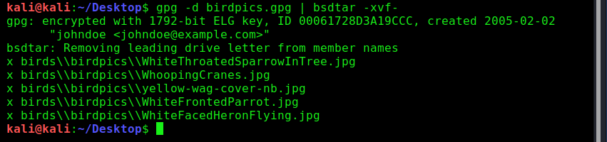

## 5 Timeline Analysis

### 5.1 Procedure for Setting up Elasticsearch and Kibana for Timeline Analysis

Firstly, the commands in Listing 17 were used to download docker images (essentially pre-packaged, ready-to-go setups which are run in isolation from the rest of the system) for Elasticsearch and Kibana.

Listing 17: Commands used to download Elasticsearch and Kibana docker images



These setups were then started using the commands in Listing 18. The command to start Elasticsearch included a mount option so its data would be stored outside the isolated docker environment and not be lost when the program was stopped.

Listing 18: Commands used to create and run docker containers for Elasticsearch and Kibana



Kibana could then be accessed by navigating to ‘localhost:5601’ in a web browser on the same workstation.

Once the log2timeline data had been imported, Kibana was browsed to, a new index pattern was created with the pattern ‘johndoe’ (the index name used when importing the data), and the field ‘datetime’ was set as the time field name. These initial setup steps (which were prompted on first browsing to Kibana) were necessary to access the data from Kibana.

### 5.2 Results

Table 5: Incidents identified through timeline analysis

|  |  |
| --- | --- |
| Incident No. | Description |
| 1 | On Feb 2, 2005, between 14:11 and 14:44 (before jane or bob first logged in):   * The user johndoe performed a Google search for 'birds', an Amazon book search for 'birds' and a Google search for 'bird wallpaper', as recorded in the user’s Firefox history. The user viewed several images with ornithological names in the browser, one of which with the same name as an image saved in the user’s ‘My Documents\My Pictures’ folder, ‘snow_geese.jpg’. * johndoe downloaded an ornithological image, ‘Firefox Wallpaper.bmp’, into the ‘C:\WINDOWS’ folder. It has a watermark matching a website johndoe was viewing, ‘naturewallpaper.net’. * johndoe downloaded (or otherwise acquired and stored) 5 ornithological images in the user's ‘My Documents\My Pictures’ folder: ‘40m.jpg’, ‘7107298.jpg’, ‘snow_geese.jpg’, ‘tn_duck_3.jpg’ and ‘wbpremium_s.jpg’. Accesses to these files were recorded in the user's IE (Internet Explorer) history, and ‘snow_geese.jpg’ matches the filename of an image the user viewed in Firefox. * johndoe performed a Google search for 'bird stories', browsed an ornithological website ‘birding.about.com’ and downloaded an ornithological webpage into the user's ‘My Documents’ folder, ‘aa010703a.htm’ (and the files in ‘aa010703a_files’). The URL ‘http://birding.about.com/library/weekly/aa010703a.htm’ was recorded in the user's Firefox history and access to the downloaded webpage was recorded in the user’s recent shortcut files. * johndoe created and saved a document containing ornithological materials in the user's ‘My Documents’ folder, ‘nestboxtips.txt’, which was recorded in the user's OpenSaveMRU list, IE history and recent shortcut files. |
| 2 | On Feb 2, 2005, between 15:10 and 15:13 (before jane or bob first logged in):   * johndoe downloaded the RealPlayer audio file ‘kakapo.ram’ into the user's ‘My Documents’ folder. The URL ‘http://www.pbs.org/lifeofbirds/songs/kakapo.ram’ was recorded in the user's Firefox history, and access to the downloaded file was recorded in the user's OpenSaveMRU list, RecentDocs list, recent shortcut files and IE history. * johndoe downloaded the RealPlayer audio file ‘dawn.ram’ into the user's ‘Local Settings\Temp folder’, as recorded in the user's Firefox downloads. The URL ‘http://www.pbs.org/lifeofbirds/songs/dawn.ram’ was recorded in the user's Firefox history, and access to the downloaded file was recorded in the user's RealPlayer history shortcut files. Note: These are network audio files and the actual audio they refer to cannot be recovered as the links appear to be inactive. |
| 3 | On Feb 2, 2005, between 16:32 and 16:47 (before jane or bob first logged in):   * johndoe created an encrypted‘.zip’ file, ‘birdpics.gpg’, containing 5 ornithological images in the user’s ‘My Documents’ folder. johndoe ran the encryption programs GPG and WinPT, which were recorded by **Windows prefetch**, and various files related to the GPG program under the user's ‘Application Data\GnuPG’ folder were created, accessed or modified. |
| 4 | On Feb 3, 2005, between 11:35 and 11:47 (after last activity of bob or jane):   * johndoe created a new volume ‘F:’, which was recorded in the user’s recent shortcut files, and stored 11 ornithological images there: ‘AlmondMarshGreatBlueHeronStalling.jpg’, ‘AmericanAvocetWinterPlumage.jpg’, ‘AmericanWhitePelicansCircling.jpg’, ‘BaldEagle7oClock.jpg’, ‘BarnOwl.jpg’, ‘BellbirdJumpingOffBranch.jpg’, ‘BlackNeckedStiltsFromBehind.jpg’, ‘BlackSwan.jpg’, ‘BlackVultureSunningOnPost.jpg’, ‘brd_Ornithologist_TWG.jpg’, and ‘blue_bird2.jpg’ (‘Df1.jpg’ in Recycle Bin – see Incident 8). * The ‘E:’ drive (an external USB disk) was recorded in johndoe's IE typed URLs and the folders ‘E:\birds\used\My Documents’, ‘E:\birds\used\johndoe’ and ‘E:\birds\used\windows’ were recorded in the user’s registry file. |
| 5 | On Feb 3, 2005, between 12:08 and 12:23 (after last activity of bob or jane):   * johndoe stored a zip archive containing 7 ornithological images and renamed to a ‘.dll’ file, ‘CrouchingKokako.dll’, in the ‘C:\WINDOWS’ folder. A file with the same name but a ‘.zip’ extension in the folder ‘E:\birds\’ was recorded in johndoe's user registry with a modification time matching that of ‘CrouchingKokako.dll’ and previous to the creation time of ‘CrouchingKokako.dll’, strongly suggesting johndoe copied this archive from the ‘E:’ drive. * johndoe performed a Google search for 'bird mating calls', visited the URL ‘http://whyfiles.org/shorties/104chick_sex/’ and downloaded the audio file ‘aggressive_song.wav’ into the ‘E:\birds\audio’ folder, as recorded in the user’s Firefox history and downloads. Access to this file was recorded in the user's OpenSaveMRU list, IE history and RecentDocs list. This file has the same name as one containing birdsong found in the folder ‘C:\Program Files\MSN’, which was recorded in the user’s recent shortcut files. The modification time of the file on the ‘C:’ drive occurs during this time, strongly suggesting it was copied from the file on the ‘E:’ drive. |
| 6 | On Feb 3, 2005, between 14:14 and 14:46 (after last activity of bob or jane):   * johndoe ran Microsoft Office, as recorded in the user’s registry UserAssist records, and created a Word document containing an ornithological image, ‘Doc1.doc’, under the user's ‘My Documents\My Music’ folder. Access to this file was recorded in johndoe's recent Windows and Office shortcut files and IE history. A matching folder ‘E:\birds\used\My Documents\My Music’ was recorded in johndoe's user registry file. * johndoe stored an ornithological image (matching the one in the above document) renamed to a ‘.exe’ file, ‘FantailFrontView.exe’, under the folder ‘C:\WINDOWS\mui’. Access to this file was recorded in johndoe's registry UserAssist records, and a matching folder ‘E:\birds\used\WINDOWS\mui’ was recorded in johndoe's registry file. The file's modification time is before its creation time, suggesting it may have been copied from the ‘E:’ drive. |
| 7 | On Feb 3, 2005, between 14:54 and 15:07 (after last activity of bob or jane):   * johndoe logged in, as recorded in the registry, and performed a Google image search for 'young chicks', as recorded in the user’s Firefox history. * johndoe downloaded an ornithological image ‘ready2fledge.jpg’ from the URL ‘http://people.cornell.edu/pages/sah67/ready2fledge.jpg’ into the user bob's ‘My Documents/My Music’ folder. * johndoe downloaded an ornithological image ‘birdtrans2.jpg’ from the URL ‘http://people.cornell.edu/pages/sah67/birdtrans2.jpg’ into the user's ‘Desktop’ folder. * johndoe downloaded 4 ornithological images into the user's ‘My Documents\My Pictures’ folder: ‘177.jpg’ from the URL ‘http://www.insaneanimals.com/items/177.jpg’, ‘babyscot_2weeks1.jpg’ from the URL ‘http://freespace.virgin.net/cobber.budgies/images/babyscot_2weeks1.jpg’, ‘babyscot_vyoung.jpg’ from the URL ‘http://freespace.virgin.net/cobber.budgies/images/babyscot_vyoung.jpg’ and ‘chicks2.jpg’ from the URL ‘http://people.cornell.edu/pages/sah67/chicks2.jpg’. * johndoe downloaded an ornithological image ‘newbies2.jpg’ from the URL ‘http://people.cornell.edu/pages/sah67/newbies2.jpg’ and an HTML document containing ornithological material ‘ostbk2b2.htm’ from the URL ‘http://www.cvm.okstate.edu/instruction/kocan/ostrich/ostbk2b2.htm’ into the user's ‘My Documents’ folder. * Downloads of all the above files were recorded in johndoe's Firefox downloads, and access to the downloaded versions were recorded in the user's IE history, OpenSaveMRU list, RecentDocs list, and recent shortcut files. The filenames ‘babyscot_vyoung.jpg’, ‘177.jpg’, ‘chicks2.jpg’ and ‘ostbk2b2.htm’ and the website names from which they were downloaded were also recorded in the user's Firefox history. |
| 8 | On Feb 3, 2005, between 15:36 and 15:56 (after last activity of bob or jane):   * 3 ornithological images were created under the ‘C:\Program Files’ folder: ‘frankbeecostume_1827_34457581’, ‘frankbeecostume_1827_84985892’ and ‘frankbeecostume_1827_96360352’. No further access to these was recorded, but a matching directory ‘E:\birds\used\Program Files’ was recorded in johndoe's user registry, and these files have modification times before their creation times, indicating a copy from another drive. * An ornithological image ‘blue_bird2.jpg’ (‘Df1.jpg’ in the Recycle Bin) was moved to the Recycle Bin from the ‘F:’ drive by johndoe. The Recycle Bin folder it was moved to is named according to the user johndoe’s unique SID number, which can be found in Appendix D, Listing 13. * A Word document containing ornithological materials, ‘guide.doc’, was created in the ‘F:’ drive. * johndoe stored a Word document containing ornithological materials, ‘birdwatching.doc’, on the ‘C:’ drive. Access to this file was recorded in johndoe's recent Windows and Office shortcut files, IE history and RecentDocs. * johndoe edited the file ‘C:\WINDOWS\ODBC.INI’, a legitimate configuration file which was found to contain ornithological text in comments. Access to this file was recorded in johndoe's recent shortcut files, RecentDocs and IE history. |
| 9 | On Feb 9, 2005, between 11:27 and 11:30 (after last activity of bob or jane):   * johndoe searched Google for 'bird screensavers' and viewed a variety of images as recorded in the user's Firefox history and cache. * johndoe downloaded a file ‘birds.zip’ from the URL ‘http://www.traveltex.com/downloads/screensavers/birds.zip’ into the user's ‘My Documents’ folder, as recorded in the user's Firefox downloads. Access to the above URL was also recorded in the user's Firefox history and cache. Access to the downloaded file was recorded in johndoe's OpenSaveMRU list, IE history, RecentDocs and recent shortcut files. * The file ‘tx_birds.exe’ was executed, and the files ‘tx_birds.exe’, ‘tx_birds.dat’, ‘tx_birds.dll’ and ‘tx_birds.scr’ were created under the ‘C:\WINDOWS’ folder. This installed program was then run, as recorded by Windows prefetch. A zip file containing a program by this name, which when run installed the above files which in turn functioned as a bird screensaver, had been created in johndoe's Firefox cache folder – this would appear to be the cached version of ‘birds.zip’, which was itself not present. |
| 10 | On Feb 9, 2005, between 16:56 and 17:10 (after last activity of bob or jane):   * A document suggestive of suspicious communication and having an ornithological title in its metadata, ‘stuf.doc’, was created by johndoe in the user's ‘My Documents’ folder. Access to this file was recorded in the user's recent Office docs, recent Windows and Office shortcut files, RecentDocs and IE history. * johndoe stored an audio file containing birdsong, ‘aggressive_song.wav’, under the ‘C:\Program Files\MSN’ folder. Access to this file was recorded in johndoe's recent shortcut files, IE history and RecentDocs. Note: A file with a matching name under ‘E:\birds\audio’ was previously downloaded by johndoe, around this file's modification time, strongly suggesting this file was copied from the external drive. * A document with a title strongly suggestive of ornithological material, ‘BirdingGuide.pdf’, along with 2 other files, ‘news_sprg2001.pdf’ and ‘57ab_perth.pdf’, were moved to the Recycle Bin by johndoe. * 12 ornithological images were created in the ‘F:’ drive: ‘GreatBlueHeronWithFish.jpg’, ‘GreatEgretInVoloBog.jpg’, ‘GreatEgretOverflyingRoseateSpoonbills.jpg’, ‘GreenHeronCloseup.jpg, ‘GreenHeronOnChicagoLakeshore.jpg’, ‘ImmatureSnowyEgretTakingOff.jpg’, ‘june03screen.jpg’, ‘junescreen01.jpg’, ‘KeaAndMountain.jpg’, ‘KeaAtTopOfMacKinnonPass0930.jpg’, ‘KeaEatingRentalCar.jpg’ and ‘KeaRetrievingBakedBeanCanFromTarn.jpg’. No further access to these was recorded. * johndoe accessed an ornithological image on the ‘F:’ drive, ‘AlmondMarshGreatBlueHeronStalling.jpg’, as recorded in the user’s recent shortcut files, RecentDocs and IE history. Access to the ‘F:’ drive by the user johndoe was also recorded in the user's recent shortcut files. |

Table 6: Timeline data relating to Incident 1

|  |  |  |  |  |
| --- | --- | --- | --- | --- |
| Datetime | Timestamp Description | Source | Message | Filename |
| 2005-02-02T14:16:36 | Creation Time | NTFS Creation Time | TSK:/WINDOWS/Firefox Wallpaper.bmp Type: file | /WINDOWS/Firefox Wallpaper.bmp |
| 2005-02-02T14:16:37 | Content Modification Time | NTFS Content Modification Time | TSK:/WINDOWS/Firefox Wallpaper.bmp Type: file | /WINDOWS/Firefox Wallpaper.bmp |
| 2005-02-02T14:16:37 | Metadata Modification Time | NTFS Metadata Modification Time | TSK:/WINDOWS/Firefox Wallpaper.bmp Type: file | /WINDOWS/Firefox Wallpaper.bmp |
| 2005-02-02T14:18:10 | Creation Time | NTFS Creation Time | TSK:/Documents and Settings/johndoe/My Documents/My Pictures/tn_duck_3.jpg Type: file | /Documents and Settings/johndoe/My Documents/My Pictures/tn_duck_3.jpg |
| 2005-02-02T14:18:11 | Content Modification Time | NTFS Content Modification Time | TSK:/Documents and Settings/johndoe/My Documents/My Pictures/tn_duck_3.jpg Type: file | /Documents and Settings/johndoe/My Documents/My Pictures/tn_duck_3.jpg |
| 2005-02-02T14:18:13 | Metadata Modification Time | NTFS Metadata Modification Time | TSK:/Documents and Settings/johndoe/My Documents/My Pictures/tn_duck_3.jpg Type: file | /Documents and Settings/johndoe/My Documents/My Pictures/tn_duck_3.jpg |
| 2005-02-02T14:18:13 | Last Visited Time | MSIE Cache File URL record | Location: Visited: johndoe@file:///C:/Documents%20and%20Settings/johndoe/My%20Documents/My%20Pictures/tn_duck_3.jpg Number of hits: 1 Cached file size: 0 | /Documents and Settings/johndoe/Local Settings/History/History.IE5/index.dat |
| 2005-02-02T14:18:53 | Creation Time | NTFS Creation Time | TSK:/Documents and Settings/johndoe/My Documents/My Pictures/snow_geese.jpg Type: file | /Documents and Settings/johndoe/My Documents/My Pictures/snow_geese.jpg |
| 2005-02-02T14:18:53 | Last Visited Time | MSIE Cache File URL record | Location: Visited: johndoe@file:///C:/Documents%20and%20Settings/johndoe/My%20Documents/My%20Pictures/snow_geese.jpg Number of hits: 1 Cached file size: 0 | /Documents and Settings/johndoe/Local Settings/History/History.IE5/index.dat |
| 2005-02-02T14:18:53 | Content Modification Time | NTFS Content Modification Time | TSK:/Documents and Settings/johndoe/My Documents/My Pictures/snow_geese.jpg Type: file | /Documents and Settings/johndoe/My Documents/My Pictures/snow_geese.jpg |
| 2005-02-02T14:18:53 | Metadata Modification Time | NTFS Metadata Modification Time | TSK:/Documents and Settings/johndoe/My Documents/My Pictures/snow_geese.jpg Type: file | /Documents and Settings/johndoe/My Documents/My Pictures/snow_geese.jpg |
| 2005-02-02T14:20:34 | Creation Time | NTFS Creation Time | TSK:/Documents and Settings/johndoe/My Documents/My Pictures/7107298.jpg Type: file | /Documents and Settings/johndoe/My Documents/My Pictures/7107298.jpg |
| 2005-02-02T14:20:34 | Last Visited Time | MSIE Cache File URL record | Location: Visited: johndoe@file:///C:/Documents%20and%20Settings/johndoe/My%20Documents/My%20Pictures/7107298.jpg Number of hits: 1 Cached file size: 0 | /Documents and Settings/johndoe/Local Settings/History/History.IE5/index.dat |
| 2005-02-02T14:20:34 | Content Modification Time | NTFS Content Modification Time | TSK:/Documents and Settings/johndoe/My Documents/My Pictures/7107298.jpg Type: file | /Documents and Settings/johndoe/My Documents/My Pictures/7107298.jpg |
| 2005-02-02T14:20:34 | Metadata Modification Time | NTFS Metadata Modification Time | TSK:/Documents and Settings/johndoe/My Documents/My Pictures/7107298.jpg Type: file | /Documents and Settings/johndoe/My Documents/My Pictures/7107298.jpg |
| 2005-02-02T14:26:00 | Creation Time | NTFS Creation Time | TSK:/Documents and Settings/johndoe/My Documents/aa010703a.htm Type: file | /Documents and Settings/johndoe/My Documents/aa010703a.htm |
| 2005-02-02T14:26:00 | Content Modification Time | Registry Key : MRU List | [HKEY_CURRENT_USER\Software\Microsoft\Windows\CurrentVersion\Explorer\FileExts\.htm\OpenWithList] Index: 1 [MRU Value a]: firefox.exe | /Documents and Settings/johndoe/NTUSER.DAT |
| 2005-02-02T14:26:00 | Creation Time | NTFS Creation Time | TSK:/Documents and Settings/johndoe/My Documents/aa010703a_files Type: directory | /Documents and Settings/johndoe/My Documents/aa010703a_files |
| 2005-02-02T14:26:00 | Creation Time | NTFS Creation Time | TSK:/Documents and Settings/johndoe/Recent/aa010703a.lnk Type: file | /Documents and Settings/johndoe/Recent/aa010703a.lnk |
| 2005-02-02T14:28:20 | Creation Time | NTFS Creation Time | TSK:/Documents and Settings/johndoe/My Documents/My Pictures/wbpremium_s.jpg Type: file | /Documents and Settings/johndoe/My Documents/My Pictures/wbpremium_s.jpg |
| 2005-02-02T14:28:20 | Content Modification Time | NTFS Content Modification Time | TSK:/Documents and Settings/johndoe/My Documents/My Pictures/wbpremium_s.jpg Type: file | /Documents and Settings/johndoe/My Documents/My Pictures/wbpremium_s.jpg |
| 2005-02-02T14:28:20 | Metadata Modification Time | NTFS Metadata Modification Time | TSK:/Documents and Settings/johndoe/My Documents/My Pictures/wbpremium_s.jpg Type: file | /Documents and Settings/johndoe/My Documents/My Pictures/wbpremium_s.jpg |
| 2005-02-02T14:28:20 | Last Visited Time | MSIE Cache File URL record | Location: Visited: johndoe@file:///C:/Documents%20and%20Settings/johndoe/My%20Documents/My%20Pictures/wbpremium_s.jpg Number of hits: 1 Cached file size: 0 | /Documents and Settings/johndoe/Local Settings/History/History.IE5/index.dat |
| 2005-02-02T14:29:07 | Content Modification Time | Registry Key : MRU List | [HKEY_CURRENT_USER\Software\Microsoft\Windows\CurrentVersion\Explorer\RunMRU] Index: 1 [MRU Value a]: notepad\1 | /Documents and Settings/johndoe/NTUSER.DAT |
| 2005-02-02T14:29:17 | Creation Time | NTFS Creation Time | TSK:/WINDOWS/Prefetch/NOTEPAD.EXE-336351A9.pf Type: file | /WINDOWS/Prefetch/NOTEPAD.EXE-336351A9.pf |
| 2005-02-02T14:29:31 | Creation Time | NTFS Creation Time | TSK:/Documents and Settings/johndoe/My Documents/nestboxtips.txt Type: file | /Documents and Settings/johndoe/My Documents/nestboxtips.txt |
| 2005-02-02T14:29:31 | Content Modification Time | Registry Key : MRU List | [HKEY_CURRENT_USER\Software\Microsoft\Windows\CurrentVersion\Explorer\ComDlg32\OpenSaveMRU\txt] Index: 1 [MRU Value a]: C:\Documents and Settings\johndoe\My Documents\nestboxtips.txt | /Documents and Settings/johndoe/NTUSER.DAT |
| 2005-02-02T14:29:31 | Content Modification Time | Registry Key : MRU List | [HKEY_CURRENT_USER\Software\Microsoft\Windows\CurrentVersion\Explorer\FileExts\.txt\OpenWithList] Index: 1 [MRU Value a]: notepad.exe | /Documents and Settings/johndoe/NTUSER.DAT |
| 2005-02-02T14:29:31 | Creation Time | NTFS Creation Time | TSK:/Documents and Settings/johndoe/Recent/nestboxtips.lnk Type: file | /Documents and Settings/johndoe/Recent/nestboxtips.lnk |
| 2005-02-02T14:29:31 | Content Modification Time | NTFS Content Modification Time | TSK:/Documents and Settings/johndoe/My Documents/nestboxtips.txt Type: file | /Documents and Settings/johndoe/My Documents/nestboxtips.txt |
| 2005-02-02T14:29:31 | Last Access Time | NTFS Last Access Time | TSK:/Documents and Settings/johndoe/My Documents/nestboxtips.txt Type: file | /Documents and Settings/johndoe/My Documents/nestboxtips.txt |
| 2005-02-02T14:29:31 | Metadata Modification Time | NTFS Metadata Modification Time | TSK:/Documents and Settings/johndoe/My Documents/nestboxtips.txt Type: file | /Documents and Settings/johndoe/My Documents/nestboxtips.txt |
| 2005-02-02T14:29:31 | Content Modification Time | NTFS Content Modification Time | TSK:/Documents and Settings/johndoe/Recent/nestboxtips.lnk Type: file | /Documents and Settings/johndoe/Recent/nestboxtips.lnk |
| 2005-02-02T14:29:31 | Metadata Modification Time | NTFS Metadata Modification Time | TSK:/Documents and Settings/johndoe/Recent/nestboxtips.lnk Type: file | /Documents and Settings/johndoe/Recent/nestboxtips.lnk |
| 2005-02-02T14:29:31 | Last Visited Time | MSIE Cache File URL record | Location: Visited: johndoe@file:///C:/Documents%20and%20Settings/johndoe/My%20Documents/nestboxtips.txt Number of hits: 1 Cached file size: 0 | /Documents and Settings/johndoe/Local Settings/History/History.IE5/index.dat |
| 2005-02-02T14:43:36 | Creation Time | NTFS Creation Time | TSK:/Documents and Settings/johndoe/My Documents/My Pictures/40m.jpg Type: file | /Documents and Settings/johndoe/My Documents/My Pictures/40m.jpg |
| 2005-02-02T14:43:36 | Content Modification Time | NTFS Content Modification Time | TSK:/Documents and Settings/johndoe/My Documents/My Pictures/40m.jpg Type: file | /Documents and Settings/johndoe/My Documents/My Pictures/40m.jpg |
| 2005-02-02T14:43:36 | Metadata Modification Time | NTFS Metadata Modification Time | TSK:/Documents and Settings/johndoe/My Documents/My Pictures/40m.jpg Type: file | /Documents and Settings/johndoe/My Documents/My Pictures/40m.jpg |
| 2005-02-02T14:43:36 | Last Visited Time | MSIE Cache File URL record | Location: Visited: johndoe@file:///C:/Documents%20and%20Settings/johndoe/My%20Documents/My%20Pictures/40m.jpg Number of hits: 1 Cached file size: 0 | /Documents and Settings/johndoe/Local Settings/History/History.IE5/index.dat |

Table 7: Timeline data relating to Incident 2

|  |  |  |  |  |
| --- | --- | --- | --- | --- |
| Datetime | Timestamp Description | Source | Message | Filename |
| 2005-02-02T15:11:41 | Content Modification Time | NTFS Content Modification Time | TSK:/Documents and Settings/johndoe/My Documents/kakapo.ram Type: file | /Documents and Settings/johndoe/My Documents/kakapo.ram |
| 2005-02-02T15:11:52 | Creation Time | NTFS Creation Time | TSK:/Documents and Settings/johndoe/My Documents/kakapo.ram Type: file | /Documents and Settings/johndoe/My Documents/kakapo.ram |
| 2005-02-02T15:11:52 | Content Modification Time | NTFS Content Modification Time | TSK:/Documents and Settings/johndoe/Recent/kakapo.lnk Type: file | /Documents and Settings/johndoe/Recent/kakapo.lnk |
| 2005-02-02T15:11:52 | Creation Time | NTFS Creation Time | TSK:/Documents and Settings/johndoe/Recent/kakapo.lnk Type: file | /Documents and Settings/johndoe/Recent/kakapo.lnk |
| 2005-02-02T15:11:52 | Metadata Modification Time | NTFS Metadata Modification Time | TSK:/Documents and Settings/johndoe/Recent/kakapo.lnk Type: file | /Documents and Settings/johndoe/Recent/kakapo.lnk |
| 2005-02-02T15:11:52 | Content Modification Time | Registry Key : MRU List | [HKEY_CURRENT_USER\Software\Microsoft\Windows\CurrentVersion\Explorer\ComDlg32\OpenSaveMRU\ram] Index: 1 [MRU Value a]: C:\Documents and Settings\johndoe\My Documents\kakapo.ram | /Documents and Settings/johndoe/NTUSER.DAT |
| 2005-02-02T15:11:52 | Last Visited Time | MSIE Cache File URL record | Location: Visited: johndoe@file:///C:/Documents%20and%20Settings/johndoe/My%20Documents/kakapo.ram Number of hits: 1 Cached file size: 0 | /Documents and Settings/johndoe/Local Settings/History/History.IE5/index.dat |
| 2005-02-02T15:11:52 | Content Modification Time | Registry Key : MRUListEx | [HKEY_CURRENT_USER\Software\Microsoft\Windows\CurrentVersion\Explorer\RecentDocs\.ram] Index: 1 [MRU Value 0]: Path: kakapo.ram, Shell item: [kakapo.lnk] | /Documents and Settings/johndoe/NTUSER.DAT |
| 2005-02-02T15:11:52 | Content Modification Time | Registry Key : MRUListEx | [HKEY_CURRENT_USER\Software\Microsoft\Windows\CurrentVersion\Explorer\RecentDocs\.ram] Index: 1 [MRU Value 0]: kakapo.ram | /Documents and Settings/johndoe/NTUSER.DAT |
| 2005-02-02T15:11:52 | Last Visited Time | MSIE Cache File URL record | Location: Visited: johndoe@file:///C:/Documents%20and%20Settings/johndoe/My%20Documents/kakapo.ram Number of hits: 1 Cached file size: 0 | /Documents and Settings/johndoe/Local Settings/History/History.IE5/index.dat |
| 2005-02-02T15:11:52 | Metadata Modification Time | NTFS Metadata Modification Time | TSK:/Documents and Settings/johndoe/My Documents/kakapo.ram Type: file | /Documents and Settings/johndoe/My Documents/kakapo.ram |
| 2005-02-02T15:11:52 | Last Checked Time | MSIE Cache File URL record | Location: Visited: johndoe@file:///C:/Documents%20and%20Settings/johndoe/My%20Documents/kakapo.ram Number of hits: 1 Cached file size: 0 | /Documents and Settings/johndoe/Local Settings/History/History.IE5/index.dat |
| 2005-02-02T15:12:06 | Content Modification Time | NTFS Content Modification Time | TSK:/Documents and Settings/johndoe/Local Settings/Temp/dawn.ram Type: file | /Documents and Settings/johndoe/Local Settings/Temp/dawn.ram |
| 2005-02-02T15:12:10 | Creation Time | NTFS Creation Time | TSK:/Documents and Settings/johndoe/Local Settings/Temp/dawn.ram Type: file | /Documents and Settings/johndoe/Local Settings/Temp/dawn.ram |
| 2005-02-02T15:12:10 | Metadata Modification Time | NTFS Metadata Modification Time | TSK:/Documents and Settings/johndoe/Local Settings/Temp/dawn.ram Type: file | /Documents and Settings/johndoe/Local Settings/Temp/dawn.ram |
| 2005-02-02T15:12:12 | Last Access Time | Windows Shortcut | [RealPlayer Clip:file://C:/DOCUME~1/JOHNDOE/LOCALS~1/TEMP/dawn.ram] File size: 204845 File attribute flags: 0x00000020 Drive type: 3 Drive serial number: 0x88412714 Local path: C:\Program Files\Real\RealPlayer\realplay.exe cmd arguments: /startpos:00:00:00.0 file://C:/DOCUME~1/JOHNDOE/LOCALS~1/TEMP/dawn.ram Relative path: ..\..\..\..\..\..\Program Files\Real\RealPlayer\realplay.exe Icon location: %ProgramFiles%\Real\RealPlayer\RealPlay.exe Link target: <My Computer> C:\Program Files\Real\RealPlayer\realplay.exe | /Documents and Settings/johndoe/Application Data/Real/RealPlayer/History/dawn.lnk |
| 2005-02-02T15:12:13 | Creation Time | NTFS Creation Time | TSK:/Documents and Settings/johndoe/Application Data/Real/RealPlayer/History/dawn.lnk Type: file | /Documents and Settings/johndoe/Application Data/Real/RealPlayer/History/dawn.lnk |
| 2005-02-02T15:12:13 | Content Modification Time | NTFS Content Modification Time | TSK:/Documents and Settings/johndoe/Application Data/Real/RealPlayer/History/dawn.lnk Type: file | /Documents and Settings/johndoe/Application Data/Real/RealPlayer/History/dawn.lnk |
| 2005-02-02T15:12:13 | Last Access Time | NTFS Last Access Time | TSK:/Documents and Settings/johndoe/Application Data/Real/RealPlayer/History/dawn.lnk Type: file | /Documents and Settings/johndoe/Application Data/Real/RealPlayer/History/dawn.lnk |
| 2005-02-02T15:12:13 | Metadata Modification Time | NTFS Metadata Modification Time | TSK:/Documents and Settings/johndoe/Application Data/Real/RealPlayer/History/dawn.lnk Type: file | /Documents and Settings/johndoe/Application Data/Real/RealPlayer/History/dawn.lnk |
| 2005-02-02T15:12:14 | Last Access Time | File entry shell item | Name: realplay.exe Long name: realplay.exe Shell item path: <My Computer> C:\Program Files\Real\RealPlayer\realplay.exe Origin: The Life of Birds- Dawn Bird.lnk | /Documents and Settings/johndoe/Application Data/Real/RealPlayer/History/The Life of Birds- Dawn Bird.lnk |
| 2005-02-02T15:12:16 | Last Access Time | Windows Shortcut | [RealPlayer Clip:file://C:/DOCUME~1/JOHNDOE/LOCALS~1/TEMP/dawn.ram] File size: 204845 File attribute flags: 0x00000020 Drive type: 3 Drive serial number: 0x88412714 Local path: C:\Program Files\Real\RealPlayer\realplay.exe cmd arguments: /startpos:00:00:00.0 file://C:/DOCUME~1/JOHNDOE/LOCALS~1/TEMP/dawn.ram Relative path: ..\..\..\..\..\..\Program Files\Real\RealPlayer\realplay.exe Icon location: %ProgramFiles%\Real\RealPlayer\RealPlay.exe Link target: <My Computer> C:\Program Files\Real\RealPlayer\realplay.exe | /Documents and Settings/johndoe/Application Data/Real/RealPlayer/History/The Life of Birds- Dawn Bird.lnk |
| 2005-02-02T15:12:16 | Creation Time | NTFS Creation Time | TSK:/Documents and Settings/johndoe/Application Data/Real/RealPlayer/History/The Life of Birds- Dawn Bird.lnk Type: file | /Documents and Settings/johndoe/Application Data/Real/RealPlayer/History/The Life of Birds- Dawn Bird.lnk |
| 2005-02-02T15:12:16 | Content Modification Time | NTFS Content Modification Time | TSK:/Documents and Settings/johndoe/Application Data/Real/RealPlayer/History/The Life of Birds- Dawn Bird.lnk Type: file | /Documents and Settings/johndoe/Application Data/Real/RealPlayer/History/The Life of Birds- Dawn Bird.lnk |
| 2005-02-02T15:12:16 | Last Access Time | NTFS Last Access Time | TSK:/Documents and Settings/johndoe/Application Data/Real/RealPlayer/History/The Life of Birds- Dawn Bird.lnk Type: file | /Documents and Settings/johndoe/Application Data/Real/RealPlayer/History/The Life of Birds- Dawn Bird.lnk |
| 2005-02-02T15:12:16 | Metadata Modification Time | NTFS Metadata Modification Time | TSK:/Documents and Settings/johndoe/Application Data/Real/RealPlayer/History/The Life of Birds- Dawn Bird.lnk Type: file | /Documents and Settings/johndoe/Application Data/Real/RealPlayer/History/The Life of Birds- Dawn Bird.lnk |

Table 8: Timeline data relating to incident 3

|  |  |  |  |  |
| --- | --- | --- | --- | --- |
| Datetime | Timestamp Description | Source | Message | Filename |
| 2005-02-02T16:32:22 | Creation Time | NTFS Creation Time | TSK:/WINDOWS/Prefetch/GPG.EXE-3205295F.pf Type: file | /WINDOWS/Prefetch/GPG.EXE-3205295F.pf |
| 2005-02-02T16:32:32 | Creation Time | NTFS Creation Time | TSK:/WINDOWS/Prefetch/WINPT.EXE-258D0ABC.pf Type: file | /WINDOWS/Prefetch/WINPT.EXE-258D0ABC.pf |
| 2005-02-02T16:34:06 | Content Modification Time | NTFS Content Modification Time | TSK:/Documents and Settings/johndoe/Application Data/GnuPG/secring.gpg Type: file | /Documents and Settings/johndoe/Application Data/GnuPG/secring.gpg |
| 2005-02-02T16:34:06 | Metadata Modification Time | NTFS Metadata Modification Time | TSK:/Documents and Settings/johndoe/Application Data/GnuPG/secring.gpg Type: file | /Documents and Settings/johndoe/Application Data/GnuPG/secring.gpg |
| 2005-02-02T16:34:06 | Creation Time | NTFS Creation Time | TSK:/Documents and Settings/johndoe/Application Data/GnuPG/trustdb.gpg Type: file | /Documents and Settings/johndoe/Application Data/GnuPG/trustdb.gpg |
| 2005-02-02T16:34:06 | Creation Time | NTFS Creation Time | TSK:/Documents and Settings/johndoe/Application Data/GnuPG/random_seed Type: file | /Documents and Settings/johndoe/Application Data/GnuPG/random_seed |
| 2005-02-02T16:35:11 | Content Modification Time | NTFS Content Modification Time | TSK:/Documents and Settings/johndoe/Application Data/GnuPG/trustdb.gpg Type: file | /Documents and Settings/johndoe/Application Data/GnuPG/trustdb.gpg |
| 2005-02-02T16:35:11 | Metadata Modification Time | NTFS Metadata Modification Time | TSK:/Documents and Settings/johndoe/Application Data/GnuPG/trustdb.gpg Type: file | /Documents and Settings/johndoe/Application Data/GnuPG/trustdb.gpg |
| 2005-02-02T16:46:32 | Creation Time | NTFS Creation Time | TSK:/Documents and Settings/johndoe/My Documents/birdpics.gpg Type: file | /Documents and Settings/johndoe/My Documents/birdpics.gpg |
| 2005-02-02T16:46:32 | Content Modification Time | NTFS Content Modification Time | TSK:/Documents and Settings/johndoe/Application Data/GnuPG/random_seed Type: file | /Documents and Settings/johndoe/Application Data/GnuPG/random_seed |
| 2005-02-02T16:46:32 | Last Access Time | NTFS Last Access Time | TSK:/Documents and Settings/johndoe/Application Data/GnuPG/random_seed Type: file | /Documents and Settings/johndoe/Application Data/GnuPG/random_seed |
| 2005-02-02T16:46:32 | Metadata Modification Time | NTFS Metadata Modification Time | TSK:/Documents and Settings/johndoe/Application Data/GnuPG/random_seed Type: file | /Documents and Settings/johndoe/Application Data/GnuPG/random_seed |
| 2005-02-02T16:46:32 | Content Modification Time | NTFS Content Modification Time | TSK:/Documents and Settings/johndoe/My Documents/birdpics.gpg Type: file | /Documents and Settings/johndoe/My Documents/birdpics.gpg |
| 2005-02-02T16:46:32 | Metadata Modification Time | NTFS Metadata Modification Time | TSK:/Documents and Settings/johndoe/My Documents/birdpics.gpg Type: file | /Documents and Settings/johndoe/My Documents/birdpics.gpg |

Table 9: Timeline data relating to Incident 4

|  |  |  |  |  |
| --- | --- | --- | --- | --- |
| Datetime | Timestamp Description | Source | Message | Filename |
| 2005-02-03T11:35:56 | Content Modification Time | NTFS Content Modification Time | TSK:/$MFTMirr Type: file | /$MFTMirr |
| 2005-02-03T11:35:56 | Creation Time | NTFS Creation Time | TSK:/$MFTMirr Type: file | /$MFTMirr |
| 2005-02-03T11:35:56 | Last Access Time | NTFS Last Access Time | TSK:/$MFTMirr Type: file | /$MFTMirr |
| 2005-02-03T11:35:56 | Metadata Modification Time | NTFS Metadata Modification Time | TSK:/$MFTMirr Type: file | /$MFTMirr |
| 2005-02-03T11:35:56 | Content Modification Time | NTFS Content Modification Time | TSK:/$MFT Type: file | /$MFT |
| 2005-02-03T11:35:56 | Creation Time | NTFS Creation Time | TSK:/$MFT Type: file | /$MFT |
| 2005-02-03T11:35:56 | Last Access Time | NTFS Last Access Time | TSK:/$MFT Type: file | /$MFT |
| 2005-02-03T11:35:56 | Content Modification Time | NTFS Content Modification Time | TSK:/$Volume Type: file | /$Volume |
| 2005-02-03T11:35:56 | Creation Time | NTFS Creation Time | TSK:/$Volume Type: file | /$Volume |
| 2005-02-03T11:35:56 | Last Access Time | NTFS Last Access Time | TSK:/$Volume Type: file | /$Volume |
| 2005-02-03T11:35:56 | Metadata Modification Time | NTFS Metadata Modification Time | TSK:/$Volume Type: file | /$Volume |
| 2005-02-03T11:35:56 | Creation Time | Windows Shortcut | [Empty description] File size: 0 File attribute flags: 0x00000016 Drive type: 3 Drive serial number: 0x708b43b0 Volume label: New Volume Local path: F:\ Link target: <My Computer> F:\ | /Documents and Settings/johndoe/Recent/New Volume (F).lnk |
| 2005-02-03T11:35:56 | Creation Time | System | \DEVICE\HARDDISKVOLUME2 Serial number: 0x708B43B0 Origin: MRT.EXE-0847AD6A.pf | /WINDOWS/Prefetch/MRT.EXE-0847AD6A.pf |
| 2005-02-03T11:35:56 | Creation Time | System | \DEVICE\HARDDISKVOLUME2 Serial number: 0x708B43B0 Origin: NTOSBOOT-B00DFAAD.pf | /WINDOWS/Prefetch/NTOSBOOT-B00DFAAD.pf |
| 2005-02-03T11:35:56 | Creation Time | System | \DEVICE\HARDDISKVOLUME2 Serial number: 0x708B43B0 Origin: WINDOWS-KB890830-V1.1-ENU.EXE-0860773E.pf | /WINDOWS/Prefetch/WINDOWS-KB890830-V1.1-ENU.EXE-0860773E.pf |
| 2005-02-03T11:36:05 | Creation Time | NTFS Creation Time | TSK:/System Volume Information Type: directory | /System Volume Information |
| 2005-02-03T11:42:19 | Creation Time | NTFS Creation Time | TSK:/AlmondMarshGreatBlueHeronStalling.jpg Type: file | /AlmondMarshGreatBlueHeronStalling.jpg |
| 2005-02-03T11:42:19 | Creation Time | Windows Shortcut | [Empty description] File size: 177015 File attribute flags: 0x00000020 Drive type: 3 Drive serial number: 0x708b43b0 Volume label: New Volume Local path: F:\AlmondMarshGreatBlueHeronStalling.jpg Working dir: F:\ Link target: <My Computer> F:\AlmondMarshGreatBlueHeronStalling.jpg | /Documents and Settings/johndoe/Recent/AlmondMarshGreatBlueHeronStalling.jpg.lnk |
| 2005-02-03T11:42:19 | Creation Time | NTFS Creation Time | TSK:/AmericanAvocetWinterPlumage.jpg Type: file | /AmericanAvocetWinterPlumage.jpg |
| 2005-02-03T11:42:19 | Metadata Modification Time | NTFS Metadata Modification Time | TSK:/AmericanAvocetWinterPlumage.jpg Type: file | /AmericanAvocetWinterPlumage.jpg |
| 2005-02-03T11:42:19 | Creation Time | NTFS Creation Time | TSK:/AmericanWhitePelicansCircling.jpg Type: file | /AmericanWhitePelicansCircling.jpg |
| 2005-02-03T11:42:19 | Metadata Modification Time | NTFS Metadata Modification Time | TSK:/AmericanWhitePelicansCircling.jpg Type: file | /AmericanWhitePelicansCircling.jpg |
| 2005-02-03T11:42:19 | Creation Time | NTFS Creation Time | TSK:/BaldEagle7oClock.jpg Type: file | /BaldEagle7oClock.jpg |
| 2005-02-03T11:42:19 | Metadata Modification Time | NTFS Metadata Modification Time | TSK:/BaldEagle7oClock.jpg Type: file | /BaldEagle7oClock.jpg |
| 2005-02-03T11:42:19 | Creation Time | NTFS Creation Time | TSK:/BarnOwl.jpg Type: file | /BarnOwl.jpg |
| 2005-02-03T11:42:19 | Metadata Modification Time | NTFS Metadata Modification Time | TSK:/BarnOwl.jpg Type: file | /BarnOwl.jpg |
| 2005-02-03T11:42:19 | Creation Time | NTFS Creation Time | TSK:/BellbirdJumpingOffBranch.jpg Type: file | /BellbirdJumpingOffBranch.jpg |
| 2005-02-03T11:42:20 | Creation Time | File entry shell item | Name: ALMOND~1.JPG Long name: AlmondMarshGreatBlueHeronStalling.jpg Shell item path: <My Computer> F:\AlmondMarshGreatBlueHeronStalling.jpg Origin: AlmondMarshGreatBlueHeronStalling.jpg.lnk | /Documents and Settings/johndoe/Recent/AlmondMarshGreatBlueHeronStalling.jpg.lnk |
| 2005-02-03T11:42:20 | Metadata Modification Time | NTFS Metadata Modification Time | TSK:/BellbirdJumpingOffBranch.jpg Type: file | /BellbirdJumpingOffBranch.jpg |
| 2005-02-03T11:42:20 | Creation Time | NTFS Creation Time | TSK:/BlackNeckedStiltsFromBehind.jpg Type: file | /BlackNeckedStiltsFromBehind.jpg |
| 2005-02-03T11:42:20 | Metadata Modification Time | NTFS Metadata Modification Time | TSK:/BlackNeckedStiltsFromBehind.jpg Type: file | /BlackNeckedStiltsFromBehind.jpg |
| 2005-02-03T11:42:20 | Creation Time | NTFS Creation Time | TSK:/BlackSwan.jpg Type: file | /BlackSwan.jpg |
| 2005-02-03T11:42:20 | Metadata Modification Time | NTFS Metadata Modification Time | TSK:/BlackSwan.jpg Type: file | /BlackSwan.jpg |
| 2005-02-03T11:42:21 | Creation Time | NTFS Creation Time | TSK:/BlackVultureSunningOnPost.jpg Type: file | /BlackVultureSunningOnPost.jpg |
| 2005-02-03T11:42:21 | Metadata Modification Time | NTFS Metadata Modification Time | TSK:/BlackVultureSunningOnPost.jpg Type: file | /BlackVultureSunningOnPost.jpg |
| 2005-02-03T11:42:21 | Creation Time | NTFS Creation Time | TSK:/RECYCLER/S-1-5-21-725345543-854245398-1202660629-1003/Df1.jpg Type: file | /RECYCLER/S-1-5-21-725345543-854245398-1202660629-1003/Df1.jpg |
| 2005-02-03T11:42:21 | Creation Time | NTFS Creation Time | TSK:/brd_Ornithologist_TWG.jpg Type: file | /brd_Ornithologist_TWG.jpg |
| 2005-02-03T11:42:21 | Metadata Modification Time | NTFS Metadata Modification Time | TSK:/brd_Ornithologist_TWG.jpg Type: file | /brd_Ornithologist_TWG.jpg |
| 2005-02-03T11:44:25 | Content Modification Time | Registry Key : Typed URLs | [HKEY_CURRENT_USER\Software\Microsoft\Internet Explorer\TypedURLs] url1: e:\ | /System Volume Information/_restore{F551F22F-0FBF-41E1-AE7D-8B7BB8E7F937}/RP8/snapshot/_REGISTRY_USER_NTUSER_S-1-5-21-725345543-854245398-1202660629-1003 |
| 2005-02-03T11:44:52 | Content Modification Time | File entry shell item | Name: MYDOCU~1 Long name: My Documents Shell item path: <My Computer> E:\birds\used\My Documents Origin: HKEY_CURRENT_USER\Software\Microsoft\Windows\CurrentVersion\Explorer\StreamMRU | /Documents and Settings/johndoe/NTUSER.DAT |
| 2005-02-03T11:44:52 | Creation Time | File entry shell item | Name: MYDOCU~1 Long name: My Documents Shell item path: <My Computer> E:\birds\used\My Documents Origin: HKEY_CURRENT_USER\Software\Microsoft\Windows\CurrentVersion\Explorer\StreamMRU | /Documents and Settings/johndoe/NTUSER.DAT |
| 2005-02-03T11:44:52 | Content Modification Time | File entry shell item | Name: johndoe Long name: johndoe Shell item path: <My Computer> E:\birds\used\johndoe Origin: HKEY_CURRENT_USER\Software\Microsoft\Windows\CurrentVersion\Explorer\StreamMRU | /Documents and Settings/johndoe/NTUSER.DAT |
| 2005-02-03T11:44:52 | Creation Time | File entry shell item | Name: johndoe Long name: johndoe Shell item path: <My Computer> E:\birds\used\johndoe Origin: HKEY_CURRENT_USER\Software\Microsoft\Windows\CurrentVersion\Explorer\StreamMRU | /Documents and Settings/johndoe/NTUSER.DAT |
| 2005-02-03T11:45:43 | Last Access Time | NTFS Last Access Time | TSK:/Documents and Settings/johndoe/My Documents/birdpics.gpg Type: file | /Documents and Settings/johndoe/My Documents/birdpics.gpg |
| 2005-02-03T11:46:42 | Content Modification Time | File entry shell item | Name: windows Long name: windows Shell item path: <My Computer> E:\birds\used\windows Origin: HKEY_CURRENT_USER\Software\Microsoft\Windows\CurrentVersion\Explorer\StreamMRU | /Documents and Settings/johndoe/NTUSER.DAT |
| 2005-02-03T11:46:42 | Creation Time | File entry shell item | Name: windows Long name: windows Shell item path: <My Computer> E:\birds\used\windows Origin: HKEY_CURRENT_USER\Software\Microsoft\Windows\CurrentVersion\Explorer\StreamMRU | /Documents and Settings/johndoe/NTUSER.DAT |

Table 10: Timeline data relating to incident 5

|  |  |  |  |  |
| --- | --- | --- | --- | --- |
| Datetime | Timestamp Description | Source | message | Filename |
| 2005-02-03T12:08:24 | Creation Time | File entry shell item | Name: CROUCH~1.ZIP Long name: CrouchingKokako.zip Shell item path: <My Computer> E:\birds\CrouchingKokako.zip Origin: HKEY_CURRENT_USER\Software\Microsoft\Windows\CurrentVersion\Explorer\StreamMRU | /Documents and Settings/johndoe/NTUSER.DAT |
| 2005-02-03T12:08:40 | Content Modification Time | NTFS Content Modification Time | TSK:/WINDOWS/CrouchingKokako.dll Type: file | /WINDOWS/CrouchingKokako.dll |
| 2005-02-03T12:08:40 | Content Modification Time | File entry shell item | Name: CROUCH~1.ZIP Long name: CrouchingKokako.zip Shell item path: <My Computer> E:\birds\CrouchingKokako.zip Origin: HKEY_CURRENT_USER\Software\Microsoft\Windows\CurrentVersion\Explorer\StreamMRU | /Documents and Settings/johndoe/NTUSER.DAT |
| 2005-02-03T12:11:41 | Creation Time | NTFS Creation Time | TSK:/WINDOWS/CrouchingKokako.dll Type: file | /WINDOWS/CrouchingKokako.dll |
| 2005-02-03T12:11:41 | Content Modification Time | Windows Shortcut | [Empty description] File size: 0 File attribute flags: 0x00000010 Drive type: 3 Drive serial number: 0x88412714 Local path: C:\WINDOWS Relative path: ..\..\..\WINDOWS Link target: <My Computer> C:\WINDOWS | /Documents and Settings/johndoe/Recent/WINDOWS.lnk |
| 2005-02-03T12:11:41 | Last Access Time | NTFS Last Access Time | TSK:/WINDOWS/CrouchingKokako.dll Type: file | /WINDOWS/CrouchingKokako.dll |
| 2005-02-03T12:11:41 | Metadata Modification Time | NTFS Metadata Modification Time | TSK:/WINDOWS/CrouchingKokako.dll Type: file | /WINDOWS/CrouchingKokako.dll |
| 2005-02-03T12:11:42 | Content Modification Time | File entry shell item | Name: WINDOWS Long name: WINDOWS Shell item path: <My Computer> C:\WINDOWS Origin: HKEY_CURRENT_USER\Software\Microsoft\Windows\CurrentVersion\Explorer\StreamMRU | /Documents and Settings/johndoe/NTUSER.DAT |
| 2005-02-03T12:11:42 | Content Modification Time | File entry shell item | Name: WINDOWS Long name: WINDOWS Shell item path: <My Computer> C:\WINDOWS Origin: ODBC.INI.lnk | /Documents and Settings/johndoe/Recent/ODBC.INI.lnk |
| 2005-02-03T12:11:42 | Content Modification Time | File entry shell item | Name: WINDOWS Long name: WINDOWS Shell item path: <My Computer> C:\WINDOWS Origin: WINDOWS.lnk | /Documents and Settings/johndoe/Recent/WINDOWS.lnk |
| 2005-02-03T12:19:07 | Last Access Time | Windows Shortcut | [Empty description] File size: 4960 File attribute flags: 0x00000020 Drive type: 3 Drive serial number: 0x88412714 Local path: C:\Documents and Settings\johndoe\Application Data\Mozilla\Firefox\Profiles\w4nf3obl.default\cookies.txt Relative path: ..\Application Data\Mozilla\Firefox\Profiles\w4nf3obl.default\cookies.txt Working dir: C:\Documents and Settings\johndoe\Application Data\Mozilla\Firefox\Profiles\w4nf3obl.default Link target: <My Computer> C:\Documents and Settings\johndoe\Application Data\Mozilla\Firefox\Profiles\w4nf3obl.default\cookies.txt | /Documents and Settings/johndoe/Recent/cookies.txt.lnk |
| 2005-02-03T12:19:07 | Metadata Modification Time | NTFS Metadata Modification Time | TSK:/Program Files/Windows NT/Accessories/wordpad.exe Type: file | /Program Files/Windows NT/Accessories/wordpad.exe |
| 2005-02-03T12:19:07 | Creation Time | NTFS Creation Time | TSK:/Documents and Settings/johndoe/Recent/cookies.txt.lnk Type: file | /Documents and Settings/johndoe/Recent/cookies.txt.lnk |
| 2005-02-03T12:19:07 | Content Modification Time | NTFS Content Modification Time | TSK:/Documents and Settings/johndoe/Recent/cookies.txt.lnk Type: file | /Documents and Settings/johndoe/Recent/cookies.txt.lnk |
| 2005-02-03T12:19:07 | Metadata Modification Time | NTFS Metadata Modification Time | TSK:/Documents and Settings/johndoe/Recent/cookies.txt.lnk Type: file | /Documents and Settings/johndoe/Recent/cookies.txt.lnk |
| 2005-02-03T12:19:07 | Content Modification Time | Registry Key : MRUListEx | [HKEY_CURRENT_USER\Software\Microsoft\Windows\CurrentVersion\Explorer\RecentDocs\.txt] Index: 1 [MRU Value 1]: Path: cookies.txt, Shell item: [cookies.txt.lnk] Index: 2 [MRU Value 0]: Path: nestboxtips.txt, Shell item: [nestboxtips.lnk] | /Documents and Settings/johndoe/NTUSER.DAT |
| 2005-02-03T12:19:07 | Content Modification Time | Registry Key : MRUListEx | [HKEY_CURRENT_USER\Software\Microsoft\Windows\CurrentVersion\Explorer\RecentDocs\.txt] Index: 1 [MRU Value 1]: cookies.txt Index: 2 [MRU Value 0]: nestboxtips.txt | /Documents and Settings/johndoe/NTUSER.DAT |
| 2005-02-03T12:19:07 | Last Visited Time | MSIE Cache File URL record | Location: Visited: johndoe@file:///C:/Documents%20and%20Settings/johndoe/Application%20Data/Mozilla/Firefox/Profiles/w4nf3obl.default/cookies.txt Number of hits: 1 Cached file size: 0 | /Documents and Settings/johndoe/Local Settings/History/History.IE5/index.dat |
| 2005-02-03T12:19:58 | Last Access Time | File entry shell item | Name: BOOKMA~1.HTM Long name: bookmarks.html Shell item path: <My Computer> C:\Documents and Settings\johndoe\Application Data\Mozilla\Firefox\Profiles\w4nf3obl.default\bookmarks.html Origin: bookmarks.html.LNK | /Documents and Settings/johndoe/Application Data/Microsoft/Office/Recent/bookmarks.html.LNK |
| 2005-02-03T12:19:58 | Last Access Time | File entry shell item | Name: BOOKMA~1.HTM Long name: bookmarks.html Shell item path: <My Computer> C:\Documents and Settings\johndoe\Application Data\Mozilla\Firefox\Profiles\w4nf3obl.default\bookmarks.html Origin: bookmarks.html.lnk | /Documents and Settings/johndoe/Recent/bookmarks.html.lnk |
| 2005-02-03T12:19:59 | Creation Time | NTFS Creation Time | TSK:/Documents and Settings/johndoe/Recent/bookmarks.html.lnk Type: file | /Documents and Settings/johndoe/Recent/bookmarks.html.lnk |
| 2005-02-03T12:20:00 | Metadata Modification Time | NTFS Metadata Modification Time | TSK:/WINDOWS/Prefetch/MSOHTMED.EXE-1BD4AAD2.pf Type: file | /WINDOWS/Prefetch/MSOHTMED.EXE-1BD4AAD2.pf |
| 2005-02-03T12:20:03 | Last Access Time | Windows Shortcut | [Empty description] File size: 16582 File attribute flags: 0x00000020 Drive type: 3 Drive serial number: 0x88412714 Local path: C:\Documents and Settings\johndoe\Application Data\Mozilla\Firefox\Profiles\w4nf3obl.default\bookmarks.html Relative path: ..\..\..\Mozilla\Firefox\Profiles\w4nf3obl.default\bookmarks.html Link target: <My Computer> C:\Documents and Settings\johndoe\Application Data\Mozilla\Firefox\Profiles\w4nf3obl.default\bookmarks.html | /Documents and Settings/johndoe/Application Data/Microsoft/Office/Recent/bookmarks.html.LNK |
| 2005-02-03T12:20:03 | Content Modification Time | Windows Shortcut | [Empty description] File size: 0 File attribute flags: 0x00000010 Drive type: 3 Drive serial number: 0x88412714 Local path: C:\Documents and Settings\johndoe\Application Data\Mozilla\Firefox\Profiles\w4nf3obl.default Relative path: ..\..\..\Mozilla\Firefox\Profiles\w4nf3obl.default Link target: <My Computer> C:\Documents and Settings\johndoe\Application Data\Mozilla\Firefox\Profiles\w4nf3obl.default | /Documents and Settings/johndoe/Application Data/Microsoft/Office/Recent/w4nf3obl.default.LNK |
| 2005-02-03T12:20:06 | Creation Time | NTFS Creation Time | TSK:/Documents and Settings/johndoe/Application Data/Microsoft/Office/Recent/bookmarks.html.LNK Type: file | /Documents and Settings/johndoe/Application Data/Microsoft/Office/Recent/bookmarks.html.LNK |
| 2005-02-03T12:20:06 | Content Modification Time | NTFS Content Modification Time | TSK:/Documents and Settings/johndoe/Application Data/Microsoft/Office/Recent/bookmarks.html.LNK Type: file | /Documents and Settings/johndoe/Application Data/Microsoft/Office/Recent/bookmarks.html.LNK |
| 2005-02-03T12:20:06 | Last Access Time | NTFS Last Access Time | TSK:/Documents and Settings/johndoe/Application Data/Microsoft/Office/Recent/bookmarks.html.LNK Type: file | /Documents and Settings/johndoe/Application Data/Microsoft/Office/Recent/bookmarks.html.LNK |
| 2005-02-03T12:20:06 | Metadata Modification Time | NTFS Metadata Modification Time | TSK:/Documents and Settings/johndoe/Application Data/Microsoft/Office/Recent/bookmarks.html.LNK Type: file | /Documents and Settings/johndoe/Application Data/Microsoft/Office/Recent/bookmarks.html.LNK |
| 2005-02-03T12:20:06 | Last Access Time | Windows Shortcut | [Empty description] File size: 0 File attribute flags: 0x00000010 Drive type: 3 Drive serial number: 0x88412714 Local path: C:\Documents and Settings\johndoe\Application Data\Mozilla\Firefox\Profiles\w4nf3obl.default Relative path: ..\..\..\Mozilla\Firefox\Profiles\w4nf3obl.default Link target: <My Computer> C:\Documents and Settings\johndoe\Application Data\Mozilla\Firefox\Profiles\w4nf3obl.default | /Documents and Settings/johndoe/Application Data/Microsoft/Office/Recent/w4nf3obl.default.LNK |
| 2005-02-03T12:20:06 | Creation Time | NTFS Creation Time | TSK:/Documents and Settings/johndoe/Application Data/Microsoft/Office/Recent/w4nf3obl.default.LNK Type: file | /Documents and Settings/johndoe/Application Data/Microsoft/Office/Recent/w4nf3obl.default.LNK |
| 2005-02-03T12:20:06 | Content Modification Time | NTFS Content Modification Time | TSK:/Documents and Settings/johndoe/Application Data/Microsoft/Office/Recent/w4nf3obl.default.LNK Type: file | /Documents and Settings/johndoe/Application Data/Microsoft/Office/Recent/w4nf3obl.default.LNK |
| 2005-02-03T12:20:06 | Last Access Time | NTFS Last Access Time | TSK:/Documents and Settings/johndoe/Application Data/Microsoft/Office/Recent/w4nf3obl.default.LNK Type: file | /Documents and Settings/johndoe/Application Data/Microsoft/Office/Recent/w4nf3obl.default.LNK |
| 2005-02-03T12:20:06 | Metadata Modification Time | NTFS Metadata Modification Time | TSK:/Documents and Settings/johndoe/Application Data/Microsoft/Office/Recent/w4nf3obl.default.LNK Type: file | /Documents and Settings/johndoe/Application Data/Microsoft/Office/Recent/w4nf3obl.default.LNK |
| 2005-02-03T12:20:20 | Last Access Time | Windows Shortcut | [Empty description] File size: 16582 File attribute flags: 0x00000020 Drive type: 3 Drive serial number: 0x88412714 Local path: C:\Documents and Settings\johndoe\Application Data\Mozilla\Firefox\Profiles\w4nf3obl.default\bookmarks.html Relative path: ..\Application Data\Mozilla\Firefox\Profiles\w4nf3obl.default\bookmarks.html Working dir: C:\Documents and Settings\johndoe\Application Data\Mozilla\Firefox\Profiles\w4nf3obl.default Link target: <My Computer> C:\Documents and Settings\johndoe\Application Data\Mozilla\Firefox\Profiles\w4nf3obl.default\bookmarks.html | /Documents and Settings/johndoe/Recent/bookmarks.html.lnk |
| 2005-02-03T12:20:21 | Content Modification Time | Registry Key : MRU List | [HKEY_CURRENT_USER\Software\Microsoft\Windows\CurrentVersion\Explorer\FileExts\.html\OpenWithList] Index: 1 [MRU Value b]: WINWORD.EXE Index: 2 [MRU Value a]: FIREFOX.EXE | /Documents and Settings/johndoe/NTUSER.DAT |
| 2005-02-03T12:20:21 | Content Modification Time | NTFS Content Modification Time | TSK:/Documents and Settings/johndoe/Recent/bookmarks.html.lnk Type: file | /Documents and Settings/johndoe/Recent/bookmarks.html.lnk |
| 2005-02-03T12:20:21 | Metadata Modification Time | NTFS Metadata Modification Time | TSK:/Documents and Settings/johndoe/Recent/bookmarks.html.lnk Type: file | /Documents and Settings/johndoe/Recent/bookmarks.html.lnk |
| 2005-02-03T12:20:21 | Last Visited Time | MSIE Cache File URL record | Location: Visited: johndoe@file:///C:/Documents%20and%20Settings/johndoe/Application%20Data/Mozilla/Firefox/Profiles/w4nf3obl.default/bookmarks.html Number of hits: 2 Cached file size: 0 | /Documents and Settings/johndoe/Local Settings/History/History.IE5/index.dat |
| 2005-02-03T12:20:21 | Content Modification Time | Registry Key : MRUListEx | [HKEY_CURRENT_USER\Software\Microsoft\Windows\CurrentVersion\Explorer\RecentDocs\.html] Index: 1 [MRU Value 0]: Path: bookmarks.html, Shell item: [bookmarks.html.lnk] | /Documents and Settings/johndoe/NTUSER.DAT |
| 2005-02-03T12:20:21 | Content Modification Time | Registry Key : MRUListEx | [HKEY_CURRENT_USER\Software\Microsoft\Windows\CurrentVersion\Explorer\RecentDocs\.html] Index: 1 [MRU Value 0]: bookmarks.html | /Documents and Settings/johndoe/NTUSER.DAT |
| 2005-02-03T12:20:42 | Last Time Executed | Registry Key: UserAssist | [HKEY_CURRENT_USER\Software\Microsoft\Windows\CurrentVersion\Explorer\UserAssist\{75048700-EF1F-11D0-9888-006097DEACF9}\Count] Value name: UEME_RUNPATH:C:\PROGRA~1\MOZILL~1\FIREFOX.EXE Count: 1 | /Documents and Settings/johndoe/NTUSER.DAT |
| 2005-02-03T12:20:52 | Creation Time | NTFS Creation Time | TSK:/WINDOWS/Prefetch/FIREFOX.EXE-17EE503B.pf Type: file | /WINDOWS/Prefetch/FIREFOX.EXE-17EE503B.pf |
| 2005-02-03T12:22:39 | Creation Time | Windows Shortcut | [Empty description] File size: 0 File attribute flags: 0x00000010 Drive type: 2 Drive serial number: 0x5009b1ff Volume label: PENDRIVE Local path: E:\birds\audio Link target: <My Computer> E:\birds\audio | /Documents and Settings/johndoe/Recent/audio.lnk |
| 2005-02-03T12:22:40 | Content Modification Time | Windows Shortcut | [Empty description] File size: 0 File attribute flags: 0x00000010 Drive type: 2 Drive serial number: 0x5009b1ff Volume label: PENDRIVE Local path: E:\birds\audio Link target: <My Computer> E:\birds\audio | /Documents and Settings/johndoe/Recent/audio.lnk |
| 2005-02-03T12:22:40 | Content Modification Time | File entry shell item | Name: audio Long name: audio Shell item path: <My Computer> E:\birds\audio Origin: HKEY_CURRENT_USER\Software\Microsoft\Windows\CurrentVersion\Explorer\StreamMRU | /Documents and Settings/johndoe/NTUSER.DAT |
| 2005-02-03T12:22:40 | Creation Time | File entry shell item | Name: audio Long name: audio Shell item path: <My Computer> E:\birds\audio Origin: HKEY_CURRENT_USER\Software\Microsoft\Windows\CurrentVersion\Explorer\StreamMRU | /Documents and Settings/johndoe/NTUSER.DAT |
| 2005-02-03T12:22:51 | Content Modification Time | Registry Key : MRU List | [HKEY_CURRENT_USER\Software\Microsoft\Windows\CurrentVersion\Explorer\ComDlg32\OpenSaveMRU] Index: 1 [MRU Value a]: C:\Documents and Settings\johndoe\My Documents\birdpics | /System Volume Information/_restore{F551F22F-0FBF-41E1-AE7D-8B7BB8E7F937}/RP8/snapshot/_REGISTRY_USER_NTUSER_S-1-5-21-725345543-854245398-1202660629-1003 |
| 2005-02-03T12:22:51 | Content Modification Time | Registry Key : MRU List | [HKEY_CURRENT_USER\Software\Microsoft\Windows\CurrentVersion\Explorer\ComDlg32\OpenSaveMRU\wav] Index: 1 [MRU Value a]: E:\birds\audio\aggressive_song.wav | /Documents and Settings/johndoe/NTUSER.DAT |
| 2005-02-03T12:22:51 | Content Modification Time | Registry Key : MRU List | [HKEY_CURRENT_USER\Software\Microsoft\Windows\CurrentVersion\Explorer\FileExts\.wav\OpenWithList] Index: 1 [MRU Value a]: FIREFOX.EXE | /System Volume Information/_restore{F551F22F-0FBF-41E1-AE7D-8B7BB8E7F937}/RP8/snapshot/_REGISTRY_USER_NTUSER_S-1-5-21-725345543-854245398-1202660629-1003 |
| 2005-02-03T12:22:52 | Creation Time | NTFS Creation Time | TSK:/Documents and Settings/johndoe/Recent/aggressive_song.wav.lnk Type: file | /Documents and Settings/johndoe/Recent/aggressive_song.wav.lnk |
| 2005-02-03T12:22:52 | Last Visited Time | MSIE Cache File URL record | Location: Visited: johndoe@file:///E:/birds/audio/aggressive_song.wav Number of hits: 1 Cached file size: 0 | /Documents and Settings/johndoe/Local Settings/History/History.IE5/index.dat |
| 2005-02-03T12:22:52 | Content Modification Time | Registry Key : MRUListEx | [HKEY_CURRENT_USER\Software\Microsoft\Windows\CurrentVersion\Explorer\RecentDocs\.wav] Index: 1 [MRU Value 0]: Path: aggressive_song.wav, Shell item: [aggressive_song.wav.lnk] | /System Volume Information/_restore{F551F22F-0FBF-41E1-AE7D-8B7BB8E7F937}/RP8/snapshot/_REGISTRY_USER_NTUSER_S-1-5-21-725345543-854245398-1202660629-1003 |
| 2005-02-03T12:22:52 | Content Modification Time | NTFS Content Modification Time | TSK:/Documents and Settings/johndoe/Recent/audio.lnk Type: file | /Documents and Settings/johndoe/Recent/audio.lnk |
| 2005-02-03T12:22:52 | Creation Time | NTFS Creation Time | TSK:/Documents and Settings/johndoe/Recent/audio.lnk Type: file | /Documents and Settings/johndoe/Recent/audio.lnk |
| 2005-02-03T12:22:52 | Metadata Modification Time | NTFS Metadata Modification Time | TSK:/Documents and Settings/johndoe/Recent/audio.lnk Type: file | /Documents and Settings/johndoe/Recent/audio.lnk |
| 2005-02-03T12:23:00 | Content Modification Time | NTFS Content Modification Time | TSK:/Program Files/MSN/aggressive_song.wav Type: file | /Program Files/MSN/aggressive_song.wav |
| 2005-02-03T12:23:00 | Content Modification Time | Windows Shortcut | [Empty description] File size: 732984 File attribute flags: 0x00000020 Drive type: 3 Drive serial number: 0x88412714 Local path: C:\Program Files\MSN\aggressive_song.wav Relative path: ..\..\..\Program Files\MSN\aggressive_song.wav Working dir: C:\Program Files\MSN Link target: <My Computer> C:\Program Files\MSN\aggressive_song.wav | /Documents and Settings/johndoe/Recent/aggressive_song.wav.lnk |
| 2005-02-03T12:23:00 | Content Modification Time | File entry shell item | Name: AGGRES~1.WAV Long name: aggressive_song.wav Shell item path: <My Computer> C:\Program Files\MSN\aggressive_song.wav Origin: aggressive_song.wav.lnk | /Documents and Settings/johndoe/Recent/aggressive_song.wav.lnk |

Table 11: Timeline data relating to incident 6

|  |  |  |  |  |
| --- | --- | --- | --- | --- |
| Datetime | Timestamp Description | Source | Message | Filename |
| 2005-02-03T14:14:46 | Creation Time | Windows Shortcut | [Empty description] File size: 165532 File attribute flags: 0x00000020 Drive type: 3 Drive serial number: 0x88412714 Local path: C:\EvanstonWoodpecker.jpg Relative path: ..\..\..\EvanstonWoodpecker.jpg Working dir: C:\ Link target: <My Computer> C:\EvanstonWoodpecker.jpg | /Documents and Settings/johndoe/Recent/EvanstonWoodpecker.jpg.lnk |
| 2005-02-03T14:14:46 | Creation Time | File entry shell item | Name: EVANST~1.JPG Long name: EvanstonWoodpecker.jpg Shell item path: <My Computer> C:\EvanstonWoodpecker.jpg Origin: EvanstonWoodpecker.jpg.lnk | /Documents and Settings/johndoe/Recent/EvanstonWoodpecker.jpg.lnk |
| 2005-02-03T14:14:46 | Last Access Time | File entry shell item | Name: EVANST~1.JPG Long name: EvanstonWoodpecker.jpg Shell item path: <My Computer> C:\EvanstonWoodpecker.jpg Origin: EvanstonWoodpecker.jpg.lnk | /Documents and Settings/johndoe/Recent/EvanstonWoodpecker.jpg.lnk |
| 2005-02-03T14:14:58 | Last Access Time | Windows Shortcut | [Empty description] File size: 165532 File attribute flags: 0x00000020 Drive type: 3 Drive serial number: 0x88412714 Local path: C:\EvanstonWoodpecker.jpg Relative path: ..\..\..\EvanstonWoodpecker.jpg Working dir: C:\ Link target: <My Computer> C:\EvanstonWoodpecker.jpg | /Documents and Settings/johndoe/Recent/EvanstonWoodpecker.jpg.lnk |
| 2005-02-03T14:15:00 | Creation Time | NTFS Creation Time | TSK:/Documents and Settings/johndoe/Recent/EvanstonWoodpecker.jpg.lnk Type: file | /Documents and Settings/johndoe/Recent/EvanstonWoodpecker.jpg.lnk |
| 2005-02-03T14:15:00 | Content Modification Time | NTFS Content Modification Time | TSK:/Documents and Settings/johndoe/Recent/EvanstonWoodpecker.jpg.lnk Type: file | /Documents and Settings/johndoe/Recent/EvanstonWoodpecker.jpg.lnk |
| 2005-02-03T14:15:00 | Metadata Modification Time | NTFS Metadata Modification Time | TSK:/Documents and Settings/johndoe/Recent/EvanstonWoodpecker.jpg.lnk Type: file | /Documents and Settings/johndoe/Recent/EvanstonWoodpecker.jpg.lnk |
| 2005-02-03T14:15:00 | Last Visited Time | MSIE Cache File URL record | Location: Visited: johndoe@file:///C:/EvanstonWoodpecker.jpg Number of hits: 1 Cached file size: 0 | /Documents and Settings/johndoe/Local Settings/History/History.IE5/index.dat |
| 2005-02-03T14:16:31 | Last Time Executed | Registry Key: UserAssist | [HKEY_CURRENT_USER\Software\Microsoft\Windows\CurrentVersion\Explorer\UserAssist\{75048700-EF1F-11D0-9888-006097DEACF9}\Count] Value name: UEME_RUNPIDL:%csidl2%\Microsoft Office Count: 1 | /Documents and Settings/johndoe/NTUSER.DAT |
| 2005-02-03T14:17:43 | Creation Time | NTFS Creation Time | TSK:/Documents and Settings/johndoe/My Documents/My Music/Doc1.doc Type: file | /Documents and Settings/johndoe/My Documents/My Music/Doc1.doc |
| 2005-02-03T14:17:43 | Creation Time | Windows Shortcut | [Empty description] File size: 334336 File attribute flags: 0x00000020 Drive type: 3 Drive serial number: 0x88412714 Local path: C:\Documents and Settings\All Users\Documents\My Music\Sample Music\Doc1.doc Relative path: ..\..\All Users\Documents\My Music\Sample Music\Doc1.doc Working dir: C:\Documents and Settings\All Users\Documents\My Music\Sample Music Link target: <My Computer> <UNKNOWN: 0x00>\My Music\Sample Music\Doc1.doc | /Documents and Settings/johndoe/Recent/Doc1.doc.lnk |
| 2005-02-03T14:17:43 | Creation Time | Windows Shortcut | [Empty description] File size: 334336 File attribute flags: 0x00000020 Drive type: 3 Drive serial number: 0x88412714 Local path: C:\Documents and Settings\All Users\Documents\My Music\Sample Music\Doc1.doc Relative path: ..\..\..\..\..\All Users\Documents\My Music\Sample Music\Doc1.doc Link target: <My Computer> C:\Documents and Settings\All Users\Documents\My Music\Sample Music\Doc1.doc | /Documents and Settings/johndoe/Application Data/Microsoft/Office/Recent/Doc1.doc.LNK |
| 2005-02-03T14:17:43 | Last Access Time | Windows Shortcut | [Empty description] File size: 334336 File attribute flags: 0x00000020 Drive type: 3 Drive serial number: 0x88412714 Local path: C:\Documents and Settings\All Users\Documents\My Music\Sample Music\Doc1.doc Relative path: ..\..\All Users\Documents\My Music\Sample Music\Doc1.doc Working dir: C:\Documents and Settings\All Users\Documents\My Music\Sample Music Link target: <My Computer> <UNKNOWN: 0x00>\My Music\Sample Music\Doc1.doc | /Documents and Settings/johndoe/Recent/Doc1.doc.lnk |
| 2005-02-03T14:17:43 | Last Access Time | Windows Shortcut | [Empty description] File size: 334336 File attribute flags: 0x00000020 Drive type: 3 Drive serial number: 0x88412714 Local path: C:\Documents and Settings\All Users\Documents\My Music\Sample Music\Doc1.doc Relative path: ..\..\..\..\..\All Users\Documents\My Music\Sample Music\Doc1.doc Link target: <My Computer> C:\Documents and Settings\All Users\Documents\My Music\Sample Music\Doc1.doc | /Documents and Settings/johndoe/Application Data/Microsoft/Office/Recent/Doc1.doc.LNK |
| 2005-02-03T14:17:43 | Content Modification Time | NTFS Content Modification Time | TSK:/Documents and Settings/johndoe/My Documents/My Music/Doc1.doc Type: file | /Documents and Settings/johndoe/My Documents/My Music/Doc1.doc |
| 2005-02-03T14:17:43 | Content Modification Time | Windows Shortcut | [Empty description] File size: 334336 File attribute flags: 0x00000020 Drive type: 3 Drive serial number: 0x88412714 Local path: C:\Documents and Settings\All Users\Documents\My Music\Sample Music\Doc1.doc Relative path: ..\..\All Users\Documents\My Music\Sample Music\Doc1.doc Working dir: C:\Documents and Settings\All Users\Documents\My Music\Sample Music Link target: <My Computer> <UNKNOWN: 0x00>\My Music\Sample Music\Doc1.doc | /Documents and Settings/johndoe/Recent/Doc1.doc.lnk |
| 2005-02-03T14:17:43 | Content Modification Time | Windows Shortcut | [Empty description] File size: 334336 File attribute flags: 0x00000020 Drive type: 3 Drive serial number: 0x88412714 Local path: C:\Documents and Settings\All Users\Documents\My Music\Sample Music\Doc1.doc Relative path: ..\..\..\..\..\All Users\Documents\My Music\Sample Music\Doc1.doc Link target: <My Computer> C:\Documents and Settings\All Users\Documents\My Music\Sample Music\Doc1.doc | /Documents and Settings/johndoe/Application Data/Microsoft/Office/Recent/Doc1.doc.LNK |
| 2005-02-03T14:17:44 | Creation Time | NTFS Creation Time | TSK:/Documents and Settings/johndoe/Application Data/Microsoft/Office/Recent/Doc1.doc.LNK Type: file | /Documents and Settings/johndoe/Application Data/Microsoft/Office/Recent/Doc1.doc.LNK |
| 2005-02-03T14:17:44 | Content Modification Time | NTFS Content Modification Time | TSK:/Documents and Settings/johndoe/Application Data/Microsoft/Office/Recent/Doc1.doc.LNK Type: file | /Documents and Settings/johndoe/Application Data/Microsoft/Office/Recent/Doc1.doc.LNK |
| 2005-02-03T14:17:44 | Last Access Time | NTFS Last Access Time | TSK:/Documents and Settings/johndoe/Application Data/Microsoft/Office/Recent/Doc1.doc.LNK Type: file | /Documents and Settings/johndoe/Application Data/Microsoft/Office/Recent/Doc1.doc.LNK |
| 2005-02-03T14:17:44 | Metadata Modification Time | NTFS Metadata Modification Time | TSK:/Documents and Settings/johndoe/Application Data/Microsoft/Office/Recent/Doc1.doc.LNK Type: file | /Documents and Settings/johndoe/Application Data/Microsoft/Office/Recent/Doc1.doc.LNK |
| 2005-02-03T14:17:44 | Content Modification Time | File entry shell item | Name: Doc1.doc Long name: Doc1.doc Shell item path: <My Computer> C:\Documents and Settings\All Users\Documents\My Music\Sample Music\Doc1.doc Origin: Doc1.doc.LNK | /Documents and Settings/johndoe/Application Data/Microsoft/Office/Recent/Doc1.doc.LNK |
| 2005-02-03T14:17:44 | Creation Time | File entry shell item | Name: Doc1.doc Long name: Doc1.doc Shell item path: <My Computer> C:\Documents and Settings\All Users\Documents\My Music\Sample Music\Doc1.doc Origin: Doc1.doc.LNK | /Documents and Settings/johndoe/Application Data/Microsoft/Office/Recent/Doc1.doc.LNK |
| 2005-02-03T14:17:44 | Last Access Time | File entry shell item | Name: Doc1.doc Long name: Doc1.doc Shell item path: <My Computer> C:\Documents and Settings\All Users\Documents\My Music\Sample Music\Doc1.doc Origin: Doc1.doc.LNK | /Documents and Settings/johndoe/Application Data/Microsoft/Office/Recent/Doc1.doc.LNK |
| 2005-02-03T14:17:48 | Content Modification Time | Registry Key : MRU List | [HKEY_CURRENT_USER\Software\Microsoft\Windows\CurrentVersion\Explorer\FileExts\.doc\OpenWithList] Index: 1 [MRU Value a]: WINWORD.EXE | /Documents and Settings/johndoe/NTUSER.DAT |
| 2005-02-03T14:17:48 | Content Modification Time | NTFS Content Modification Time | TSK:/Documents and Settings/johndoe/Recent/Doc1.doc.lnk Type: file | /Documents and Settings/johndoe/Recent/Doc1.doc.lnk |
| 2005-02-03T14:17:48 | Creation Time | NTFS Creation Time | TSK:/Documents and Settings/johndoe/Recent/Doc1.doc.lnk Type: file | /Documents and Settings/johndoe/Recent/Doc1.doc.lnk |
| 2005-02-03T14:17:48 | Metadata Modification Time | NTFS Metadata Modification Time | TSK:/Documents and Settings/johndoe/Recent/Doc1.doc.lnk Type: file | /Documents and Settings/johndoe/Recent/Doc1.doc.lnk |
| 2005-02-03T14:17:48 | Content Modification Time | Windows Shortcut | [Empty description] File size: 0 File attribute flags: 0x00000011 Drive type: 3 Drive serial number: 0x88412714 Local path: C:\Documents and Settings\All Users\Documents\My Music\Sample Music Relative path: ..\..\All Users\Documents\My Music\Sample Music Link target: <My Computer> <UNKNOWN: 0x00>\My Music\Sample Music | /Documents and Settings/johndoe/Recent/Sample Music.lnk |
| 2005-02-03T14:17:48 | Last Access Time | Windows Shortcut | [Empty description] File size: 0 File attribute flags: 0x00000011 Drive type: 3 Drive serial number: 0x88412714 Local path: C:\Documents and Settings\All Users\Documents\My Music\Sample Music Relative path: ..\..\All Users\Documents\My Music\Sample Music Link target: <My Computer> <UNKNOWN: 0x00>\My Music\Sample Music | /Documents and Settings/johndoe/Recent/Sample Music.lnk |
| 2005-02-03T14:17:48 | Last Visited Time | MSIE Cache File URL record | Location: Visited: johndoe@file:///C:/Documents%20and%20Settings/All%20Users/Documents/My%20Music/Sample%20Music/Doc1.doc Number of hits: 1 Cached file size: 0 | /Documents and Settings/johndoe/Local Settings/History/History.IE5/index.dat |
| 2005-02-03T14:18:26 | Content Modification Time | File entry shell item | Name: MYMUSI~1 Long name: My Music Shell item path: <My Computer> E:\birds\used\My Documents\My Music Origin: HKEY_CURRENT_USER\Software\Microsoft\Windows\CurrentVersion\Explorer\StreamMRU | /Documents and Settings/johndoe/NTUSER.DAT |
| 2005-02-03T14:18:55 | Metadata Modification Time | NTFS Metadata Modification Time | TSK:/Documents and Settings/johndoe/My Documents/My Music/Doc1.doc Type: file | /Documents and Settings/johndoe/My Documents/My Music/Doc1.doc |
| 2005-02-03T14:19:12 | Last Access Time | NTFS Last Access Time | TSK:/Documents and Settings/johndoe/My Documents/My Music/Doc1.doc Type: file | /Documents and Settings/johndoe/My Documents/My Music/Doc1.doc |
| 2005-02-03T14:40:40 | Creation Time | NTFS Creation Time | TSK:/WINDOWS/mui/FantailFrontView.exe Type: file | /WINDOWS/mui/FantailFrontView.exe |
| 2005-02-03T14:41:42 | Content Modification Time | File entry shell item | Name: mui Long name: mui Shell item path: <My Computer> E:\birds\used\windows\mui Origin: HKEY_CURRENT_USER\Software\Microsoft\Windows\CurrentVersion\Explorer\StreamMRU | /Documents and Settings/johndoe/NTUSER.DAT |
| 2005-02-03T14:41:42 | Creation Time | File entry shell item | Name: mui Long name: mui Shell item path: <My Computer> E:\birds\used\windows\mui Origin: HKEY_CURRENT_USER\Software\Microsoft\Windows\CurrentVersion\Explorer\StreamMRU | /Documents and Settings/johndoe/NTUSER.DAT |
| 2005-02-03T14:42:52 | Metadata Modification Time | NTFS Metadata Modification Time | TSK:/WINDOWS/mui/FantailFrontView.exe Type: file | /WINDOWS/mui/FantailFrontView.exe |
| 2005-02-03T14:45:16 | Last Time Executed | Registry Key: UserAssist | [HKEY_CURRENT_USER\Software\Microsoft\Windows\CurrentVersion\Explorer\UserAssist\{75048700-EF1F-11D0-9888-006097DEACF9}\Count] Value name: UEME_RUNPATH:C:\WINDOWS\mui\FantailFrontView.exe Count: 1 | /Documents and Settings/johndoe/NTUSER.DAT |
| 2005-02-03T14:45:18 | Last Access Time | NTFS Last Access Time | TSK:/WINDOWS/mui/FantailFrontView.exe Type: file | /WINDOWS/mui/FantailFrontView.exe |

Table 12: Timeline data relating to incident 7

|  |  |  |  |  |
| --- | --- | --- | --- | --- |
| Datetime | Timestamp Description | Source | Message | Filename |
| 2005-02-03T14:54:13 | Last Login Time | Registry Key: User Account Information | [HKEY_LOCAL_MACHINE\SAM\SAM\Domains\Account\Users] Username: johndoe RID: 1003 Login count: 18 | /System Volume Information/_restore{F551F22F-0FBF-41E1-AE7D-8B7BB8E7F937}/RP8/snapshot/_REGISTRY_MACHINE_SAM |
| 2005-02-03T14:58:59 | Last Time Executed | WinPrefetch | Prefetch [FIREFOX.EXE] was executed - run count 2 path hints: \PROGRA~1\MOZILL~1\FIREFOX.EXE hash: 0x17EE503B volume: 1 [serial number: 0x88412714, device path: \DEVICE\HARDDISKVOLUME1] | /WINDOWS/Prefetch/FIREFOX.EXE-17EE503B.pf |
| 2005-02-03T15:00:17 | Last Access Time | NTFS Last Access Time | TSK:/Documents and Settings/johndoe/My Documents/My Pictures/40m.jpg Type: file | /Documents and Settings/johndoe/My Documents/My Pictures/40m.jpg |
| 2005-02-03T15:00:18 | Last Access Time | NTFS Last Access Time | TSK:/Documents and Settings/johndoe/My Documents/My Pictures/wbpremium_s.jpg Type: file | /Documents and Settings/johndoe/My Documents/My Pictures/wbpremium_s.jpg |
| 2005-02-03T15:00:20 | Creation Time | NTFS Creation Time | TSK:/Documents and Settings/johndoe/My Documents/My Pictures/babyscot_vyoung.jpg Type: file | /Documents and Settings/johndoe/My Documents/My Pictures/babyscot_vyoung.jpg |
| 2005-02-03T15:00:20 | Creation Time | NTFS Creation Time | TSK:/Documents and Settings/johndoe/Recent/babyscot_vyoung.jpg.lnk Type: file | /Documents and Settings/johndoe/Recent/babyscot_vyoung.jpg.lnk |
| 2005-02-03T15:00:20 | Content Modification Time | NTFS Content Modification Time | TSK:/Documents and Settings/johndoe/My Documents/My Pictures/babyscot_vyoung.jpg Type: file | /Documents and Settings/johndoe/My Documents/My Pictures/babyscot_vyoung.jpg |
| 2005-02-03T15:00:20 | Metadata Modification Time | NTFS Metadata Modification Time | TSK:/Documents and Settings/johndoe/My Documents/My Pictures/babyscot_vyoung.jpg Type: file | /Documents and Settings/johndoe/My Documents/My Pictures/babyscot_vyoung.jpg |
| 2005-02-03T15:00:20 | Content Modification Time | NTFS Content Modification Time | TSK:/Documents and Settings/johndoe/Recent/babyscot_vyoung.jpg.lnk Type: file | /Documents and Settings/johndoe/Recent/babyscot_vyoung.jpg.lnk |
| 2005-02-03T15:00:20 | Last Access Time | NTFS Last Access Time | TSK:/Documents and Settings/johndoe/Recent/babyscot_vyoung.jpg.lnk Type: file | /Documents and Settings/johndoe/Recent/babyscot_vyoung.jpg.lnk |
| 2005-02-03T15:00:20 | Metadata Modification Time | NTFS Metadata Modification Time | TSK:/Documents and Settings/johndoe/Recent/babyscot_vyoung.jpg.lnk Type: file | /Documents and Settings/johndoe/Recent/babyscot_vyoung.jpg.lnk |
| 2005-02-03T15:00:20 | Last Visited Time | MSIE Cache File URL record | Location: Visited: johndoe@file:///C:/Documents%20and%20Settings/johndoe/My%20Documents/My%20Pictures/babyscot_vyoung.jpg Number of hits: 1 Cached file size: 0 | /Documents and Settings/johndoe/Local Settings/History/History.IE5/index.dat |
| 2005-02-03T15:00:26 | Last Access Time | NTFS Last Access Time | TSK:/Documents and Settings/johndoe/My Documents/My Pictures/babyscot_vyoung.jpg Type: file | /Documents and Settings/johndoe/My Documents/My Pictures/babyscot_vyoung.jpg |
| 2005-02-03T15:00:28 | Creation Time | NTFS Creation Time | TSK:/Documents and Settings/johndoe/My Documents/My Pictures/babyscot_2weeks1.jpg Type: file | /Documents and Settings/johndoe/My Documents/My Pictures/babyscot_2weeks1.jpg |
| 2005-02-03T15:00:28 | Creation Time | NTFS Creation Time | TSK:/Documents and Settings/johndoe/Recent/babyscot_2weeks1.jpg.lnk Type: file | /Documents and Settings/johndoe/Recent/babyscot_2weeks1.jpg.lnk |
| 2005-02-03T15:00:28 | Content Modification Time | NTFS Content Modification Time | TSK:/Documents and Settings/johndoe/Recent/babyscot_2weeks1.jpg.lnk Type: file | /Documents and Settings/johndoe/Recent/babyscot_2weeks1.jpg.lnk |
| 2005-02-03T15:00:28 | Last Access Time | NTFS Last Access Time | TSK:/Documents and Settings/johndoe/Recent/babyscot_2weeks1.jpg.lnk Type: file | /Documents and Settings/johndoe/Recent/babyscot_2weeks1.jpg.lnk |
| 2005-02-03T15:00:28 | Metadata Modification Time | NTFS Metadata Modification Time | TSK:/Documents and Settings/johndoe/Recent/babyscot_2weeks1.jpg.lnk Type: file | /Documents and Settings/johndoe/Recent/babyscot_2weeks1.jpg.lnk |
| 2005-02-03T15:00:28 | Last Visited Time | MSIE Cache File URL record | Location: Visited: johndoe@file:///C:/Documents%20and%20Settings/johndoe/My%20Documents/My%20Pictures/babyscot_2weeks1.jpg Number of hits: 1 Cached file size: 0 | /Documents and Settings/johndoe/Local Settings/History/History.IE5/index.dat |
| 2005-02-03T15:00:28 | Content Modification Time | NTFS Content Modification Time | TSK:/Documents and Settings/johndoe/My Documents/My Pictures/babyscot_2weeks1.jpg Type: file | /Documents and Settings/johndoe/My Documents/My Pictures/babyscot_2weeks1.jpg |
| 2005-02-03T15:00:28 | Metadata Modification Time | NTFS Metadata Modification Time | TSK:/Documents and Settings/johndoe/My Documents/My Pictures/babyscot_2weeks1.jpg Type: file | /Documents and Settings/johndoe/My Documents/My Pictures/babyscot_2weeks1.jpg |
| 2005-02-03T15:01:37 | Last Access Time | NTFS Last Access Time | TSK:/Documents and Settings/johndoe/My Documents/My Pictures/babyscot_2weeks1.jpg Type: file | /Documents and Settings/johndoe/My Documents/My Pictures/babyscot_2weeks1.jpg |
| 2005-02-03T15:01:39 | Creation Time | NTFS Creation Time | TSK:/Documents and Settings/johndoe/My Documents/My Pictures/177.jpg Type: file | /Documents and Settings/johndoe/My Documents/My Pictures/177.jpg |
| 2005-02-03T15:01:39 | Creation Time | NTFS Creation Time | TSK:/Documents and Settings/johndoe/Recent/177.jpg.lnk Type: file | /Documents and Settings/johndoe/Recent/177.jpg.lnk |
| 2005-02-03T15:01:39 | Content Modification Time | NTFS Content Modification Time | TSK:/Documents and Settings/johndoe/Recent/177.jpg.lnk Type: file | /Documents and Settings/johndoe/Recent/177.jpg.lnk |
| 2005-02-03T15:01:39 | Last Access Time | NTFS Last Access Time | TSK:/Documents and Settings/johndoe/Recent/177.jpg.lnk Type: file | /Documents and Settings/johndoe/Recent/177.jpg.lnk |
| 2005-02-03T15:01:39 | Metadata Modification Time | NTFS Metadata Modification Time | TSK:/Documents and Settings/johndoe/Recent/177.jpg.lnk Type: file | /Documents and Settings/johndoe/Recent/177.jpg.lnk |
| 2005-02-03T15:01:39 | Last Visited Time | MSIE Cache File URL record | Location: Visited: johndoe@file:///C:/Documents%20and%20Settings/johndoe/My%20Documents/My%20Pictures/177.jpg Number of hits: 1 Cached file size: 0 | /Documents and Settings/johndoe/Local Settings/History/History.IE5/index.dat |
| 2005-02-03T15:01:39 | Content Modification Time | NTFS Content Modification Time | TSK:/Documents and Settings/johndoe/My Documents/My Pictures/177.jpg Type: file | /Documents and Settings/johndoe/My Documents/My Pictures/177.jpg |
| 2005-02-03T15:01:39 | Metadata Modification Time | NTFS Metadata Modification Time | TSK:/Documents and Settings/johndoe/My Documents/My Pictures/177.jpg Type: file | /Documents and Settings/johndoe/My Documents/My Pictures/177.jpg |
| 2005-02-03T15:02:44 | Last Access Time | NTFS Last Access Time | TSK:/Documents and Settings/johndoe/My Documents/aa010703a.htm Type: file | /Documents and Settings/johndoe/My Documents/aa010703a.htm |
| 2005-02-03T15:02:45 | Creation Time | NTFS Creation Time | TSK:/Documents and Settings/johndoe/My Documents/ostbk2b2.htm Type: file | /Documents and Settings/johndoe/My Documents/ostbk2b2.htm |
| 2005-02-03T15:02:45 | Creation Time | Windows Shortcut | [Empty description] File size: 4490 File attribute flags: 0x00000020 Drive type: 3 Drive serial number: 0x88412714 Local path: C:\Documents and Settings\johndoe\My Documents\ostbk2b2.htm Relative path: ..\My Documents\ostbk2b2.htm Working dir: C:\Documents and Settings\johndoe\My Documents Link target: <My Documents> ostbk2b2.htm | /Documents and Settings/johndoe/Recent/ostbk2b2.htm.lnk |
| 2005-02-03T15:02:45 | Content Modification Time | Registry Key : MRU List | [HKEY_CURRENT_USER\Software\Microsoft\Windows\CurrentVersion\Explorer\ComDlg32\OpenSaveMRU\htm] Index: 1 [MRU Value b]: C:\Documents and Settings\johndoe\My Documents\ostbk2b2.htm Index: 2 [MRU Value a]: C:\Documents and Settings\johndoe\My Documents\aa010703a.htm | /Documents and Settings/johndoe/NTUSER.DAT |
| 2005-02-03T15:02:46 | Content Modification Time | NTFS Content Modification Time | TSK:/Documents and Settings/johndoe/My Documents/ostbk2b2.htm Type: file | /Documents and Settings/johndoe/My Documents/ostbk2b2.htm |
| 2005-02-03T15:02:46 | Content Modification Time | Windows Shortcut | [Empty description] File size: 4490 File attribute flags: 0x00000020 Drive type: 3 Drive serial number: 0x88412714 Local path: C:\Documents and Settings\johndoe\My Documents\ostbk2b2.htm Relative path: ..\My Documents\ostbk2b2.htm Working dir: C:\Documents and Settings\johndoe\My Documents Link target: <My Documents> ostbk2b2.htm | /Documents and Settings/johndoe/Recent/ostbk2b2.htm.lnk |
| 2005-02-03T15:02:46 | Last Access Time | Windows Shortcut | [Empty description] File size: 4490 File attribute flags: 0x00000020 Drive type: 3 Drive serial number: 0x88412714 Local path: C:\Documents and Settings\johndoe\My Documents\ostbk2b2.htm Relative path: ..\My Documents\ostbk2b2.htm Working dir: C:\Documents and Settings\johndoe\My Documents Link target: <My Documents> ostbk2b2.htm | /Documents and Settings/johndoe/Recent/ostbk2b2.htm.lnk |
| 2005-02-03T15:02:46 | Metadata Modification Time | NTFS Metadata Modification Time | TSK:/Documents and Settings/johndoe/My Documents/ostbk2b2.htm Type: file | /Documents and Settings/johndoe/My Documents/ostbk2b2.htm |
| 2005-02-03T15:02:46 | Content Modification Time | NTFS Content Modification Time | TSK:/Documents and Settings/johndoe/Recent/ostbk2b2.htm.lnk Type: file | /Documents and Settings/johndoe/Recent/ostbk2b2.htm.lnk |
| 2005-02-03T15:02:46 | Creation Time | NTFS Creation Time | TSK:/Documents and Settings/johndoe/Recent/ostbk2b2.htm.lnk Type: file | /Documents and Settings/johndoe/Recent/ostbk2b2.htm.lnk |
| 2005-02-03T15:02:46 | Last Access Time | NTFS Last Access Time | TSK:/Documents and Settings/johndoe/Recent/ostbk2b2.htm.lnk Type: file | /Documents and Settings/johndoe/Recent/ostbk2b2.htm.lnk |
| 2005-02-03T15:02:46 | Metadata Modification Time | NTFS Metadata Modification Time | TSK:/Documents and Settings/johndoe/Recent/ostbk2b2.htm.lnk Type: file | /Documents and Settings/johndoe/Recent/ostbk2b2.htm.lnk |
| 2005-02-03T15:02:46 | Content Modification Time | Registry Key : MRUListEx | [HKEY_CURRENT_USER\Software\Microsoft\Windows\CurrentVersion\Explorer\RecentDocs\.htm] Index: 1 [MRU Value 1]: Path: ostbk2b2.htm, Shell item: [ostbk2b2.htm.lnk] Index: 2 [MRU Value 0]: Path: aa010703a.htm, Shell item: [aa010703a.lnk] | /Documents and Settings/johndoe/NTUSER.DAT |
| 2005-02-03T15:02:46 | Content Modification Time | Registry Key : MRUListEx | [HKEY_CURRENT_USER\Software\Microsoft\Windows\CurrentVersion\Explorer\RecentDocs\.htm] Index: 1 [MRU Value 1]: ostbk2b2.htm Index: 2 [MRU Value 0]: aa010703a.htm | /Documents and Settings/johndoe/NTUSER.DAT |
| 2005-02-03T15:02:46 | Last Visited Time | MSIE Cache File URL record | Location: Visited: johndoe@file:///C:/Documents%20and%20Settings/johndoe/My%20Documents/ostbk2b2.htm Number of hits: 1 Cached file size: 0 | /Documents and Settings/johndoe/Local Settings/History/History.IE5/index.dat |
| 2005-02-03T15:04:48 | Creation Time | NTFS Creation Time | TSK:/Documents and Settings/johndoe/Desktop/birdtrans2.jpg Type: file | /Documents and Settings/johndoe/Desktop/birdtrans2.jpg |
| 2005-02-03T15:04:48 | Creation Time | Windows Shortcut | [Empty description] File size: 59614 File attribute flags: 0x00000020 Drive type: 3 Drive serial number: 0x88412714 Local path: C:\Documents and Settings\johndoe\Desktop\birdtrans2.jpg Relative path: ..\Desktop\birdtrans2.jpg Working dir: C:\Documents and Settings\johndoe\Desktop Link target: birdtrans2.jpg | /Documents and Settings/johndoe/Recent/birdtrans2.jpg.lnk |
| 2005-02-03T15:04:48 | Content Modification Time | NTFS Content Modification Time | TSK:/Documents and Settings/johndoe/Desktop Type: directory | /Documents and Settings/johndoe/Desktop |
| 2005-02-03T15:04:48 | Content Modification Time | NTFS Content Modification Time | TSK:/Documents and Settings/johndoe/Desktop/birdtrans2.jpg Type: file | /Documents and Settings/johndoe/Desktop/birdtrans2.jpg |
| 2005-02-03T15:04:48 | Last Access Time | NTFS Last Access Time | TSK:/Documents and Settings/johndoe/Desktop/birdtrans2.jpg Type: file | /Documents and Settings/johndoe/Desktop/birdtrans2.jpg |
| 2005-02-03T15:04:48 | Content Modification Time | Windows Shortcut | [Empty description] File size: 59614 File attribute flags: 0x00000020 Drive type: 3 Drive serial number: 0x88412714 Local path: C:\Documents and Settings\johndoe\Desktop\birdtrans2.jpg Relative path: ..\Desktop\birdtrans2.jpg Working dir: C:\Documents and Settings\johndoe\Desktop Link target: birdtrans2.jpg | /Documents and Settings/johndoe/Recent/birdtrans2.jpg.lnk |
| 2005-02-03T15:04:48 | Last Access Time | Windows Shortcut | [Empty description] File size: 59614 File attribute flags: 0x00000020 Drive type: 3 Drive serial number: 0x88412714 Local path: C:\Documents and Settings\johndoe\Desktop\birdtrans2.jpg Relative path: ..\Desktop\birdtrans2.jpg Working dir: C:\Documents and Settings\johndoe\Desktop Link target: birdtrans2.jpg | /Documents and Settings/johndoe/Recent/birdtrans2.jpg.lnk |
| 2005-02-03T15:04:48 | Metadata Modification Time | NTFS Metadata Modification Time | TSK:/Documents and Settings/johndoe/Desktop/birdtrans2.jpg Type: file | /Documents and Settings/johndoe/Desktop/birdtrans2.jpg |
| 2005-02-03T15:04:48 | Content Modification Time | NTFS Content Modification Time | TSK:/Documents and Settings/johndoe/Recent/birdtrans2.jpg.lnk Type: file | /Documents and Settings/johndoe/Recent/birdtrans2.jpg.lnk |
| 2005-02-03T15:04:48 | Creation Time | NTFS Creation Time | TSK:/Documents and Settings/johndoe/Recent/birdtrans2.jpg.lnk Type: file | /Documents and Settings/johndoe/Recent/birdtrans2.jpg.lnk |
| 2005-02-03T15:04:48 | Last Access Time | NTFS Last Access Time | TSK:/Documents and Settings/johndoe/Recent/birdtrans2.jpg.lnk Type: file | /Documents and Settings/johndoe/Recent/birdtrans2.jpg.lnk |
| 2005-02-03T15:04:48 | Metadata Modification Time | NTFS Metadata Modification Time | TSK:/Documents and Settings/johndoe/Recent/birdtrans2.jpg.lnk Type: file | /Documents and Settings/johndoe/Recent/birdtrans2.jpg.lnk |
| 2005-02-03T15:04:48 | Last Visited Time | MSIE Cache File URL record | Location: Visited: johndoe@file:///C:/Documents%20and%20Settings/johndoe/Desktop/birdtrans2.jpg Number of hits: 1 Cached file size: 0 | /Documents and Settings/johndoe/Local Settings/History/History.IE5/index.dat |
| 2005-02-03T15:05:02 | Last Access Time | NTFS Last Access Time | TSK:/Documents and Settings/johndoe/My Documents/My Pictures/177.jpg Type: file | /Documents and Settings/johndoe/My Documents/My Pictures/177.jpg |
| 2005-02-03T15:05:03 | Creation Time | NTFS Creation Time | TSK:/Documents and Settings/johndoe/My Documents/My Pictures/chicks2.jpg Type: file | /Documents and Settings/johndoe/My Documents/My Pictures/chicks2.jpg |
| 2005-02-03T15:05:03 | Creation Time | NTFS Creation Time | TSK:/Documents and Settings/johndoe/Recent/chicks2.jpg.lnk Type: file | /Documents and Settings/johndoe/Recent/chicks2.jpg.lnk |
| 2005-02-03T15:05:04 | Content Modification Time | NTFS Content Modification Time | TSK:/Documents and Settings/johndoe/Recent/chicks2.jpg.lnk Type: file | /Documents and Settings/johndoe/Recent/chicks2.jpg.lnk |
| 2005-02-03T15:05:04 | Last Access Time | NTFS Last Access Time | TSK:/Documents and Settings/johndoe/Recent/chicks2.jpg.lnk Type: file | /Documents and Settings/johndoe/Recent/chicks2.jpg.lnk |
| 2005-02-03T15:05:04 | Metadata Modification Time | NTFS Metadata Modification Time | TSK:/Documents and Settings/johndoe/Recent/chicks2.jpg.lnk Type: file | /Documents and Settings/johndoe/Recent/chicks2.jpg.lnk |
| 2005-02-03T15:05:04 | Content Modification Time | NTFS Content Modification Time | TSK:/Documents and Settings/johndoe/My Documents/My Pictures Type: directory | /Documents and Settings/johndoe/My Documents/My Pictures |
| 2005-02-03T15:05:04 | Content Modification Time | NTFS Content Modification Time | TSK:/Documents and Settings/johndoe/My Documents/My Pictures/chicks2.jpg Type: file | /Documents and Settings/johndoe/My Documents/My Pictures/chicks2.jpg |
| 2005-02-03T15:05:04 | Metadata Modification Time | NTFS Metadata Modification Time | TSK:/Documents and Settings/johndoe/My Documents/My Pictures/chicks2.jpg Type: file | /Documents and Settings/johndoe/My Documents/My Pictures/chicks2.jpg |
| 2005-02-03T15:05:04 | Last Visited Time | MSIE Cache File URL record | Location: Visited: johndoe@file:///C:/Documents%20and%20Settings/johndoe/My%20Documents/My%20Pictures/chicks2.jpg Number of hits: 1 Cached file size: 0 | /Documents and Settings/johndoe/Local Settings/History/History.IE5/index.dat |
| 2005-02-03T15:05:39 | Last Access Time | NTFS Last Access Time | TSK:/Documents and Settings/johndoe/My Documents/My Pictures/chicks2.jpg Type: file | /Documents and Settings/johndoe/My Documents/My Pictures/chicks2.jpg |
| 2005-02-03T15:05:44 | Creation Time | NTFS Creation Time | TSK:/Documents and Settings/johndoe/My Documents/newbies2.jpg Type: file | /Documents and Settings/johndoe/My Documents/newbies2.jpg |
| 2005-02-03T15:05:44 | Creation Time | NTFS Creation Time | TSK:/Documents and Settings/johndoe/Recent/newbies2.jpg.lnk Type: file | /Documents and Settings/johndoe/Recent/newbies2.jpg.lnk |
| 2005-02-03T15:05:44 | Content Modification Time | NTFS Content Modification Time | TSK:/Documents and Settings/johndoe/Recent/newbies2.jpg.lnk Type: file | /Documents and Settings/johndoe/Recent/newbies2.jpg.lnk |
| 2005-02-03T15:05:44 | Last Access Time | NTFS Last Access Time | TSK:/Documents and Settings/johndoe/Recent/newbies2.jpg.lnk Type: file | /Documents and Settings/johndoe/Recent/newbies2.jpg.lnk |
| 2005-02-03T15:05:44 | Metadata Modification Time | NTFS Metadata Modification Time | TSK:/Documents and Settings/johndoe/Recent/newbies2.jpg.lnk Type: file | /Documents and Settings/johndoe/Recent/newbies2.jpg.lnk |
| 2005-02-03T15:05:44 | Content Modification Time | NTFS Content Modification Time | TSK:/Documents and Settings/johndoe/My Documents/newbies2.jpg Type: file | /Documents and Settings/johndoe/My Documents/newbies2.jpg |
| 2005-02-03T15:05:44 | Metadata Modification Time | NTFS Metadata Modification Time | TSK:/Documents and Settings/johndoe/My Documents/newbies2.jpg Type: file | /Documents and Settings/johndoe/My Documents/newbies2.jpg |
| 2005-02-03T15:05:45 | Last Visited Time | MSIE Cache File URL record | Location: Visited: johndoe@file:///C:/Documents%20and%20Settings/johndoe/My%20Documents/newbies2.jpg Number of hits: 1 Cached file size: 0 | /Documents and Settings/johndoe/Local Settings/History/History.IE5/index.dat |
| 2005-02-03T15:06:42 | Creation Time | NTFS Creation Time | TSK:/Documents and Settings/bob/My Documents/My Music/ready2fledge.jpg Type: file | /Documents and Settings/bob/My Documents/My Music/ready2fledge.jpg |
| 2005-02-03T15:06:42 | Creation Time | Windows Shortcut | [Empty description] File size: 78342 File attribute flags: 0x00000020 Drive type: 3 Drive serial number: 0x88412714 Local path: C:\Documents and Settings\bob\My Documents\My Music\ready2fledge.jpg Relative path: ..\..\bob\My Documents\My Music\ready2fledge.jpg Working dir: C:\Documents and Settings\bob\My Documents\My Music Link target: <My Computer> C:\Documents and Settings\bob\My Documents\My Music\ready2fledge.jpg | /Documents and Settings/johndoe/Recent/ready2fledge.jpg.lnk |
| 2005-02-03T15:06:42 | Content Modification Time | Registry Key : MRU List | [HKEY_CURRENT_USER\Software\Microsoft\Windows\CurrentVersion\Explorer\ComDlg32\OpenSaveMRU\jpg] Index: 1 [MRU Value b]: C:\Documents and Settings\bob\My Documents\My Music\ready2fledge.jpg Index: 2 [MRU Value a]: C:\Documents and Settings\johndoe\My Documents\newbies2.jpg Index: 3 [MRU Value j]: C:\Documents and Settings\johndoe\My Documents\My Pictures\chicks2.jpg Index: 4 [MRU Value i]: C:\Documents and Settings\johndoe\Desktop\birdtrans2.jpg Index: 5 [MRU Value h]: C:\Documents and Settings\johndoe\My Documents\My Pictures\177.jpg Index: 6 [MRU Value g]: C:\Documents and Settings\johndoe\My Documents\My Pictures\babyscot_2weeks1.jpg Index: 7 [MRU Value f]: C:\Documents and Settings\johndoe\My Documents\My Pictures\babyscot_vyoung.jpg Index: 8 [MRU Value e]: C:\Documents and Settings\johndoe\My Documents\My Pictures\40m.jpg Index: 9 [MRU Value d]: C:\Documents and Settings\johndoe\My Documents\My Pictures\wbpremium_s.jpg Index: 10 [MRU Value c]: C:\Documents and Settings\johndoe\My Documents\My Pictures\7107298.jpg | /Documents and Settings/johndoe/NTUSER.DAT |
| 2005-02-03T15:06:42 | Content Modification Time | NTFS Content Modification Time | TSK:/Documents and Settings/bob/My Documents/My Music/ready2fledge.jpg Type: file | /Documents and Settings/bob/My Documents/My Music/ready2fledge.jpg |
| 2005-02-03T15:06:42 | Last Access Time | NTFS Last Access Time | TSK:/Documents and Settings/bob/My Documents/My Music/ready2fledge.jpg Type: file | /Documents and Settings/bob/My Documents/My Music/ready2fledge.jpg |
| 2005-02-03T15:06:42 | Content Modification Time | Windows Shortcut | [Empty description] File size: 78342 File attribute flags: 0x00000020 Drive type: 3 Drive serial number: 0x88412714 Local path: C:\Documents and Settings\bob\My Documents\My Music\ready2fledge.jpg Relative path: ..\..\bob\My Documents\My Music\ready2fledge.jpg Working dir: C:\Documents and Settings\bob\My Documents\My Music Link target: <My Computer> C:\Documents and Settings\bob\My Documents\My Music\ready2fledge.jpg | /Documents and Settings/johndoe/Recent/ready2fledge.jpg.lnk |
| 2005-02-03T15:06:42 | Last Access Time | Windows Shortcut | [Empty description] File size: 78342 File attribute flags: 0x00000020 Drive type: 3 Drive serial number: 0x88412714 Local path: C:\Documents and Settings\bob\My Documents\My Music\ready2fledge.jpg Relative path: ..\..\bob\My Documents\My Music\ready2fledge.jpg Working dir: C:\Documents and Settings\bob\My Documents\My Music Link target: <My Computer> C:\Documents and Settings\bob\My Documents\My Music\ready2fledge.jpg | /Documents and Settings/johndoe/Recent/ready2fledge.jpg.lnk |
| 2005-02-03T15:06:42 | Metadata Modification Time | NTFS Metadata Modification Time | TSK:/Documents and Settings/bob/My Documents/My Music/ready2fledge.jpg Type: file | /Documents and Settings/bob/My Documents/My Music/ready2fledge.jpg |
| 2005-02-03T15:06:42 | Creation Time | NTFS Creation Time | TSK:/Documents and Settings/johndoe/Recent/ready2fledge.jpg.lnk Type: file | /Documents and Settings/johndoe/Recent/ready2fledge.jpg.lnk |
| 2005-02-03T15:06:43 | Content Modification Time | NTFS Content Modification Time | TSK:/Documents and Settings/johndoe/Recent/ready2fledge.jpg.lnk Type: file | /Documents and Settings/johndoe/Recent/ready2fledge.jpg.lnk |
| 2005-02-03T15:06:43 | Last Access Time | NTFS Last Access Time | TSK:/Documents and Settings/johndoe/Recent/ready2fledge.jpg.lnk Type: file | /Documents and Settings/johndoe/Recent/ready2fledge.jpg.lnk |
| 2005-02-03T15:06:43 | Metadata Modification Time | NTFS Metadata Modification Time | TSK:/Documents and Settings/johndoe/Recent/ready2fledge.jpg.lnk Type: file | /Documents and Settings/johndoe/Recent/ready2fledge.jpg.lnk |
| 2005-02-03T15:06:43 | Last Visited Time | MSIE Cache File URL record | Location: Visited: johndoe@file:///C:/Documents%20and%20Settings/bob/My%20Documents/My%20Music/ready2fledge.jpg Number of hits: 1 Cached file size: 0 | /Documents and Settings/johndoe/Local Settings/History/History.IE5/index.dat |
| 2005-02-03T15:06:43 | Content Modification Time | Registry Key : MRUListEx | [HKEY_CURRENT_USER\Software\Microsoft\Windows\CurrentVersion\Explorer\RecentDocs\.jpg] Index: 1 [MRU Value 3]: Path: ready2fledge.jpg, Shell item: [ready2fledge.jpg.lnk] Index: 2 [MRU Value 2]: Path: newbies2.jpg, Shell item: [newbies2.jpg.lnk] Index: 3 [MRU Value 1]: Path: chicks2.jpg, Shell item: [chicks2.jpg.lnk] Index: 4 [MRU Value 0]: Path: birdtrans2.jpg, Shell item: [birdtrans2.jpg.lnk] Index: 5 [MRU Value 9]: Path: 177.jpg, Shell item: [177.jpg.lnk] Index: 6 [MRU Value 8]: Path: babyscot_2weeks1.jpg, Shell item: [babyscot_2weeks1.jpg.lnk] Index: 7 [MRU Value 7]: Path: babyscot_vyoung.jpg, Shell item: [babyscot_vyoung.jpg.lnk] Index: 8 [MRU Value 6]: Path: Killdeer.jpg, Shell item: [Killdeer.jpg.lnk] Index: 9 [MRU Value 5]: Path: EvanstonWoodpecker.jpg, Shell item: [EvanstonWoodpecker.jpg.lnk] Index: 10 [MRU Value 4]: Path: 40m.jpg, Shell item: [40m.lnk] | /System Volume Information/_restore{F551F22F-0FBF-41E1-AE7D-8B7BB8E7F937}/RP8/snapshot/_REGISTRY_USER_NTUSER_S-1-5-21-725345543-854245398-1202660629-1003 |

Table 13: Timeline data relating to incident 8

|  |  |  |  |  |
| --- | --- | --- | --- | --- |
| Datetime | Timestamp Description | Source | Message | Filename |
| 2005-02-03T15:36:54 | Last Access Time | File entry shell item | Name: WINDOWS Long name: WINDOWS Shell item path: <My Computer> C:\WINDOWS Origin: ODBC.INI.lnk | /Documents and Settings/johndoe/Recent/ODBC.INI.lnk |
| 2005-02-03T15:36:54 | Last Access Time | File entry shell item | Name: WINDOWS Long name: WINDOWS Shell item path: <My Computer> C:\WINDOWS Origin: WINDOWS.lnk | /Documents and Settings/johndoe/Recent/WINDOWS.lnk |
| 2005-02-03T15:42:17 | Creation Time | NTFS Creation Time | TSK:/Program Files/frankbeecostume_1827_34457581 Type: file | /Program Files/frankbeecostume_1827_34457581 |
| 2005-02-03T15:42:17 | Last Access Time | NTFS Last Access Time | TSK:/Program Files/frankbeecostume_1827_34457581 Type: file | /Program Files/frankbeecostume_1827_34457581 |
| 2005-02-03T15:42:17 | Metadata Modification Time | NTFS Metadata Modification Time | TSK:/Program Files/frankbeecostume_1827_34457581 Type: file | /Program Files/frankbeecostume_1827_34457581 |
| 2005-02-03T15:42:17 | Creation Time | NTFS Creation Time | TSK:/Program Files/frankbeecostume_1827_84985892 Type: file | /Program Files/frankbeecostume_1827_84985892 |
| 2005-02-03T15:42:17 | Last Access Time | NTFS Last Access Time | TSK:/Program Files/frankbeecostume_1827_84985892 Type: file | /Program Files/frankbeecostume_1827_84985892 |
| 2005-02-03T15:42:17 | Metadata Modification Time | NTFS Metadata Modification Time | TSK:/Program Files/frankbeecostume_1827_84985892 Type: file | /Program Files/frankbeecostume_1827_84985892 |
| 2005-02-03T15:42:17 | Creation Time | NTFS Creation Time | TSK:/Program Files/frankbeecostume_1827_96360352 Type: file | /Program Files/frankbeecostume_1827_96360352 |
| 2005-02-03T15:42:17 | Last Access Time | NTFS Last Access Time | TSK:/Program Files/frankbeecostume_1827_96360352 Type: file | /Program Files/frankbeecostume_1827_96360352 |
| 2005-02-03T15:42:17 | Metadata Modification Time | NTFS Metadata Modification Time | TSK:/Program Files/frankbeecostume_1827_96360352 Type: file | /Program Files/frankbeecostume_1827_96360352 |
| 2005-02-03T15:42:34 | Content Modification Time | File entry shell item | Name: PROGRA~1 Long name: Program Files Shell item path: <My Computer> E:\birds\used\Program Files Origin: HKEY_CURRENT_USER\Software\Microsoft\Windows\CurrentVersion\Explorer\StreamMRU | /Documents and Settings/johndoe/NTUSER.DAT |
| 2005-02-03T15:42:34 | Creation Time | File entry shell item | Name: PROGRA~1 Long name: Program Files Shell item path: <My Computer> E:\birds\used\Program Files Origin: HKEY_CURRENT_USER\Software\Microsoft\Windows\CurrentVersion\Explorer\StreamMRU | /Documents and Settings/johndoe/NTUSER.DAT |
| 2005-02-03T15:43:19 | Content Modification Time | Registry Key : MRU List | [HKEY_CURRENT_USER\Software\Microsoft\Windows\CurrentVersion\Explorer\FileExts\.jpg\OpenWithList] Index: 1 [MRU Value c]: mspaint.exe Index: 2 [MRU Value b]: shimgvw.dll Index: 3 [MRU Value a]: firefox.exe | /System Volume Information/_restore{F551F22F-0FBF-41E1-AE7D-8B7BB8E7F937}/RP8/snapshot/_REGISTRY_USER_NTUSER_S-1-5-21-725345543-854245398-1202660629-1003 |
| 2005-02-03T15:43:49 | Content Deletion Time | Recycle Bin | DC1 -> F:\blue_bird2.jpg (from drive: F) | /RECYCLER/S-1-5-21-725345543-854245398-1202660629-1003/INFO2 |
| 2005-02-03T15:43:49 | Content Modification Time | NTFS Content Modification Time | TSK:/RECYCLER/S-1-5-21-725345543-854245398-1202660629-1003 Type: directory | /RECYCLER/S-1-5-21-725345543-854245398-1202660629-1003 |
| 2005-02-03T15:43:49 | Metadata Modification Time | NTFS Metadata Modification Time | TSK:/RECYCLER/S-1-5-21-725345543-854245398-1202660629-1003 Type: directory | /RECYCLER/S-1-5-21-725345543-854245398-1202660629-1003 |
| 2005-02-03T15:43:49 | Metadata Modification Time | NTFS Metadata Modification Time | TSK:/RECYCLER/S-1-5-21-725345543-854245398-1202660629-1003/Df1.jpg Type: file | /RECYCLER/S-1-5-21-725345543-854245398-1202660629-1003/Df1.jpg |
| 2005-02-03T15:44:06 | Creation Time | NTFS Creation Time | TSK:/guide.doc Type: file | /guide.doc |
| 2005-02-03T15:44:06 | Last Access Time | NTFS Last Access Time | TSK:/guide.doc Type: file | /guide.doc |
| 2005-02-03T15:44:06 | Metadata Modification Time | NTFS Metadata Modification Time | TSK:/guide.doc Type: file | /guide.doc |
| 2005-02-03T15:49:19 | Creation Time | NTFS Creation Time | TSK:/birdwatching.doc Type: file | /birdwatching.doc |
| 2005-02-03T15:49:19 | Creation Time | Windows Shortcut | [Empty description] File size: 42496 File attribute flags: 0x00000020 Drive type: 3 Drive serial number: 0x88412714 Local path: C:\birdwatching.doc Relative path: ..\..\..\birdwatching.doc Working dir: C:\ Link target: <My Computer> C:\birdwatching.doc | /Documents and Settings/johndoe/Recent/birdwatching.doc.lnk |
| 2005-02-03T15:49:19 | Creation Time | Windows Shortcut | [Empty description] File size: 42496 File attribute flags: 0x00000020 Drive type: 3 Drive serial number: 0x88412714 Local path: C:\birdwatching.doc Relative path: ..\..\..\..\..\..\birdwatching.doc Link target: <My Computer> C:\birdwatching.doc | /Documents and Settings/johndoe/Application Data/Microsoft/Office/Recent/birdwatching.doc.LNK |
| 2005-02-03T15:49:20 | Creation Time | File entry shell item | Name: BIRDWA~1.DOC Long name: birdwatching.doc Shell item path: <My Computer> C:\birdwatching.doc Origin: birdwatching.doc.LNK | /Documents and Settings/johndoe/Application Data/Microsoft/Office/Recent/birdwatching.doc.LNK |
| 2005-02-03T15:49:20 | Creation Time | File entry shell item | Name: BIRDWA~1.DOC Long name: birdwatching.doc Shell item path: <My Computer> C:\birdwatching.doc Origin: birdwatching.doc.lnk | /Documents and Settings/johndoe/Recent/birdwatching.doc.lnk |
| 2005-02-03T15:49:26 | Last Access Time | File entry shell item | Name: BIRDWA~1.DOC Long name: birdwatching.doc Shell item path: <My Computer> C:\birdwatching.doc Origin: birdwatching.doc.LNK | /Documents and Settings/johndoe/Application Data/Microsoft/Office/Recent/birdwatching.doc.LNK |
| 2005-02-03T15:49:26 | Last Access Time | File entry shell item | Name: BIRDWA~1.DOC Long name: birdwatching.doc Shell item path: <My Computer> C:\birdwatching.doc Origin: birdwatching.doc.lnk | /Documents and Settings/johndoe/Recent/birdwatching.doc.lnk |
| 2005-02-03T15:49:26 | Metadata Modification Time | NTFS Metadata Modification Time | TSK:/birdwatching.doc Type: file | /birdwatching.doc |
| 2005-02-03T15:49:26 | Creation Time | NTFS Creation Time | TSK:/Documents and Settings/johndoe/Recent/birdwatching.doc.lnk Type: file | /Documents and Settings/johndoe/Recent/birdwatching.doc.lnk |
| 2005-02-03T15:49:27 | Last Access Time | NTFS Last Access Time | TSK:/birdwatching.doc Type: file | /birdwatching.doc |
| 2005-02-03T15:49:27 | Last Access Time | Windows Shortcut | [Empty description] File size: 42496 File attribute flags: 0x00000020 Drive type: 3 Drive serial number: 0x88412714 Local path: C:\birdwatching.doc Relative path: ..\..\..\birdwatching.doc Working dir: C:\ Link target: <My Computer> C:\birdwatching.doc | /Documents and Settings/johndoe/Recent/birdwatching.doc.lnk |
| 2005-02-03T15:49:27 | Last Access Time | Windows Shortcut | [Empty description] File size: 42496 File attribute flags: 0x00000020 Drive type: 3 Drive serial number: 0x88412714 Local path: C:\birdwatching.doc Relative path: ..\..\..\..\..\..\birdwatching.doc Link target: <My Computer> C:\birdwatching.doc | /Documents and Settings/johndoe/Application Data/Microsoft/Office/Recent/birdwatching.doc.LNK |
| 2005-02-03T15:49:31 | Creation Time | NTFS Creation Time | TSK:/Documents and Settings/johndoe/Application Data/Microsoft/Office/Recent/birdwatching.doc.LNK Type: file | /Documents and Settings/johndoe/Application Data/Microsoft/Office/Recent/birdwatching.doc.LNK |
| 2005-02-03T15:49:32 | Content Modification Time | NTFS Content Modification Time | TSK:/Documents and Settings/johndoe/Application Data/Microsoft/Office/Recent/birdwatching.doc.LNK Type: file | /Documents and Settings/johndoe/Application Data/Microsoft/Office/Recent/birdwatching.doc.LNK |
| 2005-02-03T15:49:32 | Last Access Time | NTFS Last Access Time | TSK:/Documents and Settings/johndoe/Application Data/Microsoft/Office/Recent/birdwatching.doc.LNK Type: file | /Documents and Settings/johndoe/Application Data/Microsoft/Office/Recent/birdwatching.doc.LNK |
| 2005-02-03T15:49:32 | Metadata Modification Time | NTFS Metadata Modification Time | TSK:/Documents and Settings/johndoe/Application Data/Microsoft/Office/Recent/birdwatching.doc.LNK Type: file | /Documents and Settings/johndoe/Application Data/Microsoft/Office/Recent/birdwatching.doc.LNK |
| 2005-02-03T15:49:39 | Content Modification Time | NTFS Content Modification Time | TSK:/Documents and Settings/johndoe/Recent/birdwatching.doc.lnk Type: file | /Documents and Settings/johndoe/Recent/birdwatching.doc.lnk |
| 2005-02-03T15:49:39 | Last Access Time | NTFS Last Access Time | TSK:/Documents and Settings/johndoe/Recent/birdwatching.doc.lnk Type: file | /Documents and Settings/johndoe/Recent/birdwatching.doc.lnk |
| 2005-02-03T15:49:39 | Metadata Modification Time | NTFS Metadata Modification Time | TSK:/Documents and Settings/johndoe/Recent/birdwatching.doc.lnk Type: file | /Documents and Settings/johndoe/Recent/birdwatching.doc.lnk |
| 2005-02-03T15:49:39 | Last Visited Time | MSIE Cache File URL record | Location: Visited: johndoe@file:///C:/birdwatching.doc Number of hits: 2 Cached file size: 0 | /Documents and Settings/johndoe/Local Settings/History/History.IE5/index.dat |
| 2005-02-03T15:51:44 | Creation Time | NTFS Creation Time | TSK:/Documents and Settings/johndoe/Recent/BookList.doc.lnk Type: file | /Documents and Settings/johndoe/Recent/BookList.doc.lnk |
| 2005-02-03T15:51:46 | Creation Time | NTFS Creation Time | TSK:/Documents and Settings/johndoe/Application Data/Microsoft/Office/Recent/BookList.doc.LNK Type: file | /Documents and Settings/johndoe/Application Data/Microsoft/Office/Recent/BookList.doc.LNK |
| 2005-02-03T15:51:46 | Content Modification Time | NTFS Content Modification Time | TSK:/Documents and Settings/johndoe/Application Data/Microsoft/Office/Recent/BookList.doc.LNK Type: file | /Documents and Settings/johndoe/Application Data/Microsoft/Office/Recent/BookList.doc.LNK |
| 2005-02-03T15:51:46 | Last Access Time | NTFS Last Access Time | TSK:/Documents and Settings/johndoe/Application Data/Microsoft/Office/Recent/BookList.doc.LNK Type: file | /Documents and Settings/johndoe/Application Data/Microsoft/Office/Recent/BookList.doc.LNK |
| 2005-02-03T15:51:46 | Metadata Modification Time | NTFS Metadata Modification Time | TSK:/Documents and Settings/johndoe/Application Data/Microsoft/Office/Recent/BookList.doc.LNK Type: file | /Documents and Settings/johndoe/Application Data/Microsoft/Office/Recent/BookList.doc.LNK |
| 2005-02-03T15:51:46 | Content Modification Time | NTFS Content Modification Time | TSK:/Documents and Settings/johndoe/Application Data/Microsoft/Office/Recent/non images.LNK Type: file | /Documents and Settings/johndoe/Application Data/Microsoft/Office/Recent/non images.LNK |
| 2005-02-03T15:51:46 | Creation Time | NTFS Creation Time | TSK:/Documents and Settings/johndoe/Application Data/Microsoft/Office/Recent/non images.LNK Type: file | /Documents and Settings/johndoe/Application Data/Microsoft/Office/Recent/non images.LNK |
| 2005-02-03T15:51:46 | Last Access Time | NTFS Last Access Time | TSK:/Documents and Settings/johndoe/Application Data/Microsoft/Office/Recent/non images.LNK Type: file | /Documents and Settings/johndoe/Application Data/Microsoft/Office/Recent/non images.LNK |
| 2005-02-03T15:51:46 | Metadata Modification Time | NTFS Metadata Modification Time | TSK:/Documents and Settings/johndoe/Application Data/Microsoft/Office/Recent/non images.LNK Type: file | /Documents and Settings/johndoe/Application Data/Microsoft/Office/Recent/non images.LNK |
| 2005-02-03T15:51:54 | Content Modification Time | NTFS Content Modification Time | TSK:/Documents and Settings/johndoe/Recent/BookList.doc.lnk Type: file | /Documents and Settings/johndoe/Recent/BookList.doc.lnk |
| 2005-02-03T15:51:54 | Last Access Time | NTFS Last Access Time | TSK:/Documents and Settings/johndoe/Recent/BookList.doc.lnk Type: file | /Documents and Settings/johndoe/Recent/BookList.doc.lnk |
| 2005-02-03T15:51:54 | Metadata Modification Time | NTFS Metadata Modification Time | TSK:/Documents and Settings/johndoe/Recent/BookList.doc.lnk Type: file | /Documents and Settings/johndoe/Recent/BookList.doc.lnk |
| 2005-02-03T15:51:54 | Last Visited Time | MSIE Cache File URL record | Location: Visited: johndoe@file:///E:/birds/non%20images/BookList.doc Number of hits: 2 Cached file size: 0 | /Documents and Settings/johndoe/Local Settings/History/History.IE5/index.dat |
| 2005-02-03T15:51:54 | Content Modification Time | Registry Key : MRUListEx | [HKEY_CURRENT_USER\Software\Microsoft\Windows\CurrentVersion\Explorer\RecentDocs\.doc] Index: 1 [MRU Value 3]: BookList.doc Index: 2 [MRU Value 2]: birdwatching.doc Index: 3 [MRU Value 0]: Doc1.doc | /System Volume Information/_restore{F551F22F-0FBF-41E1-AE7D-8B7BB8E7F937}/RP8/snapshot/_REGISTRY_USER_NTUSER_S-1-5-21-725345543-854245398-1202660629-1003 |
| 2005-02-03T15:52:01 | Last Time Executed | Registry Key: UserAssist | [HKEY_CURRENT_USER\Software\Microsoft\Windows\CurrentVersion\Explorer\UserAssist\{75048700-EF1F-11D0-9888-006097DEACF9}\Count] Value name: UEME_RUNPATH:C:\Program Files\Adobe\Acrobat 7.0\Reader\AcroRd32.exe Count: 2 | /System Volume Information/_restore{F551F22F-0FBF-41E1-AE7D-8B7BB8E7F937}/RP13/snapshot/_REGISTRY_USER_NTUSER_S-1-5-21-725345543-854245398-1202660629-1003 |
| 2005-02-03T15:52:01 | Last Time Executed | WinPrefetch | Prefetch [ACRORD32.EXE] was executed - run count 1 path hints: \PROGRAM FILES\ADOBE\ACROBAT 7.0\READER\ACRORD32.EXE hash: 0x13285B88 volume: 1 [serial number: 0x5009B1FF, device path: \DEVICE\HARDDISK1\DP(1)0-0+5], volume: 2 [serial number: 0x88412714, device path: \DEVICE\HARDDISKVOLUME1] | /WINDOWS/Prefetch/ACRORD32.EXE-13285B88.pf |
| 2005-02-03T15:52:01 | Creation Time | NTFS Creation Time | TSK:/Documents and Settings/johndoe/Recent/BirdingGuide.pdf.lnk Type: file | /Documents and Settings/johndoe/Recent/BirdingGuide.pdf.lnk |
| 2005-02-03T15:52:01 | Content Modification Time | NTFS Content Modification Time | TSK:/Documents and Settings/johndoe/Recent/BirdingGuide.pdf.lnk Type: file | /Documents and Settings/johndoe/Recent/BirdingGuide.pdf.lnk |
| 2005-02-03T15:52:01 | Last Access Time | NTFS Last Access Time | TSK:/Documents and Settings/johndoe/Recent/BirdingGuide.pdf.lnk Type: file | /Documents and Settings/johndoe/Recent/BirdingGuide.pdf.lnk |
| 2005-02-03T15:52:01 | Metadata Modification Time | NTFS Metadata Modification Time | TSK:/Documents and Settings/johndoe/Recent/BirdingGuide.pdf.lnk Type: file | /Documents and Settings/johndoe/Recent/BirdingGuide.pdf.lnk |
| 2005-02-03T15:52:01 | Last Visited Time | MSIE Cache File URL record | Location: Visited: johndoe@file:///E:/birds/non%20images/BirdingGuide.pdf Number of hits: 2 Cached file size: 0 | /Documents and Settings/johndoe/Local Settings/History/History.IE5/index.dat |
| 2005-02-03T15:52:01 | Content Modification Time | Registry Key : MRUListEx | [HKEY_CURRENT_USER\Software\Microsoft\Windows\CurrentVersion\Explorer\RecentDocs\.pdf] Index: 1 [MRU Value 0]: BirdingGuide.pdf | /Documents and Settings/johndoe/NTUSER.DAT |
| 2005-02-03T15:52:02 | Content Modification Time | NTFS Content Modification Time | TSK:/Documents and Settings/johndoe/Recent/non images.lnk Type: file | /Documents and Settings/johndoe/Recent/non images.lnk |
| 2005-02-03T15:52:02 | Last Access Time | NTFS Last Access Time | TSK:/Documents and Settings/johndoe/Recent/non images.lnk Type: file | /Documents and Settings/johndoe/Recent/non images.lnk |
| 2005-02-03T15:52:02 | Metadata Modification Time | NTFS Metadata Modification Time | TSK:/Documents and Settings/johndoe/Recent/non images.lnk Type: file | /Documents and Settings/johndoe/Recent/non images.lnk |
| 2005-02-03T15:53:50 | Metadata Modification Time | NTFS Metadata Modification Time | TSK:/WINDOWS/NOTEPAD.EXE Type: file | /WINDOWS/NOTEPAD.EXE |
| 2005-02-03T15:53:51 | Metadata Modification Time | NTFS Metadata Modification Time | TSK:/WINDOWS/regedit.exe Type: file | /WINDOWS/regedit.exe |
| 2005-02-03T15:54:01 | Last Access Time | Windows Shortcut | [Empty description] File size: 376 File attribute flags: 0x00000020 Drive type: 3 Drive serial number: 0x88412714 Local path: C:\WINDOWS\ODBC.INI Relative path: ..\..\..\WINDOWS\ODBC.INI Working dir: C:\WINDOWS Link target: <My Computer> C:\WINDOWS\ODBC.INI | /Documents and Settings/johndoe/Recent/ODBC.INI.lnk |
| 2005-02-03T15:54:01 | Content Modification Time | Registry Key : MRU List | [HKEY_CURRENT_USER\Software\Microsoft\Windows\CurrentVersion\Explorer\FileExts\.INI\OpenWithList] Index: 1 [MRU Value a]: NOTEPAD.EXE | /Documents and Settings/johndoe/NTUSER.DAT |
| 2005-02-03T15:54:06 | Metadata Modification Time | NTFS Metadata Modification Time | TSK:/WINDOWS/system32/notepad.exe Type: file | /WINDOWS/system32/notepad.exe |
| 2005-02-03T15:54:06 | Last Time Executed | Registry Key: UserAssist | [HKEY_CURRENT_USER\Software\Microsoft\Windows\CurrentVersion\Explorer\UserAssist\{75048700-EF1F-11D0-9888-006097DEACF9}\Count] Value name: UEME_RUNPATH:C:\WINDOWS\system32\notepad.exe Count: 4 | /Documents and Settings/johndoe/NTUSER.DAT |
| 2005-02-03T15:54:06 | Last Time Executed | WinPrefetch | Prefetch [NOTEPAD.EXE] was executed - run count 4 path hints: \WINDOWS\SYSTEM32\NOTEPAD.EXE hash: 0x336351A9 volume: 1 [serial number: 0x88412714, device path: \DEVICE\HARDDISKVOLUME1] | /WINDOWS/Prefetch/NOTEPAD.EXE-336351A9.pf |
| 2005-02-03T15:54:06 | Creation Time | NTFS Creation Time | TSK:/Documents and Settings/johndoe/Recent/ODBC.INI.lnk Type: file | /Documents and Settings/johndoe/Recent/ODBC.INI.lnk |
| 2005-02-03T15:54:06 | Content Modification Time | NTFS Content Modification Time | TSK:/Documents and Settings/johndoe/Recent/ODBC.INI.lnk Type: file | /Documents and Settings/johndoe/Recent/ODBC.INI.lnk |
| 2005-02-03T15:54:06 | Last Access Time | NTFS Last Access Time | TSK:/Documents and Settings/johndoe/Recent/ODBC.INI.lnk Type: file | /Documents and Settings/johndoe/Recent/ODBC.INI.lnk |
| 2005-02-03T15:54:06 | Metadata Modification Time | NTFS Metadata Modification Time | TSK:/Documents and Settings/johndoe/Recent/ODBC.INI.lnk Type: file | /Documents and Settings/johndoe/Recent/ODBC.INI.lnk |
| 2005-02-03T15:54:06 | Last Visited Time | MSIE Cache File URL record | Location: Visited: johndoe@file:///C:/WINDOWS/ODBC.INI Number of hits: 1 Cached file size: 0 | /Documents and Settings/johndoe/Local Settings/History/History.IE5/index.dat |
| 2005-02-03T15:54:06 | Content Modification Time | Registry Key : MRUListEx | [HKEY_CURRENT_USER\Software\Microsoft\Windows\CurrentVersion\Explorer\RecentDocs\.INI] Index: 1 [MRU Value 0]: ODBC.INI | /Documents and Settings/johndoe/NTUSER.DAT |
| 2005-02-03T15:54:06 | Content Modification Time | Registry Key : MRUListEx | [HKEY_CURRENT_USER\Software\Microsoft\Windows\CurrentVersion\Explorer\RecentDocs\.INI] Index: 1 [MRU Value 0]: Path: ODBC.INI, Shell item: [ODBC.INI.lnk] | /Documents and Settings/johndoe/NTUSER.DAT |
| 2005-02-03T15:54:07 | Content Modification Time | Registry Key : MRUListEx | [HKEY_CURRENT_USER\Software\Microsoft\Windows\CurrentVersion\Explorer\RecentDocs] Index: 1 [MRU Value 34]: Path: WINDOWS, Shell item: [WINDOWS.lnk] Index: 2 [MRU Value 33]: Path: ODBC.INI, Shell item: [ODBC.INI.lnk] Index: 3 [MRU Value 14]: Path: non images, Shell item: [non images.lnk] Index: 4 [MRU Value 13]: Path: BirdingGuide.pdf, Shell item: [BirdingGuide.lnk] Index: 5 [MRU Value 32]: Path: BookList.doc, Shell item: [BookList.doc.lnk] Index: 6 [MRU Value 21]: Path: Local Disk (C:), Shell item: [Local Disk (C).lnk] Index: 7 [MRU Value 5]: Path: birdwatching.doc, Shell item: [birdwatching.doc.lnk] Index: 8 [MRU Value 31]: Path: My Music, Shell item: [My Music.lnk] Index: 9 [MRU Value 3]: Path: ready2fledge.jpg, Shell item: [ready2fledge.jpg.lnk] Index: 10 [MRU Value 2]: Path: newbies2.jpg, Shell item: [newbies2.jpg.lnk] Index: 11 [MRU Value 1]: Path: My Pictures, Shell item: [My Pictures.lnk] Index: 12 [MRU Value 0]: Path: chicks2.jpg, Shell item: [chicks2.jpg.lnk] Index: 13 [MRU Value 30]: Path: birdtrans2.jpg, Shell item: [birdtrans2.jpg.lnk] Index: 14 [MRU Value 29]: Path: ostbk2b2.htm, Shell item: [ostbk2b2.htm.lnk] Index: 15 [MRU Value 28]: Path: 177.jpg, Shell item: [177.jpg.lnk] Index: 16 [MRU Value 27]: Path: babyscot_2weeks1.jpg, Shell item: [babyscot_2weeks1.jpg.lnk] Index: 17 [MRU Value 26]: Path: babyscot_vyoung.jpg, Shell item: [babyscot_vyoung.jpg.lnk] Index: 18 [MRU Value 25]: Path: birds, Shell item: [birds.lnk] Index: 19 [MRU Value 24]: Path: Killdeer.jpg, Shell item: [Killdeer.jpg.lnk] Index: 20 [MRU Value 23]: Path: Sample Music, Shell item: [Sample Music.lnk] Index: 21 [MRU Value 22]: Path: Doc1.doc, Shell item: [Doc1.doc.lnk] Index: 22 [MRU Value 20]: Path: EvanstonWoodpecker.jpg, Shell item: [EvanstonWoodpecker.jpg.lnk] Index: 23 [MRU Value 19]: Path: audio, Shell item: [audio.lnk] Index: 24 [MRU Value 18]: Path: aggressive_song.wav, Shell item: [aggressive_song.wav.lnk] Index: 25 [MRU Value 16]: Path: w4nf3obl.default, Shell item: [w4nf3obl.default.lnk] Index: 26 [MRU Value 17]: Path: bookmarks.html, Shell item: [bookmarks.html.lnk] Index: 27 [MRU Value 15]: Path: cookies.txt, Shell item: [cookies.txt.lnk] Index: 28 [MRU Value 12]: Path: kakapo.ram, Shell item: [kakapo.lnk] Index: 29 [MRU Value 11]: Path: Prac5, Shell item: [Prac5.lnk] Index: 30 [MRU Value 10]: Path: Q3 Thread (Statechart).gif, Shell item: [Q3 Thread (Statechart).lnk] Index: 31 [MRU Value 9]: Path: Prac4, Shell item: [Prac4 (2).lnk] Index: 32 [MRU Value 8]: Path: Prac4.gif, Shell item: [Prac4.lnk] Index: 33 [MRU Value 7]: Path: 40m.jpg, Shell item: [40m.lnk] Index: 34 [MRU Value 6]: Path: nestboxtips.txt, Shell item: [nestboxtips.lnk] Index: 35 [MRU Value 4]: Path: aa010703a.htm, Shell item: [aa010703a.lnk] | /System Volume Information/_restore{F551F22F-0FBF-41E1-AE7D-8B7BB8E7F937}/RP8/snapshot/_REGISTRY_USER_NTUSER_S-1-5-21-725345543-854245398-1202660629-1003 |
| 2005-02-03T15:54:16 | Content Modification Time | NTFS Content Modification Time | TSK:/WINDOWS/Prefetch/NOTEPAD.EXE-336351A9.pf Type: file | /WINDOWS/Prefetch/NOTEPAD.EXE-336351A9.pf |
| 2005-02-03T15:54:16 | Last Access Time | NTFS Last Access Time | TSK:/WINDOWS/Prefetch/NOTEPAD.EXE-336351A9.pf Type: file | /WINDOWS/Prefetch/NOTEPAD.EXE-336351A9.pf |
| 2005-02-03T15:54:16 | Metadata Modification Time | NTFS Metadata Modification Time | TSK:/WINDOWS/Prefetch/NOTEPAD.EXE-336351A9.pf Type: file | /WINDOWS/Prefetch/NOTEPAD.EXE-336351A9.pf |
| 2005-02-03T15:54:58 | Content Modification Time | NTFS Content Modification Time | TSK:/WINDOWS/ODBC.INI Type: file | /WINDOWS/ODBC.INI |
| 2005-02-03T15:54:58 | Metadata Modification Time | NTFS Metadata Modification Time | TSK:/WINDOWS/ODBC.INI Type: file | /WINDOWS/ODBC.INI |
| 2005-02-03T15:55:01 | Last Access Time | NTFS Last Access Time | TSK:/WINDOWS/ODBC.INI Type: file | /WINDOWS/ODBC.INI |

Table 14: Timeline data relating to incident 9

|  |  |  |  |  |
| --- | --- | --- | --- | --- |
| Datetime | Timestamp Description | Source | Message | Filename |
| 2005-02-09T11:27:00 | Last Visited Time | Firefox Cache | Fetched 1 time(s) [HTTP/1.0 200 OK] GET "HTTP:http://www.google.co.uk/search?client=firefox-a&rls=org.mozilla%3Aen-GB%3Aofficial_s&hl=en&q=bird+screensavers&meta=&btnG=Google+Search" | /Documents and Settings/johndoe/Application Data/Mozilla/Firefox/Profiles/w4nf3obl.default/Cache/_CACHE_001_ |
| 2005-02-09T11:27:01 | Content Modification Time | Firefox Cache | Fetched 1 time(s) [HTTP/1.0 200 OK] GET "HTTP:http://www.google.co.uk/search?client=firefox-a&rls=org.mozilla%3Aen-GB%3Aofficial_s&hl=en&q=bird+screensavers&meta=&btnG=Google+Search" | /Documents and Settings/johndoe/Application Data/Mozilla/Firefox/Profiles/w4nf3obl.default/Cache/_CACHE_001_ |
| 2005-02-09T11:27:13 | Last Visited Time | Firefox Cache | Fetched 1 time(s) [HTTP/1.0 200 OK] GET "HTTP:http://www.traveltex.com/images/sc_savers/Birds.gif" | /Documents and Settings/johndoe/Application Data/Mozilla/Firefox/Profiles/w4nf3obl.default/Cache/_CACHE_001_ |
| 2005-02-09T11:27:13 | Last Visited Time | Firefox Cache | Fetched 1 time(s) [HTTP/1.0 200 OK] GET "HTTP:http://www.traveltex.com/images/sc_savers/birds.gif" | /Documents and Settings/johndoe/Application Data/Mozilla/Firefox/Profiles/w4nf3obl.default/Cache/_CACHE_001_ |
| 2005-02-09T11:27:14 | Content Modification Time | Firefox Cache | Fetched 1 time(s) [HTTP/1.0 200 OK] GET "HTTP:http://www.traveltex.com/images/sc_savers/Birds.gif" | /Documents and Settings/johndoe/Application Data/Mozilla/Firefox/Profiles/w4nf3obl.default/Cache/_CACHE_001_ |
| 2005-02-09T11:27:17 | Content Modification Time | Firefox Cache | Fetched 1 time(s) [HTTP/1.0 200 OK] GET "HTTP:http://www.traveltex.com/images/sc_savers/birds_icon.jpg" | /Documents and Settings/johndoe/Application Data/Mozilla/Firefox/Profiles/w4nf3obl.default/Cache/_CACHE_001_ |
| 2005-02-09T11:27:18 | Content Modification Time | Firefox Cache | Fetched 1 time(s) [HTTP/1.0 200 OK] GET "HTTP:http://www.traveltex.com/images/sc_savers/birds.gif" | /Documents and Settings/johndoe/Application Data/Mozilla/Firefox/Profiles/w4nf3obl.default/Cache/_CACHE_001_ |
| 2005-02-09T11:27:47 | Last Visited Time | Firefox Cache | Fetched 1 time(s) [HTTP/1.0 200 OK] GET "HTTP:http://www.traveltex.com/downloads/screensavers/birds.zip" | /Documents and Settings/johndoe/Application Data/Mozilla/Firefox/Profiles/w4nf3obl.default/Cache/_CACHE_001_ |
| 2005-02-09T11:27:48 | Creation Time | NTFS Creation Time | TSK:/Documents and Settings/johndoe/Application Data/Mozilla/Firefox/Profiles/w4nf3obl.default/Cache/CE0AD533d01 Type: file | /Documents and Settings/johndoe/Application Data/Mozilla/Firefox/Profiles/w4nf3obl.default/Cache/CE0AD533d01 |
| 2005-02-09T11:27:54 | Content Modification Time | Firefox Cache | Fetched 1 time(s) [HTTP/1.0 200 OK] GET "HTTP:http://www.traveltex.com/downloads/screensavers/birds.zip" | /Documents and Settings/johndoe/Application Data/Mozilla/Firefox/Profiles/w4nf3obl.default/Cache/_CACHE_001_ |
| 2005-02-09T11:27:55 | Content Modification Time | NTFS Content Modification Time | TSK:/Documents and Settings/johndoe/Application Data/Mozilla/Firefox/Profiles/w4nf3obl.default/Cache/CE0AD533d01 Type: file | /Documents and Settings/johndoe/Application Data/Mozilla/Firefox/Profiles/w4nf3obl.default/Cache/CE0AD533d01 |
| 2005-02-09T11:27:55 | Last Access Time | NTFS Last Access Time | TSK:/Documents and Settings/johndoe/Application Data/Mozilla/Firefox/Profiles/w4nf3obl.default/Cache/CE0AD533d01 Type: file | /Documents and Settings/johndoe/Application Data/Mozilla/Firefox/Profiles/w4nf3obl.default/Cache/CE0AD533d01 |
| 2005-02-09T11:27:55 | Metadata Modification Time | NTFS Metadata Modification Time | TSK:/Documents and Settings/johndoe/Application Data/Mozilla/Firefox/Profiles/w4nf3obl.default/Cache/CE0AD533d01 Type: file | /Documents and Settings/johndoe/Application Data/Mozilla/Firefox/Profiles/w4nf3obl.default/Cache/CE0AD533d01 |
| 2005-02-09T11:27:56 | Content Modification Time | File entry shell item | Name: birds.zip Long name: birds.zip Shell item path: <My Documents> birds.zip Origin: HKEY_CURRENT_USER\Software\Microsoft\Windows\ShellNoRoam\BagMRU\3 | /Documents and Settings/johndoe/NTUSER.DAT |
| 2005-02-09T11:28:00 | Content Modification Time | Registry Key : MRU List | [HKEY_CURRENT_USER\Software\Microsoft\Windows\CurrentVersion\Explorer\ComDlg32\LastVisitedMRU] Index: 1 [MRU Value a]: firefox.exe Index: 2 [MRU Value c]: WinPT.exe Index: 3 [MRU Value b]: notepad.exe | /Documents and Settings/johndoe/NTUSER.DAT |
| 2005-02-09T11:28:00 | Content Modification Time | Registry Key : MRU List | [HKEY_CURRENT_USER\Software\Microsoft\Windows\CurrentVersion\Explorer\ComDlg32\OpenSaveMRU] Index: 1 [MRU Value a]: C:\Documents and Settings\johndoe\My Documents\birdpics | /Documents and Settings/johndoe/NTUSER.DAT |
| 2005-02-09T11:28:00 | Content Modification Time | Registry Key : MRU List | [HKEY_CURRENT_USER\Software\Microsoft\Windows\CurrentVersion\Explorer\ComDlg32\OpenSaveMRU\zip] Index: 1 [MRU Value a]: C:\Documents and Settings\johndoe\My Documents\birds.zip | /Documents and Settings/johndoe/NTUSER.DAT |
| 2005-02-09T11:28:00 | Content Modification Time | Registry Key : MRU List | [HKEY_CURRENT_USER\Software\Microsoft\Windows\CurrentVersion\Explorer\ComDlg32\OpenSaveMRU\*] Index: 1 [MRU Value j]: C:\Documents and Settings\johndoe\My Documents\birds.zip Index: 2 [MRU Value i]: C:\Documents and Settings\bob\My Documents\My Music\ready2fledge.jpg Index: 3 [MRU Value h]: C:\Documents and Settings\johndoe\My Documents\newbies2.jpg Index: 4 [MRU Value g]: C:\Documents and Settings\johndoe\My Documents\My Pictures\chicks2.jpg Index: 5 [MRU Value f]: C:\Documents and Settings\johndoe\Desktop\birdtrans2.jpg Index: 6 [MRU Value e]: C:\Documents and Settings\johndoe\My Documents\ostbk2b2.htm Index: 7 [MRU Value d]: C:\Documents and Settings\johndoe\My Documents\My Pictures\177.jpg Index: 8 [MRU Value c]: C:\Documents and Settings\johndoe\My Documents\My Pictures\babyscot_2weeks1.jpg Index: 9 [MRU Value b]: C:\Documents and Settings\johndoe\My Documents\My Pictures\babyscot_vyoung.jpg Index: 10 [MRU Value a]: E:\birds\audio\aggressive_song.wav | /Documents and Settings/johndoe/NTUSER.DAT |
| 2005-02-09T11:28:00 | Content Modification Time | Registry Key : MRU List | [HKEY_CURRENT_USER\Software\Microsoft\Windows\CurrentVersion\Explorer\FileExts\.zip\OpenWithList] Index: 1 [MRU Value a]: firefox.exe | /Documents and Settings/johndoe/NTUSER.DAT |
| 2005-02-09T11:28:00 | Creation Time | NTFS Creation Time | TSK:/Documents and Settings/johndoe/Recent/birds.zip.lnk Type: file | /Documents and Settings/johndoe/Recent/birds.zip.lnk |
| 2005-02-09T11:28:00 | Content Modification Time | NTFS Content Modification Time | TSK:/Documents and Settings/johndoe/Recent/birds.zip.lnk Type: file | /Documents and Settings/johndoe/Recent/birds.zip.lnk |
| 2005-02-09T11:28:00 | Last Access Time | NTFS Last Access Time | TSK:/Documents and Settings/johndoe/Recent/birds.zip.lnk Type: file | /Documents and Settings/johndoe/Recent/birds.zip.lnk |
| 2005-02-09T11:28:00 | Metadata Modification Time | NTFS Metadata Modification Time | TSK:/Documents and Settings/johndoe/Recent/birds.zip.lnk Type: file | /Documents and Settings/johndoe/Recent/birds.zip.lnk |
| 2005-02-09T11:28:00 | Last Visited Time | MSIE Cache File URL record | Location: Visited: johndoe@file:///C:/Documents%20and%20Settings/johndoe/My%20Documents/birds.zip Number of hits: 1 Cached file size: 0 | /Documents and Settings/johndoe/Local Settings/History/History.IE5/index.dat |
| 2005-02-09T11:28:00 | Content Modification Time | Registry Key : MRUListEx | [HKEY_CURRENT_USER\Software\Microsoft\Windows\CurrentVersion\Explorer\RecentDocs\.zip] Index: 1 [MRU Value 0]: Path: birds.zip, Shell item: [birds.zip.lnk] | /Documents and Settings/johndoe/NTUSER.DAT |
| 2005-02-09T11:28:00 | Content Modification Time | Registry Key : MRUListEx | [HKEY_CURRENT_USER\Software\Microsoft\Windows\CurrentVersion\Explorer\RecentDocs\.zip] Index: 1 [MRU Value 0]: birds.zip | /Documents and Settings/johndoe/NTUSER.DAT |
| 2005-02-09T11:28:22 | Metadata Modification Time | NTFS Metadata Modification Time | TSK:/Program Files/Windows Privacy Tools/WinPT/WinPT.exe Type: file | /Program Files/Windows Privacy Tools/WinPT/WinPT.exe |
| 2005-02-09T11:28:22 | Last Access Time | NTFS Last Access Time | TSK:/Documents and Settings/johndoe/My Documents/ostbk2b2.htm Type: file | /Documents and Settings/johndoe/My Documents/ostbk2b2.htm |
| 2005-02-09T11:28:26 | Metadata Modification Time | NTFS Metadata Modification Time | TSK:/WINDOWS/system32/zipfldr.dll Type: file | /WINDOWS/system32/zipfldr.dll |
| 2005-02-09T11:28:27 | Last Time Executed | WinPrefetch | Prefetch [TX_BIRDS.EXE] was executed - run count 1 path hints: \DOCUME~1\JOHNDOE\LOCALS~1\TEMP\TEMPORARY DIRECTORY 1 FOR BIRDS.ZIP\TX_BIRDS.EXE hash: 0x2861E2BC volume: 1 [serial number: 0x88412714, device path: \DEVICE\HARDDISKVOLUME1] | /WINDOWS/Prefetch/TX_BIRDS.EXE-2861E2BC.pf |
| 2005-02-09T11:28:27 | Creation Time | NTFS Creation Time | TSK:/WINDOWS/tx_birds.scr Type: file | /WINDOWS/tx_birds.scr |
| 2005-02-09T11:28:27 | Creation Time | NTFS Creation Time | TSK:/WINDOWS/tx_birds.dll Type: file | /WINDOWS/tx_birds.dll |
| 2005-02-09T11:28:27 | Content Modification Time | NTFS Content Modification Time | TSK:/WINDOWS/tx_birds.dll Type: file | /WINDOWS/tx_birds.dll |
| 2005-02-09T11:28:27 | Metadata Modification Time | NTFS Metadata Modification Time | TSK:/WINDOWS/tx_birds.dll Type: file | /WINDOWS/tx_birds.dll |
| 2005-02-09T11:28:27 | Content Modification Time | NTFS Content Modification Time | TSK:/WINDOWS/tx_birds.dat Type: file | /WINDOWS/tx_birds.dat |
| 2005-02-09T11:28:27 | Creation Time | NTFS Creation Time | TSK:/WINDOWS/tx_birds.dat Type: file | /WINDOWS/tx_birds.dat |
| 2005-02-09T11:28:27 | Metadata Modification Time | NTFS Metadata Modification Time | TSK:/WINDOWS/tx_birds.dat Type: file | /WINDOWS/tx_birds.dat |
| 2005-02-09T11:28:27 | Content Modification Time | NTFS Content Modification Time | TSK:/WINDOWS/tx_birds.scr Type: file | /WINDOWS/tx_birds.scr |
| 2005-02-09T11:28:27 | Metadata Modification Time | NTFS Metadata Modification Time | TSK:/WINDOWS/tx_birds.scr Type: file | /WINDOWS/tx_birds.scr |
| 2005-02-09T11:28:28 | Content Modification Time | NTFS Content Modification Time | TSK:/WINDOWS Type: directory | /WINDOWS |
| 2005-02-09T11:28:28 | Metadata Modification Time | NTFS Metadata Modification Time | TSK:/WINDOWS Type: directory | /WINDOWS |
| 2005-02-09T11:28:28 | Content Modification Time | NTFS Content Modification Time | TSK:/WINDOWS Type: directory | /WINDOWS |
| 2005-02-09T11:28:28 | Metadata Modification Time | NTFS Metadata Modification Time | TSK:/WINDOWS Type: directory | /WINDOWS |
| 2005-02-09T11:28:28 | Creation Time | NTFS Creation Time | TSK:/WINDOWS/tx_birds.exe Type: file | /WINDOWS/tx_birds.exe |
| 2005-02-09T11:28:28 | Content Modification Time | NTFS Content Modification Time | TSK:/WINDOWS/tx_birds.exe Type: file | /WINDOWS/tx_birds.exe |
| 2005-02-09T11:28:28 | Last Access Time | NTFS Last Access Time | TSK:/WINDOWS/Media/Windows XP Ding.wav Type: file | /WINDOWS/Media/Windows XP Ding.wav |
| 2005-02-09T11:28:29 | Content Modification Time | NTFS Content Modification Time | TSK:/WINDOWS/Prefetch/TX_BIRDS.EXE-2861E2BC.pf Type: file | /WINDOWS/Prefetch/TX_BIRDS.EXE-2861E2BC.pf |
| 2005-02-09T11:28:29 | Creation Time | NTFS Creation Time | TSK:/WINDOWS/Prefetch/TX_BIRDS.EXE-2861E2BC.pf Type: file | /WINDOWS/Prefetch/TX_BIRDS.EXE-2861E2BC.pf |
| 2005-02-09T11:28:29 | Last Access Time | NTFS Last Access Time | TSK:/WINDOWS/Prefetch/TX_BIRDS.EXE-2861E2BC.pf Type: file | /WINDOWS/Prefetch/TX_BIRDS.EXE-2861E2BC.pf |
| 2005-02-09T11:28:29 | Metadata Modification Time | NTFS Metadata Modification Time | TSK:/WINDOWS/Prefetch/TX_BIRDS.EXE-2861E2BC.pf Type: file | /WINDOWS/Prefetch/TX_BIRDS.EXE-2861E2BC.pf |
| 2005-02-09T11:29:42 | Creation Time | NTFS Creation Time | TSK:/WINDOWS/Prefetch/TX_BIRDS.SCR-03FEBFC4.pf Type: file | /WINDOWS/Prefetch/TX_BIRDS.SCR-03FEBFC4.pf |
| 2005-02-09T11:29:45 | Metadata Modification Time | NTFS Metadata Modification Time | TSK:/WINDOWS/tx_birds.exe Type: file | /WINDOWS/tx_birds.exe |
| 2005-02-09T11:29:54 | Creation Time | NTFS Creation Time | TSK:/WINDOWS/Prefetch/TX_BIRDS.EXE-24B103EC.pf Type: file | /WINDOWS/Prefetch/TX_BIRDS.EXE-24B103EC.pf |

Table 15: Timeline data relating to incident 10

|  |  |  |  |  |
| --- | --- | --- | --- | --- |
| Datetime | Timestamp Description | Source | Message | Filename |
| 2005-02-09T16:56:51 | Content Modification Time | UNKNOWN | [HKEY_CURRENT_USER\Software\Microsoft\Office\11.0\Common\Open Find\Microsoft Office Word\Settings\Save As\File Name MRU] Maximum Entries: [REG_DWORD_LE] 10 Value: [REG_MULTI_SZ] [stuf.doc] | /Documents and Settings/johndoe/NTUSER.DAT |
| 2005-02-09T16:56:51 | Creation Time | NTFS Creation Time | TSK:/Documents and Settings/johndoe/My Documents/stuf.doc Type: file | /Documents and Settings/johndoe/My Documents/stuf.doc |
| 2005-02-09T16:56:51 | Creation Time | Windows Shortcut | [Empty description] File size: 19968 File attribute flags: 0x00000020 Drive type: 3 Drive serial number: 0x88412714 Local path: C:\Documents and Settings\johndoe\My Documents\stuf.doc Relative path: ..\..\..\..\My Documents\stuf.doc Link target: <My Computer> C:\Documents and Settings\johndoe\My Documents\stuf.doc | /Documents and Settings/johndoe/Application Data/Microsoft/Office/Recent/stuf.doc.LNK |
| 2005-02-09T16:56:51 | Creation Time | Windows Shortcut | [Empty description] File size: 19968 File attribute flags: 0x00000020 Drive type: 3 Drive serial number: 0x88412714 Local path: C:\Documents and Settings\johndoe\My Documents\stuf.doc Relative path: ..\My Documents\stuf.doc Working dir: C:\Documents and Settings\johndoe\My Documents Link target: <My Documents> stuf.doc | /Documents and Settings/johndoe/Recent/stuf.doc.lnk |
| 2005-02-09T16:56:52 | Creation Time | File entry shell item | Name: stuf.doc Long name: stuf.doc Shell item path: <My Computer> C:\Documents and Settings\johndoe\My Documents\stuf.doc Origin: stuf.doc.LNK | /Documents and Settings/johndoe/Application Data/Microsoft/Office/Recent/stuf.doc.LNK |
| 2005-02-09T16:56:52 | Creation Time | File entry shell item | Name: stuf.doc Long name: stuf.doc Shell item path: <My Documents> stuf.doc Origin: stuf.doc.lnk | /Documents and Settings/johndoe/Recent/stuf.doc.lnk |
| 2005-02-09T16:56:52 | Creation Time | NTFS Creation Time | TSK:/Documents and Settings/johndoe/Application Data/Microsoft/Office/Recent/stuf.doc.LNK Type: file | /Documents and Settings/johndoe/Application Data/Microsoft/Office/Recent/stuf.doc.LNK |
| 2005-02-09T16:57:10 | Content Modification Time | UNKNOWN | [HKEY_CURRENT_USER\Software\Microsoft\Office\Common] QMLastPrompt: [REG_DWORD_LE] 29688530 QMSessionCount: [REG_DWORD_LE] 2 | /Documents and Settings/johndoe/NTUSER.DAT |
| 2005-02-09T16:57:47 | Last Access Time | NTFS Last Access Time | TSK:/Documents and Settings/johndoe/My Documents/stuf.doc Type: file | /Documents and Settings/johndoe/My Documents/stuf.doc |
| 2005-02-09T16:57:47 | Last Access Time | Windows Shortcut | [Empty description] File size: 19968 File attribute flags: 0x00000020 Drive type: 3 Drive serial number: 0x88412714 Local path: C:\Documents and Settings\johndoe\My Documents\stuf.doc Relative path: ..\..\..\..\My Documents\stuf.doc Link target: <My Computer> C:\Documents and Settings\johndoe\My Documents\stuf.doc | /Documents and Settings/johndoe/Application Data/Microsoft/Office/Recent/stuf.doc.LNK |
| 2005-02-09T16:57:47 | Last Access Time | Windows Shortcut | [Empty description] File size: 19968 File attribute flags: 0x00000020 Drive type: 3 Drive serial number: 0x88412714 Local path: C:\Documents and Settings\johndoe\My Documents\stuf.doc Relative path: ..\My Documents\stuf.doc Working dir: C:\Documents and Settings\johndoe\My Documents Link target: <My Documents> stuf.doc | /Documents and Settings/johndoe/Recent/stuf.doc.lnk |
| 2005-02-09T16:57:47 | Content Modification Time | NTFS Content Modification Time | TSK:/Documents and Settings/johndoe/My Documents/stuf.doc Type: file | /Documents and Settings/johndoe/My Documents/stuf.doc |
| 2005-02-09T16:57:47 | Content Modification Time | Windows Shortcut | [Empty description] File size: 19968 File attribute flags: 0x00000020 Drive type: 3 Drive serial number: 0x88412714 Local path: C:\Documents and Settings\johndoe\My Documents\stuf.doc Relative path: ..\..\..\..\My Documents\stuf.doc Link target: <My Computer> C:\Documents and Settings\johndoe\My Documents\stuf.doc | /Documents and Settings/johndoe/Application Data/Microsoft/Office/Recent/stuf.doc.LNK |
| 2005-02-09T16:57:47 | Content Modification Time | Windows Shortcut | [Empty description] File size: 19968 File attribute flags: 0x00000020 Drive type: 3 Drive serial number: 0x88412714 Local path: C:\Documents and Settings\johndoe\My Documents\stuf.doc Relative path: ..\My Documents\stuf.doc Working dir: C:\Documents and Settings\johndoe\My Documents Link target: <My Documents> stuf.doc | /Documents and Settings/johndoe/Recent/stuf.doc.lnk |
| 2005-02-09T16:57:47 | Content Modification Time | Windows Shortcut | [Empty description] File size: 0 File attribute flags: 0x00000011 Drive type: 3 Drive serial number: 0x88412714 Local path: C:\Documents and Settings\johndoe\My Documents Relative path: ..\..\..\..\My Documents Link target: <My Computer> C:\Documents and Settings\johndoe\My Documents | /Documents and Settings/johndoe/Application Data/Microsoft/Office/Recent/My Documents.LNK |
| 2005-02-09T16:57:47 | Metadata Modification Time | NTFS Metadata Modification Time | TSK:/Documents and Settings/johndoe/My Documents/stuf.doc Type: file | /Documents and Settings/johndoe/My Documents/stuf.doc |
| 2005-02-09T16:57:47 | Metadata Modification Time | NTFS Metadata Modification Time | TSK:/Program Files/Microsoft Office/OFFICE11/WINWORD.EXE Type: file | /Program Files/Microsoft Office/OFFICE11/WINWORD.EXE |
| 2005-02-09T16:57:47 | Content Modification Time | NTFS Content Modification Time | TSK:/Documents and Settings/johndoe/Application Data/Microsoft/Office/Recent/stuf.doc.LNK Type: file | /Documents and Settings/johndoe/Application Data/Microsoft/Office/Recent/stuf.doc.LNK |
| 2005-02-09T16:57:47 | Last Access Time | NTFS Last Access Time | TSK:/Documents and Settings/johndoe/Application Data/Microsoft/Office/Recent/stuf.doc.LNK Type: file | /Documents and Settings/johndoe/Application Data/Microsoft/Office/Recent/stuf.doc.LNK |
| 2005-02-09T16:57:47 | Metadata Modification Time | NTFS Metadata Modification Time | TSK:/Documents and Settings/johndoe/Application Data/Microsoft/Office/Recent/stuf.doc.LNK Type: file | /Documents and Settings/johndoe/Application Data/Microsoft/Office/Recent/stuf.doc.LNK |
| 2005-02-09T16:57:48 | Content Modification Time | File entry shell item | Name: MYDOCU~1 Long name: My Documents Shell item path: <My Computer> C:\Documents and Settings\johndoe\My Documents Origin: stuf.doc.LNK | /Documents and Settings/johndoe/Application Data/Microsoft/Office/Recent/stuf.doc.LNK |
| 2005-02-09T16:57:48 | Last Access Time | File entry shell item | Name: MYDOCU~1 Long name: My Documents Shell item path: <My Computer> C:\Documents and Settings\johndoe\My Documents Origin: stuf.doc.LNK | /Documents and Settings/johndoe/Application Data/Microsoft/Office/Recent/stuf.doc.LNK |
| 2005-02-09T16:57:48 | Content Modification Time | File entry shell item | Name: stuf.doc Long name: stuf.doc Shell item path: <My Computer> C:\Documents and Settings\johndoe\My Documents\stuf.doc Origin: stuf.doc.LNK | /Documents and Settings/johndoe/Application Data/Microsoft/Office/Recent/stuf.doc.LNK |
| 2005-02-09T16:57:48 | Last Access Time | File entry shell item | Name: stuf.doc Long name: stuf.doc Shell item path: <My Computer> C:\Documents and Settings\johndoe\My Documents\stuf.doc Origin: stuf.doc.LNK | /Documents and Settings/johndoe/Application Data/Microsoft/Office/Recent/stuf.doc.LNK |
| 2005-02-09T16:57:48 | Content Modification Time | File entry shell item | Name: stuf.doc Long name: stuf.doc Shell item path: <My Documents> stuf.doc Origin: stuf.doc.lnk | /Documents and Settings/johndoe/Recent/stuf.doc.lnk |
| 2005-02-09T16:57:48 | Last Access Time | File entry shell item | Name: stuf.doc Long name: stuf.doc Shell item path: <My Documents> stuf.doc Origin: stuf.doc.lnk | /Documents and Settings/johndoe/Recent/stuf.doc.lnk |
| 2005-02-09T16:57:49 | Creation Time | NTFS Creation Time | TSK:/Documents and Settings/johndoe/Recent/stuf.doc.lnk Type: file | /Documents and Settings/johndoe/Recent/stuf.doc.lnk |
| 2005-02-09T16:57:49 | Content Modification Time | NTFS Content Modification Time | TSK:/Documents and Settings/johndoe/Recent/stuf.doc.lnk Type: file | /Documents and Settings/johndoe/Recent/stuf.doc.lnk |
| 2005-02-09T16:57:49 | Last Access Time | NTFS Last Access Time | TSK:/Documents and Settings/johndoe/Recent/stuf.doc.lnk Type: file | /Documents and Settings/johndoe/Recent/stuf.doc.lnk |
| 2005-02-09T16:57:49 | Metadata Modification Time | NTFS Metadata Modification Time | TSK:/Documents and Settings/johndoe/Recent/stuf.doc.lnk Type: file | /Documents and Settings/johndoe/Recent/stuf.doc.lnk |
| 2005-02-09T16:57:49 | Content Modification Time | Registry Key : MRUListEx | [HKEY_CURRENT_USER\Software\Microsoft\Windows\CurrentVersion\Explorer\RecentDocs\.doc] Index: 1 [MRU Value 1]: Path: stuf.doc, Shell item: [stuf.doc.lnk] Index: 2 [MRU Value 3]: Path: BookList.doc, Shell item: [BookList.doc.lnk] Index: 3 [MRU Value 2]: Path: birdwatching.doc, Shell item: [birdwatching.doc.lnk] Index: 4 [MRU Value 0]: Path: Doc1.doc, Shell item: [Doc1.doc.lnk] | /Documents and Settings/johndoe/NTUSER.DAT |
| 2005-02-09T16:57:49 | Last Visited Time | MSIE Cache File URL record | Location: Visited: johndoe@file:///C:/Documents%20and%20Settings/johndoe/My%20Documents/stuf.doc Number of hits: 1 Cached file size: 0 | /Documents and Settings/johndoe/Local Settings/History/History.IE5/index.dat |
| 2005-02-09T17:00:20 | Creation Time | NTFS Creation Time | TSK:/Program Files/MSN/aggressive_song.wav Type: file | /Program Files/MSN/aggressive_song.wav |
| 2005-02-09T17:00:20 | Creation Time | Windows Shortcut | [Empty description] File size: 732984 File attribute flags: 0x00000020 Drive type: 3 Drive serial number: 0x88412714 Local path: C:\Program Files\MSN\aggressive_song.wav Relative path: ..\..\..\Program Files\MSN\aggressive_song.wav Working dir: C:\Program Files\MSN Link target: <My Computer> C:\Program Files\MSN\aggressive_song.wav | /Documents and Settings/johndoe/Recent/aggressive_song.wav.lnk |
| 2005-02-09T17:00:20 | Content Modification Time | Windows Shortcut | [Empty description] File size: 0 File attribute flags: 0x00000010 Drive type: 3 Drive serial number: 0x88412714 Local path: C:\Program Files\MSN Relative path: ..\..\..\Program Files\MSN Link target: <My Computer> C:\Program Files\MSN | /Documents and Settings/johndoe/Recent/MSN.lnk |
| 2005-02-09T17:00:21 | Last Access Time | Windows Shortcut | [Empty description] File size: 0 File attribute flags: 0x00000010 Drive type: 3 Drive serial number: 0x88412714 Local path: C:\Program Files\MSN Relative path: ..\..\..\Program Files\MSN Link target: <My Computer> C:\Program Files\MSN | /Documents and Settings/johndoe/Recent/MSN.lnk |
| 2005-02-09T17:00:21 | Last Access Time | NTFS Last Access Time | TSK:/Program Files/MSN/aggressive_song.wav Type: file | /Program Files/MSN/aggressive_song.wav |
| 2005-02-09T17:00:21 | Last Access Time | Windows Shortcut | [Empty description] File size: 732984 File attribute flags: 0x00000020 Drive type: 3 Drive serial number: 0x88412714 Local path: C:\Program Files\MSN\aggressive_song.wav Relative path: ..\..\..\Program Files\MSN\aggressive_song.wav Working dir: C:\Program Files\MSN Link target: <My Computer> C:\Program Files\MSN\aggressive_song.wav | /Documents and Settings/johndoe/Recent/aggressive_song.wav.lnk |
| 2005-02-09T17:00:22 | Creation Time | File entry shell item | Name: AGGRES~1.WAV Long name: aggressive_song.wav Shell item path: <My Computer> C:\Program Files\MSN\aggressive_song.wav Origin: aggressive_song.wav.lnk | /Documents and Settings/johndoe/Recent/aggressive_song.wav.lnk |
| 2005-02-09T17:00:22 | Last Access Time | File entry shell item | Name: AGGRES~1.WAV Long name: aggressive_song.wav Shell item path: <My Computer> C:\Program Files\MSN\aggressive_song.wav Origin: aggressive_song.wav.lnk | /Documents and Settings/johndoe/Recent/aggressive_song.wav.lnk |
| 2005-02-09T17:00:51 | Last Time Executed | Registry Key: UserAssist | [HKEY_CURRENT_USER\Software\Microsoft\Windows\CurrentVersion\Explorer\UserAssist\{75048700-EF1F-11D0-9888-006097DEACF9}\Count] Value name: UEME_RUNPATH:C:\Program Files\Real\RealPlayer\RealPlay.exe Count: 1 | /Documents and Settings/johndoe/NTUSER.DAT |
| 2005-02-09T17:00:51 | Metadata Modification Time | NTFS Metadata Modification Time | TSK:/Program Files/MSN/aggressive_song.wav Type: file | /Program Files/MSN/aggressive_song.wav |
| 2005-02-09T17:00:51 | Content Modification Time | NTFS Content Modification Time | TSK:/Documents and Settings/johndoe/Recent/aggressive_song.wav.lnk Type: file | /Documents and Settings/johndoe/Recent/aggressive_song.wav.lnk |
| 2005-02-09T17:00:51 | Last Access Time | NTFS Last Access Time | TSK:/Documents and Settings/johndoe/Recent/aggressive_song.wav.lnk Type: file | /Documents and Settings/johndoe/Recent/aggressive_song.wav.lnk |
| 2005-02-09T17:00:51 | Metadata Modification Time | NTFS Metadata Modification Time | TSK:/Documents and Settings/johndoe/Recent/aggressive_song.wav.lnk Type: file | /Documents and Settings/johndoe/Recent/aggressive_song.wav.lnk |
| 2005-02-09T17:00:51 | Content Modification Time | Registry Key : MRUListEx | [HKEY_CURRENT_USER\Software\Microsoft\Windows\CurrentVersion\Explorer\RecentDocs\.wav] Index: 1 [MRU Value 0]: Path: aggressive_song.wav, Shell item: [aggressive_song.wav.lnk] | /Documents and Settings/johndoe/NTUSER.DAT |
| 2005-02-09T17:00:51 | Content Modification Time | Registry Key : MRUListEx | [HKEY_CURRENT_USER\Software\Microsoft\Windows\CurrentVersion\Explorer\RecentDocs\.wav] Index: 1 [MRU Value 0]: aggressive_song.wav | /Documents and Settings/johndoe/NTUSER.DAT |
| 2005-02-09T17:00:51 | Last Visited Time | MSIE Cache File URL record | Location: Visited: johndoe@file:///C:/Program%20Files/MSN/aggressive_song.wav Number of hits: 1 Cached file size: 0 | /Documents and Settings/johndoe/Local Settings/History/History.IE5/index.dat |
| 2005-02-09T17:00:51 | Creation Time | NTFS Creation Time | TSK:/Documents and Settings/johndoe/Recent/MSN.lnk Type: file | /Documents and Settings/johndoe/Recent/MSN.lnk |
| 2005-02-09T17:00:51 | Content Modification Time | NTFS Content Modification Time | TSK:/Documents and Settings/johndoe/Recent/MSN.lnk Type: file | /Documents and Settings/johndoe/Recent/MSN.lnk |
| 2005-02-09T17:00:51 | Last Access Time | NTFS Last Access Time | TSK:/Documents and Settings/johndoe/Recent/MSN.lnk Type: file | /Documents and Settings/johndoe/Recent/MSN.lnk |
| 2005-02-09T17:00:51 | Metadata Modification Time | NTFS Metadata Modification Time | TSK:/Documents and Settings/johndoe/Recent/MSN.lnk Type: file | /Documents and Settings/johndoe/Recent/MSN.lnk |
| 2005-02-09T17:01:19 | Last Access Time | Windows Shortcut | [RealPlayer Clip:file://C:/Program Files/MSN/aggressive_song.wav] File size: 204845 File attribute flags: 0x00000020 Drive type: 3 Drive serial number: 0x88412714 Local path: C:\Program Files\Real\RealPlayer\realplay.exe cmd arguments: /startpos:00:00:00.0 file://C:/Program Files/MSN/aggressive_song.wav Relative path: ..\..\..\..\..\..\Program Files\Real\RealPlayer\realplay.exe Icon location: %ProgramFiles%\Real\RealPlayer\RealPlay.exe Link target: <My Computer> C:\Program Files\Real\RealPlayer\realplay.exe | /Documents and Settings/johndoe/Application Data/Real/RealPlayer/History/aggressive_song.lnk |
| 2005-02-09T17:01:19 | Content Modification Time | NTFS Content Modification Time | TSK:/Documents and Settings/johndoe/Application Data/Real/RealPlayer/History/aggressive_song.lnk Type: file | /Documents and Settings/johndoe/Application Data/Real/RealPlayer/History/aggressive_song.lnk |
| 2005-02-09T17:01:19 | Last Access Time | NTFS Last Access Time | TSK:/Documents and Settings/johndoe/Application Data/Real/RealPlayer/History/aggressive_song.lnk Type: file | /Documents and Settings/johndoe/Application Data/Real/RealPlayer/History/aggressive_song.lnk |
| 2005-02-09T17:01:19 | Metadata Modification Time | NTFS Metadata Modification Time | TSK:/Documents and Settings/johndoe/Application Data/Real/RealPlayer/History/aggressive_song.lnk Type: file | /Documents and Settings/johndoe/Application Data/Real/RealPlayer/History/aggressive_song.lnk |
| 2005-02-09T17:01:35 | Metadata Modification Time | NTFS Metadata Modification Time | TSK:/Documents and Settings/johndoe/Application Data/Real/RealPlayer/skins/data/normal/state.ini Type: file | /Documents and Settings/johndoe/Application Data/Real/RealPlayer/skins/data/normal/state.ini |
| 2005-02-09T17:01:35 | Content Modification Time | UNKNOWN | [HKEY_CURRENT_USER\Software\RealNetworks\RealPlayer\6.0\Preferences\MostRecentClips1] (default): [REG_SZ] aggressive_song|file://C:/Program Files/MSN/aggressive_song.wav|0 | /Documents and Settings/johndoe/NTUSER.DAT |
| 2005-02-09T17:01:35 | Content Modification Time | UNKNOWN | [HKEY_CURRENT_USER\Software\RealNetworks\RealPlayer\6.0\Preferences\MostRecentClips2] (default): [REG_SZ] The Life of Birds: Dawn Bird|file://C:/DOCUME~1/JOHNDOE/LOCALS~1/TEMP/dawn.ram|0 | /Documents and Settings/johndoe/NTUSER.DAT |
| 2005-02-09T17:01:35 | Content Modification Time | UNKNOWN | [HKEY_CURRENT_USER\Software\RealNetworks\RealPlayer\6.0\Preferences\MostRecentClips3] (default): [REG_SZ] Welcome to RealPlayer|file://C:/Program Files/Real/RealPlayer/Firstrun/firstrun.smil|0 | /Documents and Settings/johndoe/NTUSER.DAT |
| 2005-02-09T17:03:54 | Last Time Executed | WinPrefetch | Prefetch [REALPLAY.EXE] was executed - run count 296 path hints: \PROGRAM FILES\REAL\REALPLAYER\REALPLAY.EXE hash: 0x1BF219BD volume: 1 [serial number: 0x88412714, device path: \DEVICE\HARDDISKVOLUME1] | /WINDOWS/Prefetch/REALPLAY.EXE-1BF219BD.pf |
| 2005-02-09T17:03:59 | Content Deletion Time | Recycle Bin | DC1 -> C:\Documents and Settings\johndoe\My Documents\BirdingGuide.pdf (from drive: C) | /RECYCLER/S-1-5-21-725345543-854245398-1202660629-1003/INFO2 |
| 2005-02-09T17:03:59 | Content Deletion Time | Recycle Bin | DC2 -> C:\Documents and Settings\johndoe\My Documents\news_sprg2001.pdf (from drive: C) | /RECYCLER/S-1-5-21-725345543-854245398-1202660629-1003/INFO2 |
| 2005-02-09T17:04:00 | Content Deletion Time | Recycle Bin | DC3 -> C:\Documents and Settings\johndoe\My Documents\57ab_perth.pdf (from drive: C) | /RECYCLER/S-1-5-21-725345543-854245398-1202660629-1003/INFO2 |
| 2005-02-09T17:04:05 | Content Modification Time | NTFS Content Modification Time | TSK:/WINDOWS/Prefetch/REALPLAY.EXE-1BF219BD.pf Type: file | /WINDOWS/Prefetch/REALPLAY.EXE-1BF219BD.pf |
| 2005-02-09T17:04:05 | Last Access Time | NTFS Last Access Time | TSK:/WINDOWS/Prefetch/REALPLAY.EXE-1BF219BD.pf Type: file | /WINDOWS/Prefetch/REALPLAY.EXE-1BF219BD.pf |
| 2005-02-09T17:04:05 | Metadata Modification Time | NTFS Metadata Modification Time | TSK:/WINDOWS/Prefetch/REALPLAY.EXE-1BF219BD.pf Type: file | /WINDOWS/Prefetch/REALPLAY.EXE-1BF219BD.pf |
| 2005-02-09T17:04:16 | Content Modification Time | NTFS Content Modification Time | TSK:/RECYCLER/S-1-5-21-725345543-854245398-1202660629-1003 Type: directory | /RECYCLER/S-1-5-21-725345543-854245398-1202660629-1003 |
| 2005-02-09T17:04:16 | Metadata Modification Time | NTFS Metadata Modification Time | TSK:/RECYCLER/S-1-5-21-725345543-854245398-1202660629-1003 Type: directory | /RECYCLER/S-1-5-21-725345543-854245398-1202660629-1003 |
| 2005-02-09T17:04:16 | Content Modification Time | NTFS Content Modification Time | TSK:/RECYCLER/S-1-5-21-725345543-854245398-1202660629-1003 Type: directory | /RECYCLER/S-1-5-21-725345543-854245398-1202660629-1003 |
| 2005-02-09T17:04:16 | Metadata Modification Time | NTFS Metadata Modification Time | TSK:/RECYCLER/S-1-5-21-725345543-854245398-1202660629-1003 Type: directory | /RECYCLER/S-1-5-21-725345543-854245398-1202660629-1003 |
| 2005-02-09T17:04:16 | Last Access Time | NTFS Last Access Time | TSK:/RECYCLER/S-1-5-21-725345543-854245398-1202660629-1003 Type: directory | /RECYCLER/S-1-5-21-725345543-854245398-1202660629-1003 |
| 2005-02-09T17:04:16 | Last Access Time | NTFS Last Access Time | TSK:/RECYCLER/S-1-5-21-725345543-854245398-1202660629-1003 Type: directory | /RECYCLER/S-1-5-21-725345543-854245398-1202660629-1003 |
| 2005-02-09T17:05:44 | Creation Time | NTFS Creation Time | TSK:/GreatBlueHeronWithFish.jpg Type: file | /GreatBlueHeronWithFish.jpg |
| 2005-02-09T17:05:44 | Last Access Time | NTFS Last Access Time | TSK:/GreatBlueHeronWithFish.jpg Type: file | /GreatBlueHeronWithFish.jpg |
| 2005-02-09T17:05:44 | Metadata Modification Time | NTFS Metadata Modification Time | TSK:/GreatBlueHeronWithFish.jpg Type: file | /GreatBlueHeronWithFish.jpg |
| 2005-02-09T17:05:44 | Creation Time | NTFS Creation Time | TSK:/GreatEgretInVoloBog.jpg Type: file | /GreatEgretInVoloBog.jpg |
| 2005-02-09T17:05:44 | Last Access Time | NTFS Last Access Time | TSK:/GreatEgretInVoloBog.jpg Type: file | /GreatEgretInVoloBog.jpg |
| 2005-02-09T17:05:44 | Metadata Modification Time | NTFS Metadata Modification Time | TSK:/GreatEgretInVoloBog.jpg Type: file | /GreatEgretInVoloBog.jpg |
| 2005-02-09T17:05:44 | Creation Time | NTFS Creation Time | TSK:/GreatEgretOverflyingRoseateSpoonbills.jpg Type: file | /GreatEgretOverflyingRoseateSpoonbills.jpg |
| 2005-02-09T17:05:44 | Last Access Time | NTFS Last Access Time | TSK:/GreatEgretOverflyingRoseateSpoonbills.jpg Type: file | /GreatEgretOverflyingRoseateSpoonbills.jpg |
| 2005-02-09T17:05:44 | Metadata Modification Time | NTFS Metadata Modification Time | TSK:/GreatEgretOverflyingRoseateSpoonbills.jpg Type: file | /GreatEgretOverflyingRoseateSpoonbills.jpg |
| 2005-02-09T17:05:44 | Creation Time | NTFS Creation Time | TSK:/GreenHeronCloseup.jpg Type: file | /GreenHeronCloseup.jpg |
| 2005-02-09T17:05:44 | Last Access Time | NTFS Last Access Time | TSK:/GreenHeronCloseup.jpg Type: file | /GreenHeronCloseup.jpg |
| 2005-02-09T17:05:44 | Metadata Modification Time | NTFS Metadata Modification Time | TSK:/GreenHeronCloseup.jpg Type: file | /GreenHeronCloseup.jpg |
| 2005-02-09T17:05:44 | Creation Time | NTFS Creation Time | TSK:/GreenHeronOnChicagoLakeshore.jpg Type: file | /GreenHeronOnChicagoLakeshore.jpg |
| 2005-02-09T17:05:44 | Last Access Time | NTFS Last Access Time | TSK:/GreenHeronOnChicagoLakeshore.jpg Type: file | /GreenHeronOnChicagoLakeshore.jpg |
| 2005-02-09T17:05:44 | Metadata Modification Time | NTFS Metadata Modification Time | TSK:/GreenHeronOnChicagoLakeshore.jpg Type: file | /GreenHeronOnChicagoLakeshore.jpg |
| 2005-02-09T17:05:44 | Creation Time | NTFS Creation Time | TSK:/ImmatureSnowyEgretTakingOff.jpg Type: file | /ImmatureSnowyEgretTakingOff.jpg |
| 2005-02-09T17:05:44 | Last Access Time | NTFS Last Access Time | TSK:/ImmatureSnowyEgretTakingOff.jpg Type: file | /ImmatureSnowyEgretTakingOff.jpg |
| 2005-02-09T17:05:44 | Metadata Modification Time | NTFS Metadata Modification Time | TSK:/ImmatureSnowyEgretTakingOff.jpg Type: file | /ImmatureSnowyEgretTakingOff.jpg |
| 2005-02-09T17:05:44 | Creation Time | NTFS Creation Time | TSK:/june03screen.jpg Type: file | /june03screen.jpg |
| 2005-02-09T17:05:44 | Last Access Time | NTFS Last Access Time | TSK:/june03screen.jpg Type: file | /june03screen.jpg |
| 2005-02-09T17:05:44 | Metadata Modification Time | NTFS Metadata Modification Time | TSK:/june03screen.jpg Type: file | /june03screen.jpg |
| 2005-02-09T17:05:44 | Creation Time | NTFS Creation Time | TSK:/junescreen01.jpg Type: file | /junescreen01.jpg |
| 2005-02-09T17:05:44 | Last Access Time | NTFS Last Access Time | TSK:/junescreen01.jpg Type: file | /junescreen01.jpg |
| 2005-02-09T17:05:44 | Metadata Modification Time | NTFS Metadata Modification Time | TSK:/junescreen01.jpg Type: file | /junescreen01.jpg |
| 2005-02-09T17:05:44 | Creation Time | NTFS Creation Time | TSK:/KeaAndMountain.jpg Type: file | /KeaAndMountain.jpg |
| 2005-02-09T17:05:44 | Last Access Time | NTFS Last Access Time | TSK:/KeaAndMountain.jpg Type: file | /KeaAndMountain.jpg |
| 2005-02-09T17:05:44 | Metadata Modification Time | NTFS Metadata Modification Time | TSK:/KeaAndMountain.jpg Type: file | /KeaAndMountain.jpg |
| 2005-02-09T17:05:44 | Creation Time | NTFS Creation Time | TSK:/KeaAtTopOfMacKinnonPass0930.jpg Type: file | /KeaAtTopOfMacKinnonPass0930.jpg |
| 2005-02-09T17:05:44 | Last Access Time | NTFS Last Access Time | TSK:/KeaAtTopOfMacKinnonPass0930.jpg Type: file | /KeaAtTopOfMacKinnonPass0930.jpg |
| 2005-02-09T17:05:44 | Metadata Modification Time | NTFS Metadata Modification Time | TSK:/KeaAtTopOfMacKinnonPass0930.jpg Type: file | /KeaAtTopOfMacKinnonPass0930.jpg |
| 2005-02-09T17:05:44 | Creation Time | NTFS Creation Time | TSK:/KeaEatingRentalCar.jpg Type: file | /KeaEatingRentalCar.jpg |
| 2005-02-09T17:05:44 | Last Access Time | NTFS Last Access Time | TSK:/KeaEatingRentalCar.jpg Type: file | /KeaEatingRentalCar.jpg |
| 2005-02-09T17:05:44 | Metadata Modification Time | NTFS Metadata Modification Time | TSK:/KeaEatingRentalCar.jpg Type: file | /KeaEatingRentalCar.jpg |
| 2005-02-09T17:05:44 | Creation Time | NTFS Creation Time | TSK:/KeaRetrievingBakedBeanCanFromTarn.jpg Type: file | /KeaRetrievingBakedBeanCanFromTarn.jpg |
| 2005-02-09T17:05:44 | Content Modification Time | Windows Shortcut | [Empty description] File size: 0 File attribute flags: 0x00000016 Drive type: 3 Drive serial number: 0x708b43b0 Volume label: New Volume Local path: F:\ Link target: <My Computer> F:\ | /Documents and Settings/johndoe/Recent/New Volume (F).lnk |
| 2005-02-09T17:05:44 | Last Access Time | NTFS Last Access Time | TSK:/KeaRetrievingBakedBeanCanFromTarn.jpg Type: file | /KeaRetrievingBakedBeanCanFromTarn.jpg |
| 2005-02-09T17:05:44 | Metadata Modification Time | NTFS Metadata Modification Time | TSK:/KeaRetrievingBakedBeanCanFromTarn.jpg Type: file | /KeaRetrievingBakedBeanCanFromTarn.jpg |
| 2005-02-09T17:05:48 | Last Access Time | NTFS Last Access Time | TSK:/brd_Ornithologist_TWG.jpg Type: file | /brd_Ornithologist_TWG.jpg |
| 2005-02-09T17:05:48 | Last Access Time | NTFS Last Access Time | TSK:/BlackVultureSunningOnPost.jpg Type: file | /BlackVultureSunningOnPost.jpg |
| 2005-02-09T17:05:48 | Last Access Time | NTFS Last Access Time | TSK:/BlackSwan.jpg Type: file | /BlackSwan.jpg |
| 2005-02-09T17:05:48 | Last Access Time | NTFS Last Access Time | TSK:/BlackNeckedStiltsFromBehind.jpg Type: file | /BlackNeckedStiltsFromBehind.jpg |
| 2005-02-09T17:05:48 | Last Access Time | NTFS Last Access Time | TSK:/BellbirdJumpingOffBranch.jpg Type: file | /BellbirdJumpingOffBranch.jpg |
| 2005-02-09T17:05:48 | Last Access Time | NTFS Last Access Time | TSK:/BarnOwl.jpg Type: file | /BarnOwl.jpg |
| 2005-02-09T17:05:48 | Last Access Time | NTFS Last Access Time | TSK:/BaldEagle7oClock.jpg Type: file | /BaldEagle7oClock.jpg |
| 2005-02-09T17:05:48 | Last Access Time | NTFS Last Access Time | TSK:/AmericanWhitePelicansCircling.jpg Type: file | /AmericanWhitePelicansCircling.jpg |
| 2005-02-09T17:05:48 | Last Access Time | NTFS Last Access Time | TSK:/AmericanAvocetWinterPlumage.jpg Type: file | /AmericanAvocetWinterPlumage.jpg |
| 2005-02-09T17:05:50 | Last Access Time | File entry shell item | Name: ALMOND~1.JPG Long name: AlmondMarshGreatBlueHeronStalling.jpg Shell item path: <My Computer> F:\AlmondMarshGreatBlueHeronStalling.jpg Origin: AlmondMarshGreatBlueHeronStalling.jpg.lnk | /Documents and Settings/johndoe/Recent/AlmondMarshGreatBlueHeronStalling.jpg.lnk |
| 2005-02-09T17:06:25 | Last Access Time | Windows Shortcut | [Empty description] File size: 0 File attribute flags: 0x00000016 Drive type: 3 Drive serial number: 0x708b43b0 Volume label: New Volume Local path: F:\ Link target: <My Computer> F:\ | /Documents and Settings/johndoe/Recent/New Volume (F).lnk |
| 2005-02-09T17:06:28 | Last Access Time | NTFS Last Access Time | TSK:/WINDOWS/system32/mspaint.exe Type: file | /WINDOWS/system32/mspaint.exe |
| 2005-02-09T17:06:28 | Content Modification Time | Registry Key : MRU List | [HKEY_CURRENT_USER\Software\Microsoft\Windows\CurrentVersion\Explorer\FileExts\.jpg\OpenWithList] Index: 1 [MRU Value c]: mspaint.exe Index: 2 [MRU Value b]: shimgvw.dll Index: 3 [MRU Value a]: firefox.exe | /Documents and Settings/johndoe/NTUSER.DAT |
| 2005-02-09T17:06:28 | Last Access Time | NTFS Last Access Time | TSK:/AlmondMarshGreatBlueHeronStalling.jpg Type: file | /AlmondMarshGreatBlueHeronStalling.jpg |
| 2005-02-09T17:06:28 | Last Access Time | Windows Shortcut | [Empty description] File size: 177015 File attribute flags: 0x00000020 Drive type: 3 Drive serial number: 0x708b43b0 Volume label: New Volume Local path: F:\AlmondMarshGreatBlueHeronStalling.jpg Working dir: F:\ Link target: <My Computer> F:\AlmondMarshGreatBlueHeronStalling.jpg | /Documents and Settings/johndoe/Recent/AlmondMarshGreatBlueHeronStalling.jpg.lnk |
| 2005-02-09T17:06:28 | Metadata Modification Time | NTFS Metadata Modification Time | TSK:/AlmondMarshGreatBlueHeronStalling.jpg Type: file | /AlmondMarshGreatBlueHeronStalling.jpg |
| 2005-02-09T17:06:28 | Creation Time | NTFS Creation Time | TSK:/Documents and Settings/johndoe/Recent/AlmondMarshGreatBlueHeronStalling.jpg.lnk Type: file | /Documents and Settings/johndoe/Recent/AlmondMarshGreatBlueHeronStalling.jpg.lnk |
| 2005-02-09T17:06:28 | Content Modification Time | NTFS Content Modification Time | TSK:/Documents and Settings/johndoe/Recent/AlmondMarshGreatBlueHeronStalling.jpg.lnk Type: file | /Documents and Settings/johndoe/Recent/AlmondMarshGreatBlueHeronStalling.jpg.lnk |
| 2005-02-09T17:06:28 | Last Access Time | NTFS Last Access Time | TSK:/Documents and Settings/johndoe/Recent/AlmondMarshGreatBlueHeronStalling.jpg.lnk Type: file | /Documents and Settings/johndoe/Recent/AlmondMarshGreatBlueHeronStalling.jpg.lnk |
| 2005-02-09T17:06:28 | Metadata Modification Time | NTFS Metadata Modification Time | TSK:/Documents and Settings/johndoe/Recent/AlmondMarshGreatBlueHeronStalling.jpg.lnk Type: file | /Documents and Settings/johndoe/Recent/AlmondMarshGreatBlueHeronStalling.jpg.lnk |
| 2005-02-09T17:06:28 | Content Modification Time | Registry Key : MRUListEx | [HKEY_CURRENT_USER\Software\Microsoft\Windows\CurrentVersion\Explorer\RecentDocs\.jpg] Index: 1 [MRU Value 4]: AlmondMarshGreatBlueHeronStalling.jpg Index: 2 [MRU Value 3]: ready2fledge.jpg Index: 3 [MRU Value 2]: newbies2.jpg Index: 4 [MRU Value 1]: chicks2.jpg Index: 5 [MRU Value 0]: birdtrans2.jpg Index: 6 [MRU Value 9]: 177.jpg Index: 7 [MRU Value 8]: babyscot_2weeks1.jpg Index: 8 [MRU Value 7]: babyscot_vyoung.jpg Index: 9 [MRU Value 6]: Killdeer.jpg Index: 10 [MRU Value 5]: EvanstonWoodpecker.jpg | /Documents and Settings/johndoe/NTUSER.DAT |
| 2005-02-09T17:06:28 | Content Modification Time | Registry Key : MRUListEx | [HKEY_CURRENT_USER\Software\Microsoft\Windows\CurrentVersion\Explorer\RecentDocs\.jpg] Index: 1 [MRU Value 4]: Path: AlmondMarshGreatBlueHeronStalling.jpg, Shell item: [AlmondMarshGreatBlueHeronStalling.jpg.lnk] Index: 2 [MRU Value 3]: Path: ready2fledge.jpg, Shell item: [ready2fledge.jpg.lnk] Index: 3 [MRU Value 2]: Path: newbies2.jpg, Shell item: [newbies2.jpg.lnk] Index: 4 [MRU Value 1]: Path: chicks2.jpg, Shell item: [chicks2.jpg.lnk] Index: 5 [MRU Value 0]: Path: birdtrans2.jpg, Shell item: [birdtrans2.jpg.lnk] Index: 6 [MRU Value 9]: Path: 177.jpg, Shell item: [177.jpg.lnk] Index: 7 [MRU Value 8]: Path: babyscot_2weeks1.jpg, Shell item: [babyscot_2weeks1.jpg.lnk] Index: 8 [MRU Value 7]: Path: babyscot_vyoung.jpg, Shell item: [babyscot_vyoung.jpg.lnk] Index: 9 [MRU Value 6]: Path: Killdeer.jpg, Shell item: [Killdeer.jpg.lnk] Index: 10 [MRU Value 5]: Path: EvanstonWoodpecker.jpg, Shell item: [EvanstonWoodpecker.jpg.lnk] | /Documents and Settings/johndoe/NTUSER.DAT |
| 2005-02-09T17:06:28 | Last Visited Time | MSIE Cache File URL record | Location: Visited: johndoe@file:///F:/AlmondMarshGreatBlueHeronStalling.jpg Number of hits: 1 Cached file size: 0 | /Documents and Settings/johndoe/Local Settings/History/History.IE5/index.dat |
| 2005-02-09T17:06:28 | Creation Time | NTFS Creation Time | TSK:/Documents and Settings/johndoe/Recent/New Volume (F).lnk Type: file | /Documents and Settings/johndoe/Recent/New Volume (F).lnk |
| 2005-02-09T17:06:28 | Content Modification Time | NTFS Content Modification Time | TSK:/Documents and Settings/johndoe/Recent/New Volume (F).lnk Type: file | /Documents and Settings/johndoe/Recent/New Volume (F).lnk |
| 2005-02-09T17:06:28 | Last Access Time | NTFS Last Access Time | TSK:/Documents and Settings/johndoe/Recent/New Volume (F).lnk Type: file | /Documents and Settings/johndoe/Recent/New Volume (F).lnk |
| 2005-02-09T17:06:28 | Metadata Modification Time | NTFS Metadata Modification Time | TSK:/Documents and Settings/johndoe/Recent/New Volume (F).lnk Type: file | /Documents and Settings/johndoe/Recent/New Volume (F).lnk |
| 2005-02-09T17:09:32 | Content Modification Time | NTFS Content Modification Time | TSK:/Documents and Settings/johndoe/NTUSER.DAT Type: file | /Documents and Settings/johndoe/NTUSER.DAT |
| 2005-02-09T17:09:32 | Last Access Time | NTFS Last Access Time | TSK:/Documents and Settings/johndoe/NTUSER.DAT Type: file | /Documents and Settings/johndoe/NTUSER.DAT |

Table 16: Timline of user registry file activity

|  |  |  |
| --- | --- | --- |
| Datetime | Timestamp Description | Filename |
| 2005-01-24T15:56:56 | Creation Time | /Documents and Settings/johndoe/NTUSER.DAT |
| 2005-02-03T10:12:36 | Creation Time | /Documents and Settings/bob/NTUSER.DAT |
| 2005-02-03T10:30:33 | Metadata Modification Time | /Documents and Settings/bob/NTUSER.DAT |
| 2005-02-03T10:30:39 | Content Modification Time | /Documents and Settings/bob/NTUSER.DAT |
| 2005-02-03T11:23:06 | Creation Time | /Documents and Settings/jane/NTUSER.DAT |
| 2005-02-03T11:27:14 | Metadata Modification Time | /Documents and Settings/jane/NTUSER.DAT |
| 2005-02-03T11:27:18 | Content Modification Time | /Documents and Settings/jane/NTUSER.DAT |
| 2005-02-09T13:03:07 | Last Access Time | /Documents and Settings/jane/NTUSER.DAT |
| 2005-02-09T13:03:07 | Last Access Time | /Documents and Settings/bob/NTUSER.DAT |
| 2005-02-09T17:09:15 | Metadata Modification Time | /Documents and Settings/johndoe/NTUSER.DAT |
| 2005-02-09T17:09:32 | Content Modification Time | /Documents and Settings/johndoe/NTUSER.DAT |
| 2005-02-09T17:09:32 | Last Access Time | /Documents and Settings/johndoe/NTUSER.DAT |

# Appendix E: Software Versions

**Avast Antivirus** 20.1.2397 (build 20.1.5069.562), virus definitions 200408-4 (9 April 2020 08:36)

**Docker** 19.03.6

**Elasticsearch** 7.6.1

**Kibana** 7.6.1

**lnk.pl** from [**https://github.com/keydet89/Tools**](https://github.com/keydet89/Tools)as of March 31, 2020

**log2timeline.py** and **psort.py** from **plaso** 20200227

**OSFMount** 3.0 (1005)

**Pasco** 20040505

**RegRipper** 2.8